Eligibility Review Document – Medicaid
CITIZENSHIP/IDENTITY

Attachment 1 – Updated 4/1/2017
LEVEL 1
DOCUMENT | LIMITATIONS, EXPLANATIONS, COMMENTS
U.S. Passport | May be expired. Not sufficient if issued with limitation(s); however, may be used for ID.
OTHERS: Certificate of Naturalization (N-550 or N-570); Certificate of Citizenship (N-560 or N-561); American Indian Card (I-872); Tribal documentation issued by a Federally recognized Tribe such as Certificate of Degree of Indian Blood or other U.S. American Indian/Alaska Native tribal document (must have photo or other personal ID info); Born in US to mother authorized for Medicaid for the delivery
LEVEL 1
SSA Citizen/Identity Match | A data match consistent with SSA information
Note: Level 1 documents satisfy the documentation requirement for both citizenship and identity ,with limitations noted.
LEVEL 2
DOCUMENT | LIMITATIONS, EXPLANATIONS, COMMENTS
U.S. Public Birth Record  Shows birth in U.S., D.C., and U.S. territories | - Data match with the local Register of Deeds or State Vital Records or copy of certified birth certificate is acceptable.  - Must be recorded by the state, commonwealth, territory, or local jurisdiction prior to individual’s fifth birthday.  - If born in Puerto Rico, the Virgin Islands, or the Northern Mariana Islands, the individual may be collectively naturalized. See MA-3330/MA- 2504 Figure 10 for more information.
DATA MATCH with database of other state or federal agency | Agency must be known to verify citizenship.
Final Adoption Decree | Must show name and U.S. place of birth (POB). If adoption not final and state will not issue birth certificate (b.c.) prior to final adoption, obtain statement from the State-approved adoption agency including child’s name and U.S. place of birth, and that info is based on original b.c.
Proof of Civil Service Employment | Must show employment prior to 6/1/76.
Military Service Record | Must show a U.S. place of birth.
DOHS Systematic Alien Verification for Entitlement (SAVE) program | May be used to verify citizenship of naturalized citizens.
OTHERS: Certificate of Report of Birth (DS-1350); Consular Report of Birth Abroad of a Citizen of the U.S. (FS-240); Certificate of Birth Abroad (FS-545); Child adopted outside the U.S. (IR-3);
Child coming to the U.S. to be adopted (IR-4); United States Citizen Identification Card (I-197 or I-179);
LEVEL 3
DOCUMENT | LIMITATIONS, EXPLANATIONS, COMMENTS
Extract of hospital record on hospital letterhead | Must have been created at least 5 yrs. before initial MA DOA and indicate U.S. POB. “Souvenir” b.c. issued by hospital not acceptable.
Life/health/other insurance record | Must show U.S. POB and have been created at least 5 yrs. before initial MA DOA.
Early school records showing a U.S. place of birth | Must show name of child, date of school admission, DOB, POB, and name and POB of applicant’s parents.
Religious records recorded in U.S. within 3 mos. of birth | Must show birth in the U.S. and either DOB or individual’s age at time record was made. Entries in family bible are not recorded religious records.
LEVEL 4
DOCUMENT | LIMITATIONS, EXPLANATIONS, COMMENTS
Federal/State Census | For persons born between 1900 and 1950. Must show U.S. Citizen or POB and age. See MA-3330/2504 for info on how to obtain.
OTHERS: (Must have been created at least 5 years before initial MA DOA & show U.S. POB) U.S. State Vital Statistics official notification of birth registration; Delayed U.S. public birth record
(delayed > 5 yr after DOB); Statement from attending Dr/midwife who witnessed birth; Admission documents (NHM/SNF, other institutions); Medical record (clinic, dr, hosp – not immunization records!).
Newborns and Children under 16 only: Medical (clinic, doctor, or hospital) record created near the time of birth or at least five years prior to the Medicaid date of application.
Written Affidavit | Last resort!! See MA-3330/2504 for specific requirements.

DOCUMENTATION OF IDENTITY – LEVEL 5
DOCUMENT | LIMITATIONS, EXPLANATIONS, COMMENTS
SOLQ or DATA MATCH w/other state agency | Data match must indicate that an identity has been verified. SOLQ returned with message “SSN verified”.
For children under 16, school, clinic, doctor, hsp. records | School records Include nursery/daycare. All must show date of birth.
School , Military (incl dependent) ID or draft record | School ID must have photo.
Driver’s license | Must have photograph or other identifying information such as name, age, sex, race, height, weight, eye color.
ID issued by local, state or federal government | Must contain same info as a driver’s license.
Affidavit (for newborns, children <16 and disabled individuals in residential care facilities only) | All affidavits must be signed under penalty of perjury. If in a residential care facility, the facility director or administrator may attest to the disabled individual’s identity.
OTHERS: U.S. Coast Guard Merchant Mariner card; Three or more corroborating documents such as high school and college diplomas, marriage certificates, divorce decrees, property deeds/titles, and employee id cards.
Note: Documentation of citizenship from Types 2, 3 and 4 also require documentation of ID from Type 5. Type 4 should be used only rarely.
See MA-2506/3332 for detailed information regarding documenting citizenship/identity. Obtain copies of all documentation. Place in the Citizenship/Identity file.

STATE RESIDENCY

Attachment 2 - Updated 5/30/2023
When online verification is not available, the a/b may provide documentation that verifies their physical address. Send a DHB-5097/5097sp, Request for Information form requesting one of the following:

- A valid North Carolina driver license or other identification card issued by the North Carolina Division of Motor Vehicles.

- A current North Carolina rent or mortgage payment receipt, or current utility bill in the name of the applicant or the applicant's legal spouse showing a North Carolina address.

- A valid North Carolina motor vehicle registration in the applicant's name and 5 showing the applicant's current address.

- A document showing that the applicant is employed in this State.

- One or more documents proving that the applicant's domicile in the applicant's prior state of domicile has ended, such as closing of a bank account, termination of employment, or sale of a home.

- The tax records of the applicant or the applicant's legal spouse, showing a current North Carolina address.

- A document showing that the applicant has registered with a public or private employment service in this State.

- A document showing that the applicant has enrolled the applicant's children in a public or private school or childcare facility located in this State.

- A document showing that the applicant is receiving public assistance or other services requiring proof of domicile, other than medical assistance, in this State.

- Records from a health department or other health care provider located in this State showing the applicant's current North Carolina address.

- A written declaration, completed DHB-5152, North Carolina Residency Declaration, Work First DSS-5276, North Carolina Residency Applicant Statement or DSS-5275 North Carolina Residency Declaration made under penalty of perjury from a person who has a social, family, or economic relationship with the applicant and who has personal knowledge of the applicant's intent to live in North Carolina permanently or for an indefinite period of time or that the applicant is residing in North Carolina to seek employment or with a job commitment.

- Current North Carolina voter registration card.

STATE RESIDENCY VERIFICATION (Cont’d)

Attachment 2 - Updated 5/30/2023

- A document from the U.S. Department of Veterans Affairs, U.S. Department of Defense, or the U.S. Department of Homeland Security verifying the applicant's intent to live in North Carolina permanently or for an indefinite period of time or that the applicant is residing in North Carolina to seek employment or with a job commitment.

14. Official North Carolina school records, signed by school officials, or diplomas issued by North Carolina schools, including secondary schools, community colleges, colleges, and universities verifying the applicant's intent to live in North Carolina permanently or for an indefinite period of time or that the applicant is residing in North Carolina to seek employment or with a job commitment.

- A written declaration from a person who has a social, family, or economic relationship with the applicant and who has personal knowledge of the applicant's intent to live in North Carolina permanently may be accepted as proof of state residency. DHB-5152, North Carolina Residency Declaration.
- A written declaration (DHB-5152) from the a/b when they self-attest they are homeless. If the a/b does not have a mailing address to receive mail, the caseworker may use the local agency’s address and must document it in the NC FAST.

The county may deny eligibility on the 45th/90th day, if there is substantial evidence showing that the documentation is false. If reasonably necessary, the caseworker must send DHB-5097/5097sp to request additional documentation to verify residency.

CONVERSIONS
Attachment 3 – Updated 4/1/2017
Total gross income for each pay/benefit period. Divide by the number of pay periods. This is the average income. Convert the average income to a gross monthly amount.

  - If received weekly, multiply by 4.3.
  - If received bi-weekly, multiply by 2.15.
  - If received semi-monthly, multiply by 2.
  - If received monthly, use the monthly gross.
  - If salaried, and contract renewed annually, divide annual income, etc., by 12.

EXAMPLE: Applicant receives income bi-weekly. On Sept. 7, he received $300 gross and on 9-21, he received $300 gross. $300 plus $300 = $600. Divide $600 by 2 (number of pay periods received and used). This equals $300 (average income). Convert the $300 by multiplying $300 by 2.15 = $645.00 (countable gross monthly income).
NOTE: Actual previous month’s income is used in determining eligibility for Medicaid for Pregnant Women (MPW)
Income Exclusions and Deductions

Medicaid for Aged, Blind and Disabled  M-AABD Eligibility Manual Section MA-2250 IX. | Non-MAGI Family and Children’s Medicaid/  Family & Children’s Eligibility Manual Section MA-3306.
- Unearned Income – Deduct $20.00 General Income Deduction (do not give deduction if only income is VA pension or if budgeting for Long Term Care)  - Self-Employment/Farm Income – Compute net self-employment by subtracting operational expenses from gross self-employment to determine net income (refer to M-AABD Manual Section MA-2250 VII. D. and E. for procedures)  - Student Earned Income Deduction for Blind or Disabled child attending school and working - exclude $400.00 per month but no more than $1620.00 per year  - Earned Income Deduction – Exclude $65.00 and ½ of remainder ( do not give deduction if budgeting for Long Term Care)  - Work Expense Exclusion for the Blind – exclude income attributable to earning the income  - Impairment Related Work Expense for the Disabled – exclude expenses which allow a disabled person to work.  *Deem spousal or parental income to applicant if applicable. Record should contain budget sheet or computation – refer to MA-2260. | - Deduct Earned Income Tax Credit payments from gross earned income  - For MAF-C only, deduct 27.5% Earned Income Deduction from gross earned income (if over limit, deduct Standard Work Related Expense and Child Care/Incapacitated Adult care costs, if more)  - Deduct Standard Work Related Expense of $90.00 from earned income  - Deduct Child Care/Incapacitated Adult Care Costs up to:  $175.00 for each child age 2 or older, or, for incapacitated adult  $200.00 for each child under age 2  - Court Ordered Child Support/Alimony – subtract amount actually paid by the parent whose income is counted  - Subtract Parent’s Income Deemed to a Work First Case  * Parental or spousal income is counted in the budget process.

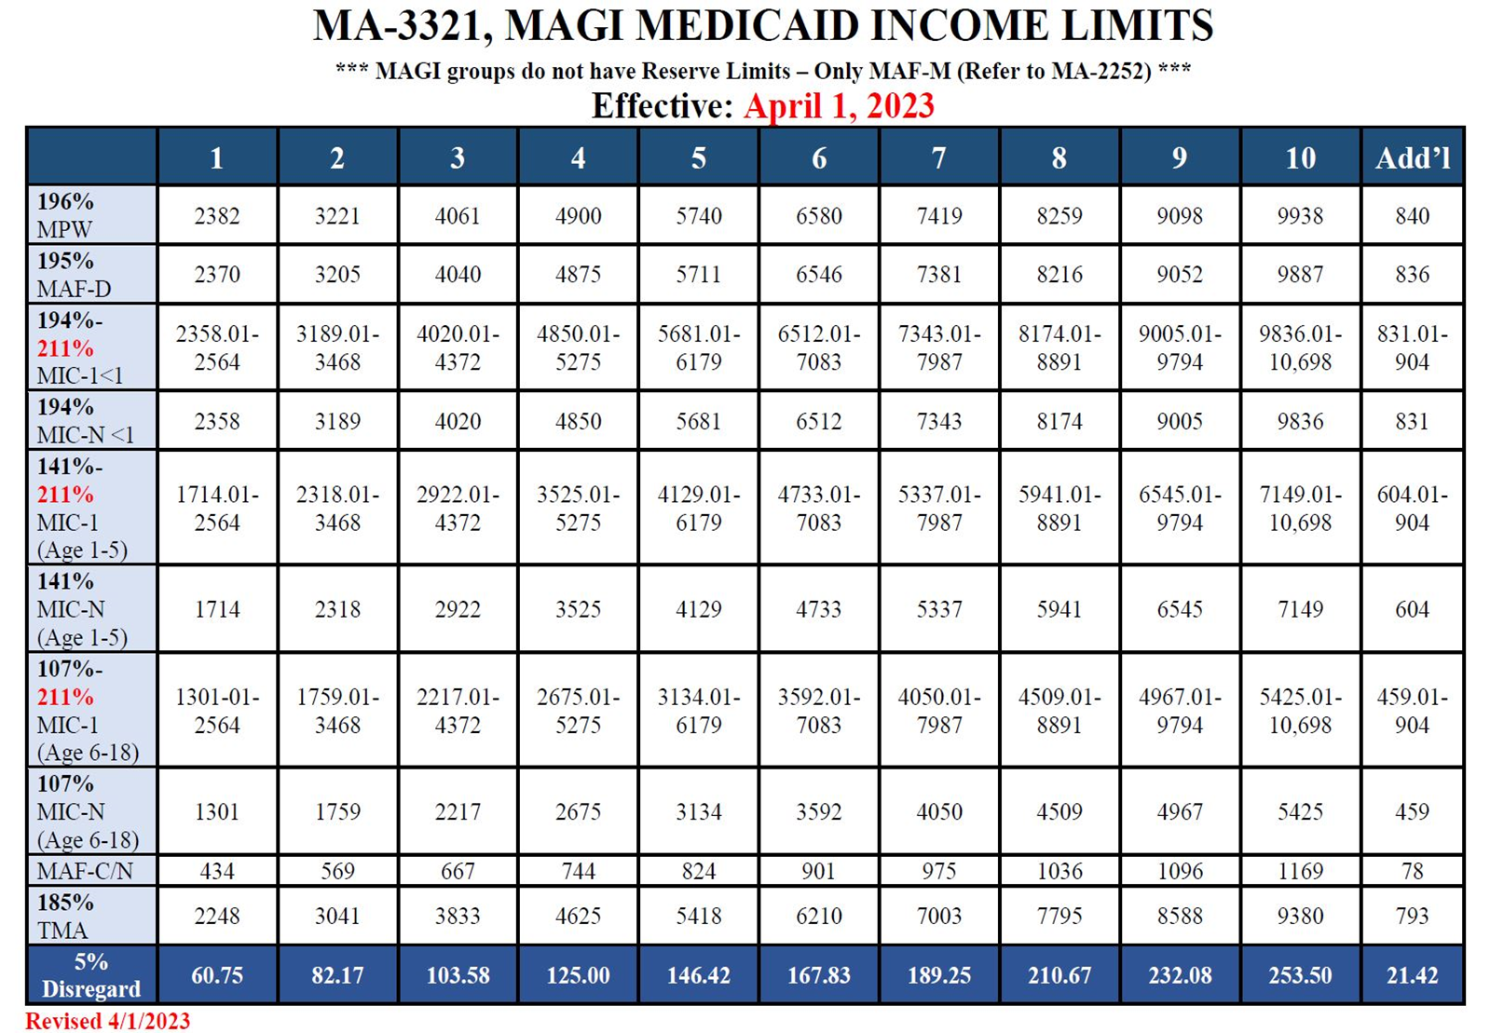
INCOME LIMITS - Attachment 4a
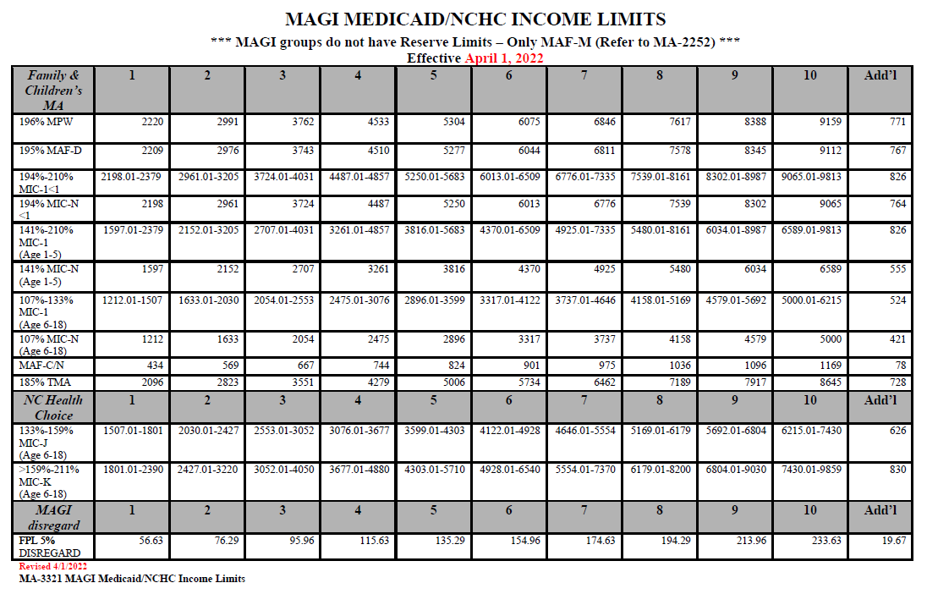

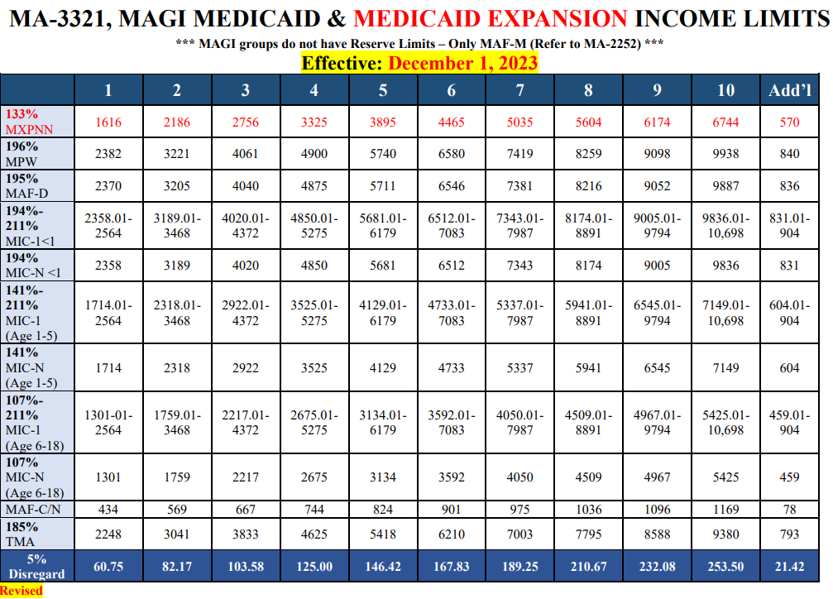
INCOME LIMITS - Attachment 4b
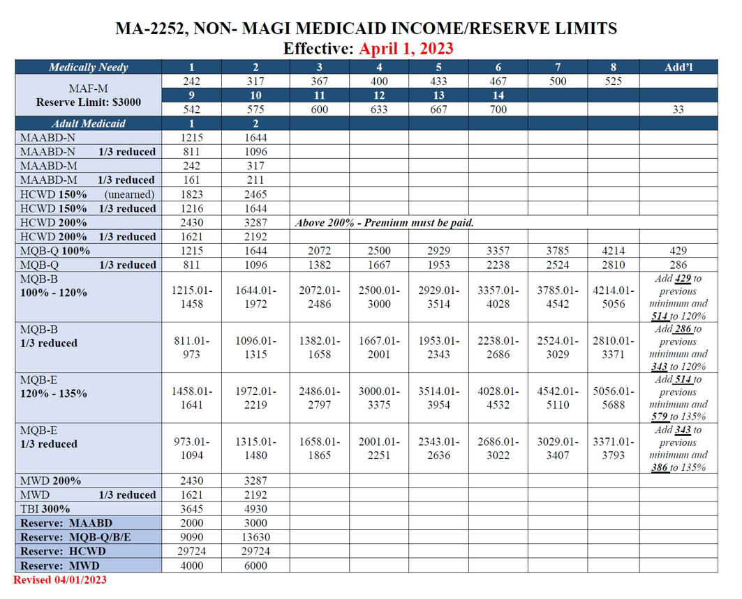
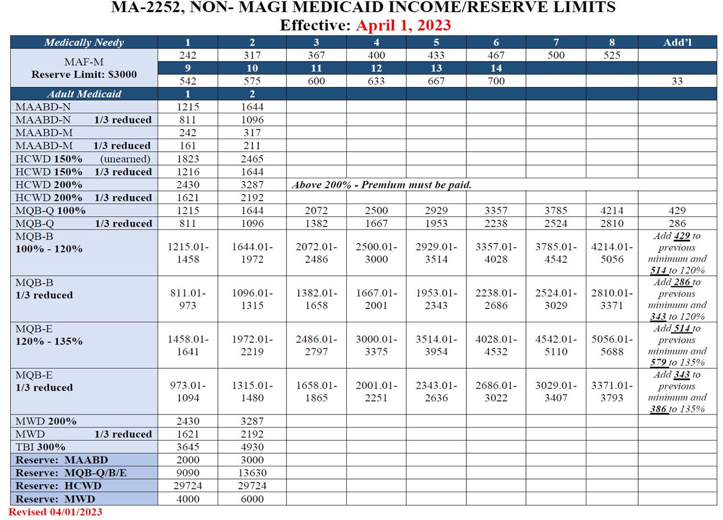
INCOME LIMITS – Attachment 4c

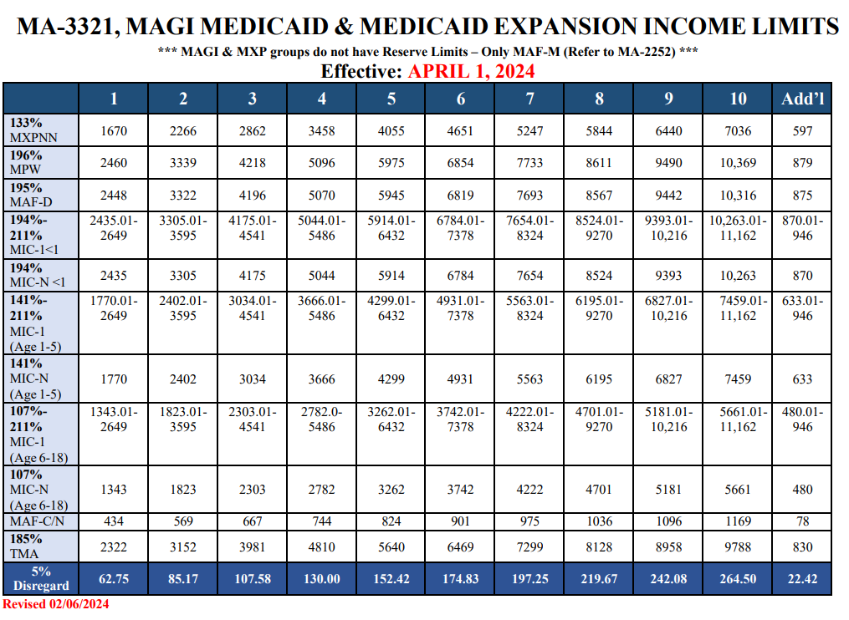
INCOME LIMITS - Attachment 4d

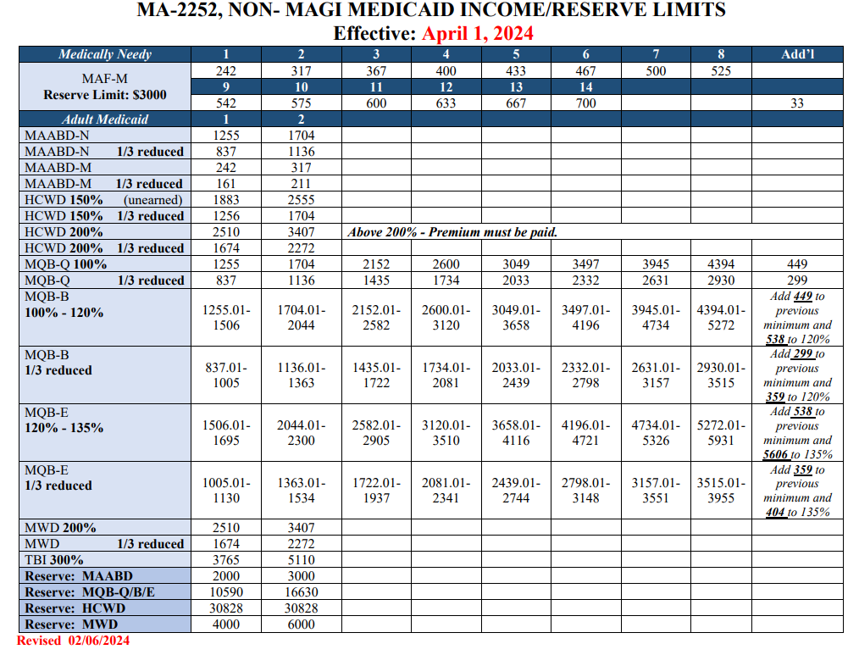
INCOME LIMITS – Attachment 4e
RECORD OF MEDICAL EXPENSE APPLIED TO THE DEDUCTIBLE

Attachment 5

1. CASEHEAD: 2. CASE ID: 3. CO. CASE NO.:
4. CERTIFICATION PERIOD: FROM THRU

Record medical expenses in the order in which they are incurred: |  |  |  |  |  |  |  | 5.  DED. AMOUNT
6. BU  MEMBER | 7.  DATE OF SERVICE | 8.  DATE OF LAST PAYMENT | 9.  PROVIDER | 10.  AMOUNT CHARGED | 11. TPR | 12.  CLIENT RESP | 13.  AMOUNT APPLIED TO DED. | 14. DED.  BALANCE | 15.  VERIFICATION

