Management’s Discussion and Analysis

For the Year Ended June 30, 2026

As management of the City of Dogwood (the “City”), we offer readers of the City’s financial statements this management discussion and analysis (MD&A). The MD&A provides a narrative overview and analysis of the financial statements of the City of Dogwood for the fiscal year ended June 30, 2026, focusing on why amounts changed from the prior year. We encourage readers to consider the information presented here in conjunction with additional information furnished in this report.

Note to preparer: The MD&A is an opportunity for management to proactively address any issues that might be affecting the unit’s financial status, including the effects of recent hurricanes or other natural disasters or uses of federal or other funds (such as American Rescue Plan Act (ARPA) or Opioid Settlement funds), or questions that might be posed by readers of the financial statements. The MD&A provides an objective and easily readable analysis of the government’s financial activities based on currently known facts, decisions, or conditions and presents comparisons between the current year and the prior year. Governmental Accounting Standards Board Statement No. 103 (GASB 103) requires that the information presented in MD&A be limited to the related topics discussed in five sections: (1) Overview of the Financial Statements, (2) Financial Summary, (3) Detailed Analyses, (4) Significant Capital Asset and Long-Term Financing Activity, and (5) Currently Known Facts, Decisions, or Conditions. GASB 103 also stresses that the detailed analyses should explain why balances and results of operations changed rather than simply presenting the amounts or percentages by which they changed. GASB 103 emphasizes that the analysis provided in MD&A should avoid unnecessary duplication by not repeating explanations that may be relevant to multiple sections and that “boilerplate” discussions should be avoided by presenting only the most relevant information, focused on the primary government.

Overview of the Financial Statements
This discussion and analysis is intended to serve as an introduction to the City’s basic financial statements. The City’s basic financial statements consist of three components: 1) government-wide financial statements, 2) fund financial statements, and 3) notes to the financial statements. The basic financial statements present two different views of the City through the use of government-wide statements and fund financial statements. In addition to the basic financial statements, this report contains other supplemental information that will enhance the reader’s understanding of the financial condition of the City of Dogwood.

Government-wide Financial Statements. The government-wide financial statements are designed to provide readers with a broad overview of the City’s finances, in a manner similar to private sector business. The government-wide financial statements include the City’s governmental activities, the business-type activities, and discretely presented component unit.

The statement of net position presents financial information on all of the City’s assets, liabilities, and deferred inflows/outflows of resources, with the difference reported as net position. Over time, increases or decreases in net position may serve as a useful indicator of whether the financial position of the City is improving or deteriorating.

The statement of activities presents information showing how the City’s net position changed during the most recent fiscal year. All changes in net position are reported as soon as the underlying event giving rise to the change occurs regardless of the timing of related cash flows. Thus, revenues and expenses are reported for some items that will only result in cash flows in future fiscal years (e.g. uncollected taxes and earned but unused vacation leave).

Both government-wide financial statements distinguish functions of the City that are principally supported by taxes and intergovernmental revenues (governmental activities) from other functions that are intended to recover all or a significant portion of their costs through user fees and charges (business-type activities). The governmental activities of the City include general government, public safety, transportation, economic & physical development, environmental protection, and cultural and recreation. The business-type activities of the City include electric and water & sewer operations.

The government-wide financial statements include not only the City itself (known as the primary government), but also an ABC Board operation (liquor sales), for which the City is financially accountable. Financial information for this component unit is reported separately from the financial information presented for the primary government itself.

Fund Financial Statements. A fund is a grouping of related accounts that is used to maintain control over resources that have been segregated for specific activities or objectives. The City, like other state and local governments, uses fund accounting to ensure and demonstrate compliance with finance-related legal requirements. All of the funds of the City can be divided into three categories: governmental funds, proprietary funds, and fiduciary funds.

Governmental Funds – Governmental funds are used to account for essentially the same functions reported as governmental activities in the government-wide financial statements. However, unlike the government-wide financial statements, governmental fund financial statements focus on near-term inflows and outflows of spendable resources available at the end of the fiscal year. Such information may be useful in assessing a government’s near-term financing requirements.

Because the focus of governmental funds is narrower than that of the government-wide financial statements, it is useful to compare the information presented for governmental funds with similar information presented for governmental activities in the government-wide financial statements. By doing so, readers may better understand the long-term impact of the government’s near-term financing decisions. Both the governmental fund balance sheet and the governmental fund statement of revenues, expenditures, and changes in fund balances provide a reconciliation to facilitate this comparison between governmental funds and governmental activities.

The City maintains six individual governmental funds. Information is presented separately in the governmental fund balance sheet and in the governmental fund statement of revenues, expenditures, and changes in fund balances for the General Fund, the Emergency Telephone System Fund, and the Parking and Recreation Capital Project Fund, which are considered to be major funds. Data from the other governmental funds are combined into a single aggregated presentation. Individual fund data for each of these non-major governmental funds is provided in the form of combining statements in the combining and individual fund statements and schedules section of this report.

Proprietary Funds – The City has one kind of proprietary fund. Enterprise funds are used to report the same functions presented as business-type activities in the government-wide financial statements. The City uses enterprise funds to account for its electric and water and sewer activities.

Proprietary funds provide the same type of information as the government-wide financial statements, only in more detail. The proprietary fund financial statements provide separate information for the Electric Fund, as well for the Water & Sewer Fund. The Electric Fund and the Water & Sewer Fund are major funds of the City.

Notes to the Financial Statements. The notes provide additional information that is necessary to acquire a full understanding of the data provided in the financial statements. The City uses notes to present information in greater detail than is possible within the financial statements themselves, explain the nature of amounts reported in the financial statements and how those amounts were determined, and report certain information that does not meet the requirements for inclusion in the financial statements (such as certain contingencies).

Other Information. In addition to the basic financial statements and accompanying notes, this report includes certain required supplementary information. The City presents budgetary comparison schedules for the General Fund, the Economic Development Fund (consolidated into the General Fund), and the Emergency Telephone System Fund, as well as the City’s progress in funding its obligations to provide pension and OPEB benefits to its employees.

The combining statements referred to earlier in connection with nonmajor governmental funds are presented immediately following the required supplementary information on budgetary comparisons, and pensions and OPEB.

Financial Summary and Detailed Analysis

Note to preparer: GASB 103 states that the MD&A should discuss the current-year balances and
results of operations in comparison with the prior year, with emphasis on the current year. This analysis should be fact based and should discuss the activities that have had either a significant positive impact or a significant negative impact on the government’s balances and results of operations in comparison with the prior year. The analysis should assist users in understanding why balances and results of operations reported in the current year’s financial statements changed from the prior year rather than simply presenting the amounts or percentages by which they changed. The use of charts, graphs, and tables is encouraged to enhance the understandability of the information.

Net position. As noted earlier, net position may serve over time as a useful indicator of a government’s financial position. The City’s assets and deferred outflows of resources exceeded liabilities and deferred inflows of resources by $14.2 million at the close of the most recent fiscal year, an increase of $2.1 million.

City of Dogwood’s Net Position
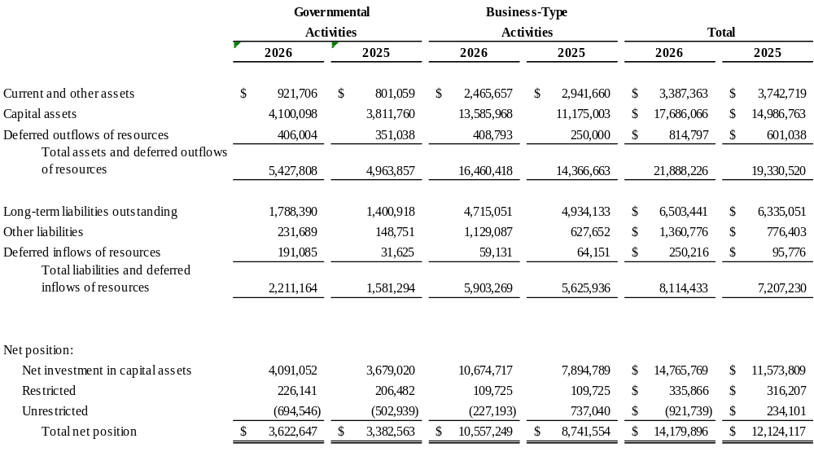Figure 1

The largest portion of the City’s net position, $14,765,769, reflects its investment in capital assets (e.g., land, buildings, machinery, equipment, vehicles, and infrastructure), net of accumulated depreciation/amortization and less any related outstanding debt that was used to acquire those assets. The City uses these capital assets to provide a variety of services to citizens. Accordingly, these assets are not available for future spending. Although the City’s investment in capital assets is reported net of related debt, it should be noted that the resources used to repay this debt must be provided from other sources, since the capital assets themselves cannot be used to liquidate these liabilities.

An additional portion of the City’s net position, $335,866, represents resources that are subject to external restrictions on how they may be used. As of the end of the current fiscal year, the City’s unrestricted net position was a deficit of $921,739, caused by approximately $2.1 million of post-employment liabilities for the City’s two pension plans ($874,148) and its other post-employment benefit plan for retiree healthcare ($1,197,320). The following sections analyze the finances of the governmental activities and business-type activities separately.

Governmental activities. Current and other assets increased by $120,647 (15.1 percent) from the prior year from unspent cash provided by a debt issuance.

Capital assets increased by $288,388 (7.6 percent) from capitalized capital outlay expenditures offset by depreciation expense and an asset impairment loss of $268,745.

Long-term liabilities, which consist of bonds, notes, leases, subscription-based IT arrangements, compensated absences and postemployment benefit obligations, increased by $387,472 (27.7 percent) from the previous year. New debt of $283,621 was issued and was accompanied by increases in pension and OPEB liabilities.

Business-type activities. Current and other assets decreased by $476,003 (16.2 percent) from cash used for capital expenditures for water & sewer. Capital assets increased by $2,410,965 from water and sewer capital outlays of $5,072,977 and an impairment loss of $2,368,954. The impairment loss was the result of a record flood and the collapse of the Cardinal Point Dam, a water and sewer capital asset. The City received $3,650,000 from an insurance recovery and completed the rebuilding of the dam prior to fiscal year end (see Note D).

City of Dogwood’s Changes in Net Position
Figure 2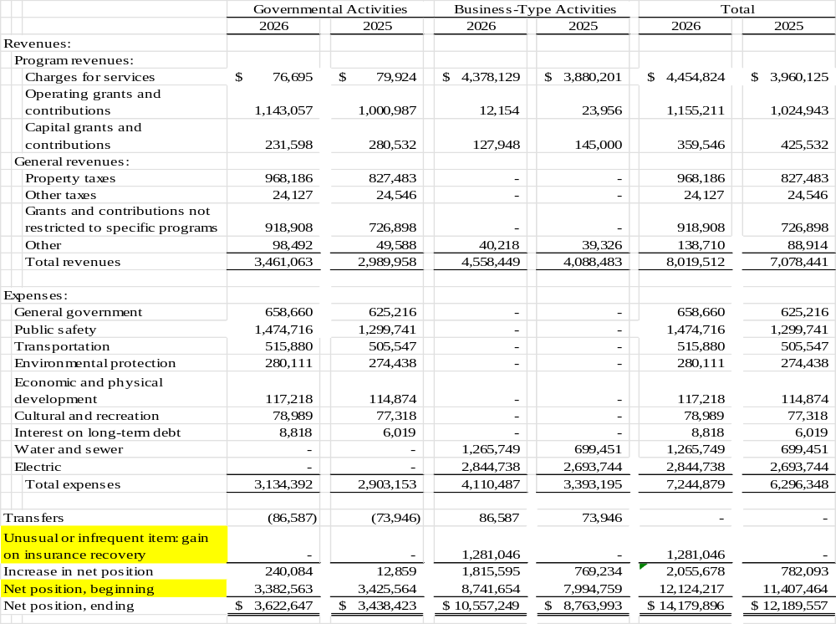

The City’s overall net position increased $2,055,678 from the prior year. The reasons for this overall increase are discussed in the following sections for governmental activities and business-type activities.
Governmental activities. Governmental activities increased the City’s net position by $240,084. During the current year City management continued to reduce non-essential programs to a minimum and implemented cost saving strategies across City departments. Certain non-recurring expenses were either postponed or renegotiated to maintain a healthy net position. These efforts helped to minimize expenses for the current fiscal year. As a result, the City did not experience a significant increase in any of the functional expenditure categories of governmental activities. The $124,781 (4.3 percent) increase in total expenses was largely attributable to salary increases provided to employees during the current fiscal year.

Management believes healthy investment in the City will result in additional revenues, adding to the City’s net position by investing in capital assets. The City was able to fund some items in its capital spending plan with cultural, recreational, and economic development grant revenues. This effort was aided through an insurance recovery of $325,000 that was used to repair the flood damage to the Tarheel Municipal Building.

The total revenues of City increased by $471,105 (15.8 percent) over the prior year. One of the main factors contributed to this overall increase was that the property valuation used in the calculation of the fiscal year 2026 tax levy increased by $24,970,000 which in turn caused a $139,927 increase in the net levy. In addition, there was an increase in revenues from grants and contributions of $192,010. These federal and state grants were to aid in the cleanup, recovery, and restoration related to the flood damage sustained by the City.

Note to preparer: List here anything you wish to highlight – fee revenue or tax revenue increases due to economic growth, reductions in spending, savings from debt refunding, new operating grants received, etc. The language above and below are examples based on the City of Dogwood. Also, please note the statewide tax collection average changes annually. The management of cash, taxes and fund balance available reports provide comparative cash and investment, fund balance available, and tax levy information for local governments in North Carolina. Information and averages presented in these reports are based on data reported by local governments to the Local Government Commission as of the date of the report. To access the report server, please visit our Financial Analysis Tools and Reports webpage. A link to generate this report is offered in the “Reports” section of the webpage. Accessing the report online allows you to generate the desired report by selecting the audit year and the unit type (either county or municipality).

Business-type activities. Business-type activities increased the City’s net position by $1,815,595, accounting for 83.97 percent of the total growth in the government’s total net position. A key element of this increase was due to an unusual or infrequent item, a gain on insurance recovery of $1,281,046 due to the collapse of the Cardinal Point Dam and subsequent flooding of the wastewater aeration facility. The City received $3,650,000 in an insurance recovery to offset an asset impairment loss of $2,368,954 resulting in an unusual or infrequent item, a gain of $1,281,046. Restoration cost of $3,800,000 has been capitalized in the Water and Sewer Fund. Overall Water and Sewer Enterprise fund expenses increased by $566,298 (80.96% over the prior year). Expenses for the cleanup, recovery and restoration related to the flood were the cause of the increase.

Cost-saving measures were able to limit the expenses of the Electric Enterprise Fund. The increase in those expenses was $150,994 (5.61 percent) over the prior year. This was largely attributable to salary increases provided to employees during the current fiscal year. The City’s adopted budget included rate increases for both the Electric and Water and Sewer Enterprise funds. The 5 percent increase in rates plus increases in the consumption of electric and water services resulted in an increase of $497,928 in those revenues.
Note to preparer: Include anything in the above discussion that you wish to highlight with regards to business-type activities as reasons for increases in net position.

Detailed Analysis of Governmental Funds

Note to preparer: Discussions should be limited to major funds of the primary government.

As noted earlier, the City of Dogwood uses fund accounting to ensure and demonstrate compliance with finance-related legal requirements. The City reports three major funds individually in the governmental fund financial statements, the General Fund, the Emergency Telephone System Fund, and the Parking and Recreation Capital Projects Fund.

General Fund. The General Fund is the chief operating fund of the City. At the end of the fiscal year, the City’s fund balance available was $364,608, while total fund balance was $500,541. The Governing Body of the City has determined that the City should maintain an available fund balance of 5% of general fund expenditures in case of unforeseen needs or opportunities, in addition to meeting cash flow needs. The City currently has an available fund balance of 17.01% of General Fund expenditures, and total fund balance represents 24.92% of the same amount.

On June 30, 2026, governmental funds reported a combined fund balance of $558,617 with a net decrease in fund balance of $100,842.

The total fund balance of the General Fund decreased by $131,292 from greater than expected expenditures that resulted from an unexpected building heating and air conditioning system replacement and from higher Police Department expenditures for part-time employees and from overtime paid.

Like governmental activities, the General Fund also had increased property tax revenues because of the increased property valuation used for the calculation of the current year tax levy. During the current year the City of Dogwood enhanced its tax collection policies and procedures. The effort focused on the collection of prior year unpaid taxes. On the accrual basis used for government-wide financial statements the taxes were previously recognized as revenue in the period they were intended to finance. However, on the modified accrual basis used for governmental fund financial statements property tax revenues must be available to be recognized as revenue. The unpaid taxes of prior years only become available when they are actually collected. The enhanced collection efforts in the current year resulted in the collection and recognition of revenue of approximately $29,000.

The Parking and Recreation Capital Projects Fund neared completion of a parking deck project with a $200,00 grant and capital expenditures of $590,000.

Note to preparer: GASB 103 requires a discussion of significant events for each major governmental fund.

Note to preparer: Budgetary highlights and budget analysis are in Required Supplementary Information per GASB 103.

Detailed Analysis of Enterprise Funds.

The City reports two enterprise funds in the proprietary fund financial statements, the Electric Fund and the Water and Sewer Fund, both major. The City’s enterprise funds provide the same type of information found in the government-wide statements but in more detail.

Unrestricted net position for the Water and Sewer Fund at the end of the fiscal year was a deficit of $245,557. The total change in net position for the Water and Sewer Fund was an increase of $1,831,714. The change in net position in the Water and Sewer Fund was the result of a gain from insurance proceeds as a result of the collapse in the Cardinal Point Dam and subsequent damage to the wastewater aerating facility.

Unrestricted net position of the Electric Fund was $18,064. The total change in net position for the Electric Fund was a decrease of $16,419. The change in net position was the result of an operating loss of $11,661 caused by higher than anticipated costs of electric power purchases.

Significant Capital Asset and Long-term Financing Activity

Note to Preparer: GASBS 34 ¶11.f. provides for, at a minimum, inclusion of “[a] description of significant capital asset and long-term debt activity during the year, including a discussion of commitments made for capital expenditures, changes in credit ratings, and debt limitations that may affect the financing of planned facilities or services.

Capital assets. The City’s capital assets for its governmental and business–type activities as of June 30, 2026, totaled $18,049,559 (net of accumulated depreciation), an increase of 20.68 percent over the prior year. These assets include buildings, infrastructure, land, machinery and equipment, park facilities, vehicles and right to use assets for leases and IT subscriptions.

Note to preparer: List of major activities, including demolitions or impairments. The following is an example based on the City of Dogwood.

Major capital asset events during the year include the following:

Governmental Activities
- Restoration costs of $395,240 for flood damage repairs to the municipal building were capitalized.
- $590,000 was added to construction in progress for additional amounts spent on the parking deck and various recreational facilities.

Business-type Activities
- Restoration costs of $3,925,364 for flood damage repairs to the wastewater aerating facility were capitalized.
- $1,147,613 was added to construction in progress for additional amounts spent on water and sewer treatment facilities.

City of Dogwood’s Capital Assets (net of depreciation/amortization)
Figure 3
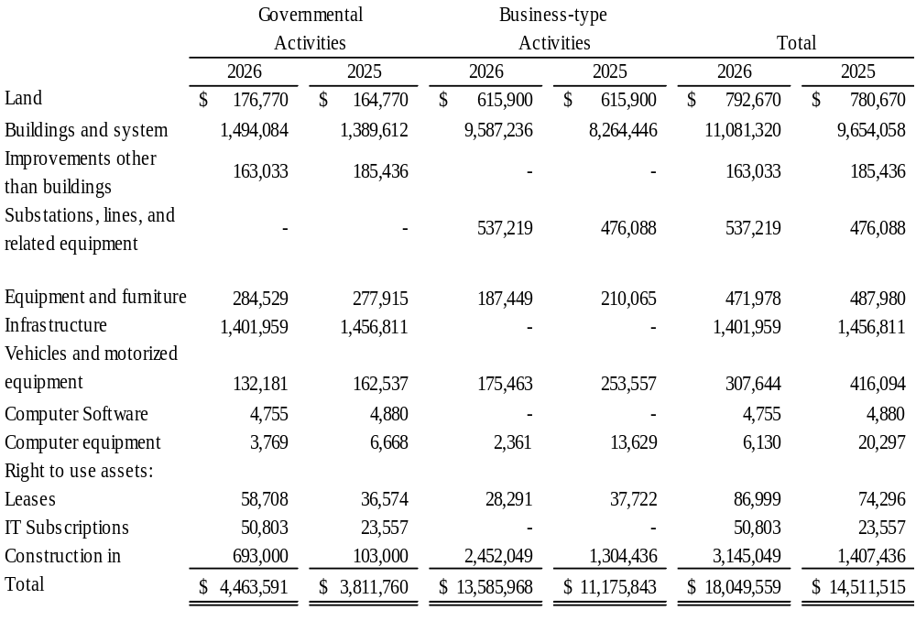

Both leases and software subscriptions (SBITA) are intangible, right to use assets. The City does not own these assets but rather has the right to use them in operations as specified in their respective contracts. When entering into a lease or SBITA contract, a liability is also recognized, which is included in the long-term financings discussion below.

Additional information on the City’s capital assets can be found in Note III.A.5 of the Basic Financial Statements.

Long-term financing. As of June 30, 2026, the City had total long-term financing liabilities of $6,597,106, composed of installment financings, general obligation bonds, revenue bonds, lease liabilities, subscription liabilities, post-employment healthcare liabilities, pension liabilities, and compensated absences liabilities. The City had total outstanding bonded debt of $3,925,537. Of this, $3,018,614 is debt backed by the full faith and credit of the City. Changes in long-term financing liabilities are as follows:
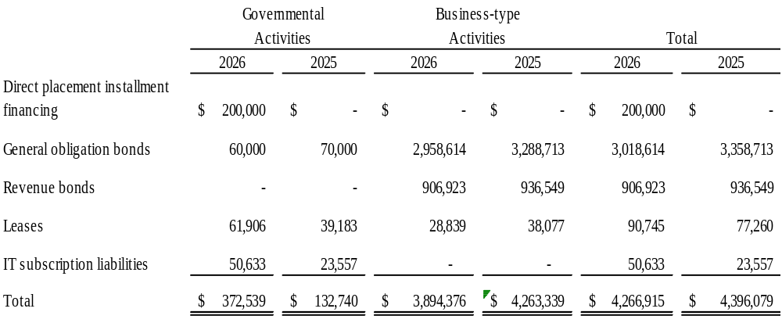Figure 4

The City’s total long-term financing liabilities decreased by $129,164 or 2.9 percent from the prior year. Key factors in the increase were the issuance of $200,000 in installment purchase financing for parking improvements at Municipal Park to be paid from the General Fund, offset by principal payments of $396,735. There was also an increase in the net pension liability for the Local Governmental Employees’ Retirement System (LGERS) of $307,969. Of the increase in the liability to LGERS $186,320 relates to governmental activities and $121,649 relates to business-type activities. These increases were offset by planned debt service principal payments of $369,725.
The City also issued a bond anticipation note (BAN) of $675,000 for Water and Sewer improvements. While a short-term liability (amount is due November 23, 2027), it was issued with the intent to issue long-term debt of $750,000 during the next fiscal year to provide resources to pay off the BAN and to provide some additional resources for water and sewer projects.
For the 10th consecutive year, the City maintained its Aa1 bond rating from Moody’s Investors Service, and its AA+ rating from both Standard and Poor’s Financial Services and Fitch Ratings. The bond ratings are a clear indication of the sound financial condition of the City. This achievement is a primary factor in keeping interest costs low on the City’s outstanding debt.
North Carolina general statutes limit the amount of general obligation and installment financing debt that a unit of government can issue to 8% of the total assessed value of taxable property located within that government’s boundaries. The legal debt margin for the City was $10,847,306. The City has $1,000,000 in bonds authorized but unissued at June 30, 2026.

Additional information regarding the City’s long-term financings can be found in Note III.B.6 of this report.

Currently known facts, decisions, or conditions

The City of Dogwood was aware of the following items that will impact future finances and were considered in developing the 2027 fiscal year budget.

Note to preparer: GASBS 103 ¶8.e requires a description of currently known facts, decisions, or conditions that are expected to have a significant effect on financial position (net position) or that are expected to produce significant differences from current-period results of operations (revenues, expenses, and other changes in net position). Information about any additional types of currently known facts, decisions, or conditions that are expected to have a significant effect on financial position or to produce significant differences from current-period results of operations should be provided.
Note to preparer: List items such as the number of new jobs created, the number of occupied square feet of business property, the unemployment rate and how it compares to state average, total retail sales for the unit for the year, etc. This is also an opportunity to discuss the impact of unusual events such as the effects of COVID-19 on the unit’s economy. UNC School of Government ARPA Resources may be found here.

The following are expected to have significant positive effects upon the net position of the city:
- Low unemployment. The City’s unemployment rate of 3.9 percent is well below the State average.
- New manufacturing jobs. Management’s emphasis on economic development continues to attract business. The City added approximately 4,000 new jobs last year in the manufacturing sector with the opening of the Doohickey Factory.
- Occupancy rates on office and retail space. The City’s occupancy rates are about 90 percent for the year, which is an increase from last year and higher than the area average of 85 percent. Management expects that the occupancy rate for fiscal year 2027 will remain high.

Requests for Information

This report is designed to provide an overview of the City’s finances for all those with an interest in the government’s finances. Questions concerning any of the information found in this report or requests for additional information should be directed to the Director of Finance, City of Dogwood, 789 Government Drive, Dogwood, NC 00000. You can also call (000)-000-0000, visit our website at: __________ or send an email to ________________ for more information.

