Notes to the Financial Statements

Notes to the Financial Statements
For the Fiscal Year Ended June 30, 2026

I. Summary of Significant Accounting Policies

The accounting policies of the City of Dogwood and its discretely presented component unit conform to generally accepted accounting principles as applicable to governments. The following is a summary of the more significant accounting policies:
A. Reporting Entity

The City of Dogwood (the City) is a municipal corporation that is governed by an elected mayor and a five-member council. As required by generally accepted accounting principles (GAAP), these financial statements present the City and its component unit, a legally separate entity for which the City is financially accountable. The discretely presented component unit presented below is reported in a separate column in the financial statements to emphasize that it is legally separate from the City.

City of Dogwood ABC Board
The members of the City of Dogwood ABC Board's (the ABC Board) governing board are appointed by the city. In addition, the ABC Board is required by State statute to distribute its surpluses to the General Fund of the City. The ABC Board, which has a June 30 year-end, is presented as if it were a proprietary fund (discrete presentation). Complete financial statements for the ABC Board may be obtained from the entity's administrative offices at City of Dogwood ABC Board, 456 Cardinal Avenue, Dogwood, NC 00000. The ABC Board is a major component unit due to the significant nature of services provided.

Note to preparer: The notes for the ABC Board have been streamlined to include only the material items of cash, inventory, and capital assets. This satisfies reporting required by GASB Statement No. 14, as amended by GASB Statements Nos. 39 and 61.

B. Basis of Presentation, Basis of Accounting

Government-wide Statements: The statement of net position and the statement of activities display information about the primary government (the City) and its component units. These statements include the financial activities of the overall government. Eliminations have been made to minimize the double-counting of internal activities. These statements distinguish between the governmental and business-type activities of the City. Governmental activities are generally financed through taxes, intergovernmental revenues, and other non-exchange transactions. Business-type activities are financed in whole or in part by fees charged to external parties.

The statement of activities presents a comparison between direct expenses and program revenues for the different business-type activities of the City and each function of the City’s governmental activities. Direct expenses are those that are specifically associated with a program or function and, therefore, are identifiable to a particular function. Indirect expense allocations made in the funds have been reversed for the statement of activities. Program revenues include (a) fees paid by the recipients of goods or services offered by the programs and (b) grants and contributions that are restricted to meeting the operational or capital requirements of a particular program. Revenues that are not classified as program revenues, including all taxes, are presented as general revenues.

Fund Financial Statements: The fund financial statements provide information about the City’s funds. Separate statements for each fund category – governmental and proprietary – are presented. The City has no fiduciary funds to report. The emphasis of the fund financial statements is on major governmental and enterprise funds, each displayed in a separate column. All remaining governmental and enterprise funds are aggregated and reported as non-major funds.
Proprietary fund operating revenues, such as charges for services, result from exchange transactions associated with the principal activity of the fund. Exchange transactions are those in which each party receives and gives up essentially equal values. Non-operating revenues, such as subsidies, result from non-exchange transactions or ancillary activities.

The City reports the following major governmental funds:

General Fund. The General Fund is the general operating fund of the City. It accounts for all financial resources of the general government except those that are required to be accounted for in another fund. The City has legally adopted an Economic Development Fund which is consolidated into the General Fund in accordance with Governmental Accounting Standards Board (GASB) Statement No. 54.

Emergency Telephone System Special Revenue Fund. This fund is used to account for 911 revenues received by the State 911 Board to enhance the State’s 911 system.

Parking and Recreation Capital Projects Fund. This fund is used to account for the construction of a new city park and parking facilities.

The City reports the following non-major governmental funds:

Grant Project (Special Revenue) Fund. This fund is used to account for grant funds that are restricted for a specific purpose.

Fines and Forfeitures (Special Revenue) Fund. This fund accounts for various legal fines and forfeitures that the City is required to remit to the Carolina County Board of Education.

Cemetery (Permanent) Fund. This fund is used to account for the perpetual care of the municipal cemetery.

The City reports the following major enterprise funds:

Electric Fund. This fund is used to account for the City’s electric operations. An Electric Rate Stabilization Fund has been consolidated into the Electric Fund for financial reporting purposes. The budgetary comparison for the Electric Rate Stabilization Fund has been included in the supplemental information.

Water and Sewer Fund. This fund is used to account for the City’s water and sewer operations. A Water and Sewer Capital Projects Fund has been consolidated into the Water and Sewer Fund for financial reporting purposes. The budgetary comparison for the Water and Sewer Capital Projects Fund has been included in the supplemental information.

The City also reports the following fund type:

Internal Service Fund. The Central Garage Fund is used to account for the accumulation and allocation of costs associated with the City’s central garage.

Note to preparer: If your unit has American Rescue Plan Act (ARPA) funds in a special revenue fund, please refer to the Carolina County Illustrative Statements for guidance.

During the course of operations, the City has activity between funds for various purposes. Any residual balances outstanding at year end are reported as due from/to other funds. Activity occurs during the year involving transfers of resources between funds, which are reported at gross amounts as transfers in/out. While these balances are reported in the fund financial statements, certain eliminations are made for the preparation of the government‐wide financial statements. Balances between the funds included in governmental activities (governmental and internal service funds) are eliminated so that only the net amount is included as internal balances in the governmental activities column. Similarly, balances between the funds included in business‐type activities (enterprise funds) are eliminated so that only the net amount is included as internal balances in the business‐type activities column. Transfers between the funds included in governmental activities are eliminated so that only net amounts are included as transfers in the governmental activities column. Similarly, balances between the funds included in business‐type activities are eliminated so that only net amounts are included as transfers in the business‐type activities column.

C. Measurement Focus and Basis of Accounting

In accordance with North Carolina General Statutes (G.S.), all funds of the City are maintained during the year using the modified accrual basis of accounting.

Government-wide and Proprietary Fund Financial Statements. The government-wide and proprietary fund financial statements are reported using the economic resources measurement focus. The government-wide and proprietary fund financial statements are reported using the accrual basis of accounting. Revenues are recorded when earned and expenses are recorded at the time liabilities are incurred, regardless of when the related cash flows take place. Non-exchange transactions, in which the City gives (or receives) value without directly receiving (or giving) equal value in exchange, include property taxes, grants, and donations. On an accrual basis, revenue from property taxes is recognized in the fiscal year for which the taxes are levied. Revenue from grants and donations is recognized in the fiscal year in which all eligibility requirements have been satisfied.

Amounts reported as program revenues include 1) charges to customers or applicants for goods, services, or privileges provided, 2) operating grants and contributions, and 3) capital grants and contributions, including special assessments. Internally dedicated resources are reported as general revenues rather than as program revenues. Likewise, general revenues include all taxes.

Proprietary funds distinguish operating revenues and expenses from non-operating items. Operating revenues and expenses generally result from providing services and producing and delivering goods in connection with a proprietary fund’s principal ongoing operations. The principal operating revenues of the City enterprise funds are charges to customers for sales and services. The city also recognizes as operating revenue the portion of tap fees intended to recover the cost of connecting new customers to the water and sewer system. Operating expenses for enterprise funds include the cost of sales and services, administrative expenses, and depreciation/amortization on capital assets. All revenues and expenses not meeting this definition are reported as non-operating revenues and expenses.

Governmental Fund Financial Statements. Governmental funds are reported using the current financial resources measurement focus and the modified accrual basis of accounting. Under this method, revenues are recognized when measurable and available. Expenditures are recorded when the related fund liability is incurred, except for principal and interest on general long-term debt, including lease and information technology subscription (SBITA) liabilities, claims and judgments, and compensated absences, which are recognized as expenditures to the extent they have matured. General capital asset acquisitions are reported as expenditures in governmental funds. Issuance of general long-term debt and acquisitions under leases and subscription-based information technology arrangements (SBITAs) are reported as other financing sources.

The City considers all revenues available if they are collected within 90 days after year-end, except for property taxes. Ad valorem taxes receivable is not accrued as revenue because the amount is not susceptible to accrual. On June 30, taxes receivable for property other than motor vehicles are materially past due and are not considered to be an available resource to finance the operations of the current year. Also, as of September 1, 2013, State law altered the procedures for the assessment and collection of property taxes on registered motor vehicles in North Carolina. Effective with this change in the law, the State of North Carolina is responsible for billing and collecting the property taxes on registered motor vehicles on behalf of all municipalities and special tax districts. Property taxes are due when vehicles are registered. The billed taxes apply to the fiscal year in which they are received. Uncollected taxes that were billed in periods before September 1, 2013, and for limited registration plates are shown as receivables in these financial statements and are offset by deferred inflows of resources.

Note to preparer: Any motor vehicle property taxes collected by the State for municipalities or special tax districts before June 30 that are not remitted to those governmental entities until after the fiscal year end should be reported as collected property taxes at year-end by those entities. The amounts of tax monies due from the State via the County should be reported as an intergovernmental receivable. The SLGFD anticipates that any receivables from limited registration plates will be immaterial. They have been included in the note for illustrative purposes.

Sales taxes and certain intergovernmental revenues, such as the beer and wine tax, collected and held by the State at year-end on behalf of the city are recognized as revenue. Sales taxes are considered a shared revenue for the City of Dogwood because the tax is levied by Carolina County and then remitted to and distributed by the State. Most intergovernmental revenues and sales and services are not susceptible to accrual because generally they are not measurable until received in cash. All taxes, including those dedicated for specific purposes, are reported as general revenues rather than program revenues.

Under the terms of grant agreements, the City funds certain programs by a combination of specific cost-reimbursement grants, categorical block grants, and general revenues. Thus, when program expenses are incurred, there is both restricted and unrestricted net position available to finance the program. It is the City’s policy to first apply cost-reimbursement grant resources to such programs, followed by categorical block grants, and then general revenues.

Note to preparer: The prior year section 1.D has been moved to the Required Supplementary Information, Notes to the Budgetary Schedules per GASB Statement No. 103.

D. Assets, Liabilities, Deferred Outflows/Inflows of Resources, and Fund Equity

1. Deposits and Investments

All deposits of the City and the ABC Board are made in board-designated official depositories and are secured as required by G.S. 159-31. The City and the ABC Board may designate, as an official depository, any bank or savings association whose principal office is in North Carolina. Also, the City and the ABC Board may establish time deposit accounts such as NOW and Super NOW accounts, money market accounts, and certificates of deposit.

G.S. 159-30 authorizes the City and the ABC Board to invest in obligations of the United States or obligations fully guaranteed both as to principal and interest by the United States, obligations of the State of North Carolina, bonds and notes of any North Carolina local government or public authority, obligations of certain non-guaranteed federal agencies, certain high quality issues of commercial paper, bankers’ acceptances, and mutual fund shares when the mutual fund is certified by the Local Government Commission. The City’s and the ABC Board’s investments are generally reported at fair value.

The North Carolina Capital Management Trust (NCCMT) Government Portfolio is an SEC-registered money market mutual fund that is currently certified by the Local Government Commission under the provisions of G.S. 159-30(c)(8) and the North Carolina Administrative Code. The Government Portfolio is a 2a7 fund that invests in treasuries, government agencies, and repurchase agreements collateralized by treasuries. It is rated AAAm by S&P and AAA-mf by Moody's Investors Service and reported at fair value.

The City has invested in securities that are callable and that provide for periodic interest rate increases in specific increments until maturity. These investments are reported at fair value as determined by quoted market prices.

2. Cash and Cash Equivalents

The City pools money from several funds to facilitate disbursement and investment and to maximize investment income and considers all cash and investments to be cash and cash equivalents. The ABC Board considers all highly liquid investments (including restricted assets) with a maturity of three months or less when purchased to be cash and cash equivalents.

3. Restricted Assets

The unexpended bond proceeds of Water and Sewer Fund serial bonds issued by the City are classified as restricted assets for the enterprise fund because their use is completely restricted to the purpose for which the bonds were originally issued. Customer deposits held by the city before any services are supplied are restricted to the service for which the deposit was collected. Money in the Economic Development Fund is classified as restricted assets because its use is restricted to the Economic Development Fund per G.S. Chapter 159, Article 3, Part 2. Powell Bill funds are also classified as restricted cash because they can be expended only for the purposes outlined in G.S. 136-41.1 through 41.4.

4. Ad Valorem Taxes Receivable

By G.S. 105-347 and G.S.159-13(a), the City levies ad valorem taxes on property other than motor vehicles on July 1, the beginning of the fiscal year. The taxes are due on September 1 (lien date); however, interest does not accrue until the following January 6. These taxes are based on the assessed values as of January 1, 2025. As allowed by State law, the City has established a schedule of discounts that apply to taxes that are paid before the due date. In the City’s General Fund, ad valorem tax revenues are reported net of such discounts.

Note to preparer: Modify the assessed value as of the date of the unit’s last valuation date.

5. Allowances for Doubtful Accounts

All receivables that historically experience uncollectible accounts are shown net of an allowance for doubtful accounts. This amount is estimated by analyzing the percentage of receivables that were written off in prior years.

6. Leases Receivable

The City’s leases receivable are measured at the present value of lease payments expected to be received during the lease term. Under the lease agreement, the City may receive variable lease payments that are dependent upon the lessee’s revenue. The variable payments are recorded as an inflow of resources in the period the payment is received. A deferred inflow of resources is recorded for leases. The deferred inflow of resources is recorded at the initiation of the lease in an amount equal to the initial recording of the lease receivable. The deferred inflow of resources is amortized on a straight-line basis over the term of the lease.

7. Inventories and Prepaid Items

The inventories of the City and the ABC Board are valued at cost (first-in, first-out), which approximates market. The City’s General Fund inventory consists of expendable supplies that are recognized as expenditures when purchased. If a significant amount of inventory is on hand at year-end, expenditures are adjusted, and inventory is reported on the balance sheet in the governmental funds. However, in the Government-wide Statement of Activities, the cost of these inventories is expensed as the items are used. The inventories of the City’s enterprise fund and those of the ABC Board consist of materials and supplies held for subsequent use. The cost of these inventories is expensed when consumed rather than when purchased.

Certain payments to vendors reflect costs applicable to future accounting periods and are recorded as prepaid items in both government-wide and fund financial statements and expensed as the items are used.

Note to preparer: If your unit is using the consumption method or purchases method of accounting for prepaid expenses, this will need to be disclosed here.

8. Capital Assets

Capital assets are defined by the government as assets with an initial, individual cost of more than a certain cost and an estimated useful life in excess of two years. Minimum capitalization costs are as follows: land, $10,000; buildings, improvements, substations, lines, and other plant and distribution systems, $15,000; infrastructure, $20,000; equipment and furniture, $5,000; vehicles and motorized equipment, $10,000; computer software, $5,000; and computer equipment, $500. Donated capital assets received prior to June 30, 2015, are recorded at their estimated fair value at the date of donation. Donated capital assets received after June 30, 2015, are recorded at acquisition value. All other purchased or constructed capital assets are reported at cost or estimated historical cost. General infrastructure assets acquired prior to July 1, 2003, consist of the road network and water and sewer system assets that were acquired or that received substantial improvements after July 1, 1980, and are reported at estimated historical cost using deflated replacement cost. The cost of normal maintenance and repairs that do not add to the functionality of the asset or materially extend the asset’s life are not capitalized.

The City’s capital assets also include certain right to use assets. These right to use assets arise in association with agreements where the City reports a lease (only applies when the City is the lessee) or agreements where the City reports a SBITA in accordance with the requirements of GASB Statement No. 87 and GASB Statement No. 96, respectively.

The right to use lease assets are initially measured at an amount equal to the initial measurement of the related lease liability plus any lease payments made at or before the start of the lease term, less lease incentives received from the lessor at or before the start of the lease term, and ancillary charges necessary to place the lease asset into service. The right to use lease assets are amortized on a straight-line basis over the life of the related lease.

The right to use SBITA assets are initially measured at an amount equal to the initial measurement of the subscription liability plus any subscription payments made at the start of the subscription term, if applicable, plus capitalizable initial implementation costs at the start of the subscription term, less any incentives received from the SBITA vendor at the start of the subscription term. Subscription payments, as well as payments for capitalizable implementation costs made before the start of the subscription term, should be reported as a prepayment (asset). Such prepayments should be reduced by any incentives received from the same vendor before the start of the subscription term if a right of offset exists. The net amount of the prepayments and incentives should be reported as an asset or liability, as appropriate, before the start of the subscription term, at which time the amount should be included in the initial measurement of the subscription asset. The right to use subscription assets are amortized on a straight-line basis over the subscription term.

Note to preparer: For more information, please refer to GASB Statement No. 51, Accounting and Financial Reporting for Intangible Assets. Statement 51 requires internally generated/modified computer software to be capitalized. Like other internally generated intangible assets, computer software should be expensed until the occurrence of all the requirements listed in Statement 51, paragraph 8. GASB Statement No. 72 requires that donations of specific capital assets during fiscal years beginning after June 15, 2015, be measured at acquisition value. For more information on the acquisition value requirements for certain donated capital assets, please refer to paragraph 79 of Statement 72.

Capital assets are depreciated using the straight-line method over the following estimated useful lives:
 | Useful Life
Infrastructure | 50 years
Substations, lines, and related equipment | 40 years
Buildings and systems | 30 years
Equipment and furniture | 10 years
Vehicles and motorized equipment | 6 years
Computer software | 5 years
Computer equipment | 3 years

Property, plant, and equipment of the ABC Board are depreciated over their useful lives on a straight-line basis as follows:
 | Useful Life
Buildings | 20 years
Equipment and furniture | 10 years
Vehicles | 3-5 years
Computer equipment | 3 years

9. Deferred Outflows/inflows of Resources

In addition to assets, the statement of financial position will sometimes report a separate section for deferred outflows of resources. This separate financial statement element, Deferred Outflows of Resources, represents a consumption of net position that applies to a future period and so will not be recognized as an expense or expenditure until then. For the 2026 fiscal year, the city has three items that meet this criterion: pension deferrals, OPEB deferrals, and an unamortized loss on a bond defeasance for Water and Sewer refunding bonds. In addition to liabilities, the statement of financial position will sometimes report a separate section for deferred inflows of resources. This separate financial statement element, Deferred Inflows of Resources, represents an acquisition of net position that applies to a future period and so will not be recognized as revenue until then. The City has several items that meet the criterion for this category: prepaid taxes, property taxes receivable, unavailable revenues (reported only on the Balance Sheet of the Governmental Funds), leases, and pension and OPEB deferrals.

Note to preparer: The deferred inflows of resources based on the taxes receivable amount does not include the portion related to penalties levied on the ad valorem taxes. As a reminder, penalties should be turned over to the local educational agency (LEA). These penalties will not be due to the LEA until received. Therefore, they should not be included in deferred inflows of resources. When cash is finally received for these penalties, it will immediately be set aside for the LEA in the Fines and Forfeitures Special Revenue Fund (formerly an Agency fund prior to the implementation of GASB Statement No. 84).

10. Long-Term Obligations

In the government-wide financial statements and proprietary fund types in the fund financial statements, long-term debt and other long-term obligations are reported as liabilities in the statements of net position. Bond premiums and discounts are deferred and amortized over the life of the bonds using the straight-line method, which approximates the effective interest method. Bonds payable are reported net of the applicable bond premiums or discounts. Bond issuance costs, except for prepaid insurance costs, are expensed in the reporting period in which they are incurred. Prepaid insurance costs are expensed over the life of the debt.

In fund financial statements, governmental fund types recognize bond premiums and discounts, as well as bond issuance costs, during the current period. The face amount of debt issued is reported as other financing sources. Premiums received on debt issuances are reported as other financing sources, while discounts on debt issuances are reported as other financing uses. Issuance costs, whether withheld from the actual debt proceeds received or not, are reported as debt service expenditures.

11. Compensated Absences

The City recognizes a liability for compensated absences for leave time that (1) has been earned for services previously rendered by employees, (2) accumulates and is allowed to be carried over to subsequent years, and (3) is more likely than not to be used as time off or settled (for example, paid in cash to the employee or paid to an employee flex spending account) during or upon separation from employment. Based on the criteria above, two types of leave qualify for liability recognition for compensated absences – vacation and sick leave. The liability for compensated absences is recorded as incurred in the government-wide and proprietary fund financial statements. A liability for compensated absences is recorded in the governmental funds only if the liability has matured because of employee resignations or retirements. The liability for compensated absences includes salary-related benefits where applicable.

The vacation policies of the City and the ABC Board provide for the accumulation of up to thirty days earned vacation leave, with such leave being fully vested when earned. Vacation leave over thirty days is transferred to an employee’s sick leave balance at the end of each calendar year.

The City's and ABC Board’s sick leave policies provide for an unlimited accumulation of earned sick leave. Sick leave does not vest, but any unused sick leave accumulated at the time of retirement may be used in the determination of length of service for retirement benefit purposes. Any unused sick leave accumulated for employees who leave the city or the ABC Board before retirement is forfeited.

Note to Preparer: GASB concluded that gross presentation of compensated absences is less meaningful than for other long-term liabilities. To meet long-term liabilities disclosure requirements of GASB Statement No. 34, a government has the option to present either the separate increases and decreases (gross presentation) or a net increase or a net decrease in its compensated absences liability. A government that discloses a net increase or a net decrease should indicate that it is a net amount. GASB Statement No. 101 also eliminates the Statement 34 requirement to disclose which governmental funds typically have been used to liquidate the compensated absence liability. Preparers should refer to the guidance in Memorandum #2025-05 on the DST Website.

12. Net Position/Fund Balances

Net Position
Net position in government-wide and proprietary fund financial statements is classified as net investment in capital assets, restricted, and unrestricted. Restricted net position represents constraints on resources that are externally imposed either by creditors, grantors, contributors, or laws or regulations of other governments or imposed by law through state statute.

Fund Balances
In the governmental fund financial statements, fund balance is composed of five classifications designed to disclose the hierarchy of constraints placed on how fund balance can be spent.

The governmental fund types classify fund balances as follows:

Nonspendable – This classification includes amounts that cannot be spent because they are either (a) not in spendable form or (b) legally or contractually required to be maintained intact.

Inventories - a portion of fund balance that is not an available resource because it represents the year-end balance of ending inventories, which are not spendable resources.

Leases Receivable, net – a portion of fund balance that is not an available resource because it represents the year-end balance of the lease receivable, more than the deferred inflow of resources for the lease receivable, which is not a spendable resource.

Perpetual maintenance – Cemetery resources that are required to be retained in perpetuity for maintenance of the City of Dogwood Cemetery.

Restricted Fund Balance – This classification includes amounts that are restricted to specific purposes externally imposed by creditors or imposed by law.

Note to preparer: Restricted and Committed classifications of fund balance must be listed by purpose. The name of the restricting source is not a purpose. Example: Restricted for Powell Bill should be labeled “Restricted for Streets,” not “Restricted for Powell Bill”.

Restricted for Stabilization by State Statute – G.S. 159-8 prohibits units of government from budgeting or spending a portion of their fund balance. This is one of several statutes enacted by the North Carolina State Legislature in the 1930s that were designed to improve and maintain the fiscal health of local government units. Restricted by State Statute (RSS) is calculated at the end of each fiscal year for all annually budgeted funds. The calculation in G.S. 159-8 provides a formula for determining what portion of the fund balance is available for appropriation. The amount of fund balance not available for appropriation is what is known as “Restricted by State Statute” defined as follows: “Appropriated fund balance in any fund shall not exceed the sum of cash and investments minus the sum of liabilities, encumbrances, and deferred revenues arising from cash receipts, as those figures stand at the close of the fiscal year next preceding the budget”. RSS is considered a resource upon which a restriction is imposed by law through constitutional provisions or enabling legislation. RSS is reduced by inventories, prepaids, and lease receivables in excess of deferred inflows of resources for leases, as they are classified as non-spendable. Outstanding encumbrances are included within RSS. RSS is included as a component of Restricted Net position and Restricted fund balance on the face of the balance sheet.

Restricted for Streets – Powell Bill portion of fund balance that is restricted by revenue source for street construction and maintenance expenditures. This amount represents the balance of unexpended Powell Bill funds.

Restricted for Public Safety – a portion of fund balance that is restricted by revenue source for certain emergency telephone system expenditures.

Restricted for Economic Development – portion of fund balance restricted for economic development [G.S. 159-3.2].

Restricted for Education – portion of fund balance that is restricted for the Carolina County Board of Education.

Committed Fund Balance – a portion of fund balance that can only be used for specific purposes imposed by majority vote by a quorum of the City’s governing body (the highest level of decision-making authority). The governing body can, by adoption of an ordinance before the end of the fiscal year, commit fund balance. Once adopted, the limitation imposed by the ordinance remains in place until a similar action is taken (the adoption of another ordinance) to remove or revise the limitation.

Assigned fund balance – portion of fund balance that the City intends to use for specific purposes.

Note to preparer: The Unit of government must disclose the body or official that has the authority to assign fund balance to a specific purpose and the policy by the governing body that established this authorization.

Assigned for Parking and Recreation – portion of fund balance that has been budgeted by the Board for the construction of a public baseball field.

Subsequent year’s expenditures – portion of fund balance that is appropriated in the next year’s budget that is not already classified as restricted or committed. The governing body approves the appropriation; however, the budget ordinance authorizes the manager to modify the appropriations by resource or appropriation within funds up to $100,000.

Unassigned fund balance – the portion of fund balance that has not been restricted, committed, or assigned to specific purposes or other funds and that has not been reported as non-spendable fund balance.

The City has a revenue spending policy that guides programs with multiple revenue sources. The Finance Officer will use resources in the following hierarchy: bond proceeds, federal funds, State funds, local non-city funds, and city funds. For purposes of fund balance classification, expenditures are to be spent from restricted fund balance first, followed in order by committed fund balance, assigned fund balance, and lastly unassigned fund balance. The Finance Officer has the authority to deviate from this policy if it is in the best interest of the City.

Note to preparer: Although units of government are not required to adopt one, a minimum fund balance policy should be disclosed if such has been adopted. Units should modify the language here to reflect their policy. Used properly, a fund balance policy can help the unit establish the expectation and the foundation for ongoing fiscal strength and guide the governing board and management through financial decisions. A General Fund minimum fund balance policy reflects the unit’s commitment to continued fiscal strength and is favorably viewed by major credit rating agencies.

The fund balance policy language presented here for the City of Dogwood is for illustrative purposes only and should not be considered a requirement. If the unit does have a board approved fund balance policy, then it is to be disclosed in the notes. For specific presentation guidance, see GASB Statement No. 54, Fund Balance Reporting and Governmental Fund Type Definitions.

The City has also adopted a minimum fund balance policy for the General Fund, which instructs management to conduct the business of the City in such a manner that available fund balance is at least equal to or greater than 5% of budgeted expenditures. Any portion of the general fund balance over 5% of budgeted expenditures may be appropriated for one-time expenditures and may not be used for any purpose that would obligate the City in a future budget.

13. Defined Benefit Cost-Sharing Plans

For purposes of measuring the net pension liability, deferred outflows of resources and deferred inflows of resources related to pensions, and pension expense, information about the fiduciary net position of the Local Governmental Employees’ Retirement System (LGERS) and additions to/deductions from LGERS’ fiduciary net position have been determined on the same basis as they are reported by LGERS. For this purpose, plan member contributions are recognized in the period in which the contributions are due. The City’s employer contributions are recognized when due and the City has a legal requirement to provide the contributions. Benefits and refunds are recognized when due and payable by the terms of LGERS. Investments are reported at fair value.

For purposes of measuring the net pension expense, information about the fiduciary net position of the Firefighters’ and Rescue Squad Workers’ Pension Fund (FRSWPF) and additions to/deductions from FRSWPF’s fiduciary net position have been determined on the same basis as they are reported by FRSWPF. For this purpose, benefit payments (including refunds of employee contributions) are recognized when due and payable by the benefit terms. Investments are reported at fair value.

Note to preparer: If the revenue and expense amounts contributed by the State are deemed immaterial, make no note disclosure regarding the FRSWPF. Required Supplementary Information (RSI) for the FRSWPF should be excluded as well. This paragraph should be modified if retiree benefits are being provided through the State’s Retiree Health Benefit Fund (RHBF) or the Disability Income Plan of NC (DIPNC). Please see the Carolina County Board of Education Statements for sample reporting for both plans.

II. Stewardship, Compliance, and Accountability

A. Significant Violations of Finance-Related Legal and Contractual Provisions

1. Noncompliance with North Carolina General Statutes

The City's repurchase agreement is not eligible per G.S. 159-30(c)(12). State law requires that the security be delivered to the city or its safekeeping agent, other than the provider of the repurchase agreement, and that the security must be in the City's name. The underlying security is held by the financial institution providing the transaction and is not in the City's name. The City will establish a custodial agreement with a separate financial institution that will hold the security in the City’s name.

Expenditures for the Public Building Department exceeded appropriations by $36,808 (7.3 percent). An unanticipated HVAC replacement was required, and the final cost was greater than estimated when the department budget was amended. Responsible staff have completed budget monitoring and control training.

Expenditures for the Police Department exceeded appropriations by $97,550 (26.7 percent). Both part-time and overtime payroll and fringe expenditures were not properly monitored by the department. Responsible staff have received budget monitoring and control training specific to salaries and fringes.

Note to preparer: All budgetary violations are statutory violations to be shown in this footnote and must include a concise description of the actions taken to address the violation. If no action has been taken as of the date the financial statements are available to be issued, the disclosure should state such. For funds which have a Budgetary Comparison Schedule in the RSI, any excess of expenditures over appropriations are to be disclosed in the Required Supplementary Information Notes to the Budgetary Comparison Schedules per GASB 103.

Note to preparer: Other significant instances of noncompliance with the fiscal and budgetary requirements of the General Statutes should be disclosed in this section, along with a corrective action plan. Items such as the following should be disclosed: failure to adopt an annual balanced budget for an enterprise fund, a performance bond for the Finance Officer or other employee that does not meet the revised requirements of NCGS 159-29: Fidelity bonds, or failure to timely file the semiannual report of cash and investments (LGC-203) per G.S. 159-33. or material instances of budgetary noncompliance in any fund based on the legal level of budgetary control. A corrective action plan should be included for each statutory violation.

2. Contractual Violations

Note to preparer: For those governmental units with outstanding revenue bonds, any failures of the unit to comply with reserve levels, coverage ratio requirements, or other terms of the bond documents should be disclosed. Any other material violations of various contractual agreements should also be disclosed. A corrective action plan should be included for each violation.

B. Deficit in Fund Balance of Individual Funds Not Appropriated in the Subsequent Year’s Budget Ordinance

Note to preparer: Any individual funds with a deficit in fund balance should be disclosed along with the unit’s action to fund the deficit in the subsequent year as required by G.S. 159-13(b)(2), “The full amount of any deficit in each fund shall be appropriated”.

III. Detail Notes on All Funds

A. Assets

1. Deposits

All the deposits of the City and the ABC Board are either insured or collateralized by using one of two methods. Under the Dedicated Method, all deposits that exceed the federal depository insurance coverage level are collateralized with securities held by the City's or the ABC Board’s agents in these units' names. Under the Pooling Method, which is a collateral pool, all uninsured deposits are collateralized with securities held by the State Treasurer's agent in the name of the State Treasurer. Since the State Treasurer is acting in a fiduciary capacity for the City and the ABC Board, these deposits are considered to be held by the City's and the ABC Board’s agents in the entities’ names. The amount of the pledged collateral is based on an approved averaging method for non-interest-bearing deposits and the actual current balance for interest-bearing deposits. Depositories using the Pooling Method report to the State Treasurer the adequacy of their pooled collateral covering uninsured deposits. The State Treasurer does not confirm this information with the city, the ABC Board, or the escrow agent. Because of the inability to measure the exact amounts of collateral pledged for the city and the ABC Board under the Pooling Method, the potential exists for under-collateralization. This risk may increase in periods of high cash flows. However, the State Treasurer of North Carolina enforces strict standards of financial stability for each depository that collateralizes public deposits under the Pooling Method. The City has no formal policy regarding custodial credit risk for deposits but relies on the State Treasurer to enforce standards of minimum capitalization for all pooling method financial institutions and to monitor them for compliance. The City complies with the provisions of G.S. 159-31 when designating official depositories and verifying that deposits are properly secured. The ABC Board has no formal policy regarding custodial credit risk for deposits.

On June 30, 2026, the City's deposits had a carrying amount of $433,297 and a bank balance of $434,673. Of the bank balance, $250,000 was covered by federal depository insurance, and the remainder was covered by collateral held under the pooling method. The carrying amount of deposits for the ABC Board was $77,038, and the bank balance was $72,087. All of the bank's balance was covered by federal depository insurance. On June 30, 2026, the City’s petty cash fund totaled $1,600.

Restricted cash and cash equivalents consisted of the following as of June 30, 2026:

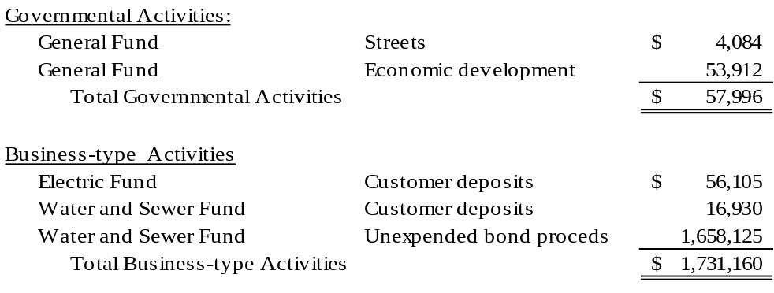

Note to preparer: The unit should disclose if its Board has adopted a formal policy for any of the different deposit and investment risks it encounters. In addition, the unit may include whether its management follows any internal practices to avoid applicable risks. Please see Memorandum #1056 for additional information. See Note III.A.1 of Carolina County for an example of a formal policy and Note III.A.1 of the Carolina County Board of Education for an example when the Board has not formally adopted a policy, nor does management have an internal policy. Please note in the above Deposit note, the City of Dogwood is presented as only using the pooling method of banks. If your government uses dedicated method banks, then additional information may need to be added.

2. Investments

Note to preparer: For units whose only investments are with the North Carolina Capital Management Trust Government Portfolio, the following statement is all that is required for GASB 40 disclosure: “At June 30, 2026, the City of Dogwood had $556,592 invested with the North Carolina Capital Management Trust’s Government Portfolio, which carried a credit rating of AAAm by Standard & Poor’s (S&P) and AAA-mf by Moody’s Investors Service. The City has no policy regarding credit risk.”

Note to preparer: City of Dogwood demonstrates the specific identification method requiring that each investment be listed. If the segmented time distribution method is preferred, please see Carolina County.

On June 30, 2026, the City’s investment balances were as follows:

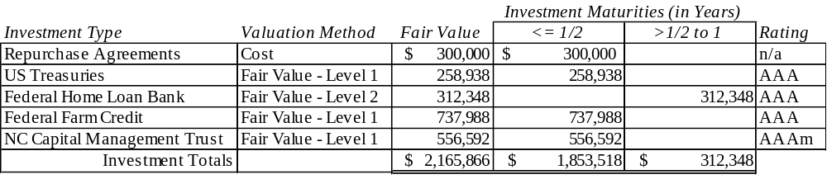

All investments are measured using the market approach by using prices and other relevant information generated by market transactions involving identical or comparable assets or a group of assets.

Level of fair value hierarchy: Level 1 debt securities are valued using directly observable, quoted prices (unadjusted) in active markets for identical assets. Level 2 debt securities are valued using a matrix pricing technique. Matrix pricing is used to value securities based on the securities’ benchmark quoted prices.

Interest Rate Risk. The City has no formal investment policy regarding interest rate risk. As a means of limiting its exposure to fair value losses arising from rising interest rates, the City’s internal investment policy limits at least half of the City’s investment portfolio to maturities of less than 12 months. Also, the City’s internal management policy requires purchases of securities to be laddered with staggered maturity dates and limits all securities to a final maturity of no more than two years.

Note to preparer: The investment policy used by the unit to manage interest rate risk should be included in the notes. If the unit does not have a Board-approved policy, a statement to the effect that “the unit does not have a formal investment policy” should be made. See the Carolina County Board of Education for an example.

When fair value measurements are used in determining the amounts recognized in the financial statements, GASB Statement No. 72 requires additional disclosures to be made in the notes about fair value measurements, the level of fair value hierarchy, and valuation techniques. Governments should organize these disclosures by type of asset or liability reported at fair value. The statement also requires additional disclosures regarding investments in certain entities that calculate net asset value per share (or its equivalent). For more details on Statement 72, please review Memorandum #2016-05: GASB Statement 72, Fair Value Measurement and Application.

Credit risk. The City has no formal policy regarding credit risk but has internal management procedures that limit the City’s investments to the provisions of G.S. 159-30 and restrict the purchase of securities to the highest possible ratings whenever particular types of securities are rated. The investment in the Federal Home Loan Bank is rated AAAm by Standard & Poor’s and AAA-mf by Moody’s Investors Service. The City’s investment in Urban County Bonds is rated AAA by Standard & Poor’s and Aaa by Moody’s Investors Service. The City’s investment in the NC Capital Management Trust Government Portfolio carried a credit rating of AAAm by Standard & Poor’s and AAA-mf by Moody’s Investors Service as of June 30, 2026.

Note to preparer: Credit risk must be disclosed for the North Carolina Capital Management Trust for the Government Portfolio. If the unit does not have any investment in the Government Portfolio, the respective sentences should be omitted. Repurchase agreements are omitted because underlying securities (Treasuries and Government National Mortgage Association (GNMA)) are exempt. Treasuries are also exempt from credit risk disclosure. See Carolina County for an example of a formal policy.

Custodial credit risk. For an investment, the custodial risk is the risk that in the event of the failure of the counterparty, the City will not be able to recover the value of its investments or collateral securities that are in the possession of an outside party. The City’s $300,000 investments in repurchase agreements are uninsured and unregistered investments for which the securities are held by the counterparty, or by its trust department, but not in the City’s name. The City has no formal policy on custodial credit risk, but management procedures are that the City shall utilize a third-party custodial agent for book entry transactions, all of which shall be held in the City’s name.

Note to preparer: Only Category 3 custodial risk should be disclosed. If there are none, then the paragraph above should be omitted. Negative disclosures are not acceptable. Proceeds from installment financing held in escrow by a bank or its trust department will be a Category 3 investment if the trust department/escrow agent purchases and holds the securities, which is often common with these financing arrangements. This is not a new situation, but it will meet the exception standard of disclosing Category 3 investments for custodial credit risk under GASB Statement No. 40. If the unit has custodial credit risk, then it will need to disclose whether it has a formal policy or internal management policy. See Carolina County for an example of a formal policy.

Concentration of Credit Risk. The City’s Board places no limit on the amount that the city may invest in any one issuer. More than five percent of the City’s investments are in Federal Home Loan Bank securities and Urban County Bonds. These investments are 14.4% and 34.1%, respectively, of the City’s total investments.

Note to preparer: Concentration risk is only included if one of the issuers is 5% or greater of the total investment portfolio (excludes deposits). It should be omitted if no holdings meet the 5% rule. Treasuries and the NCCMT do not qualify for this disclosure. Repurchase agreements in NC are limited to Treasuries and GNMA; therefore, no concentration risk disclosure is required. However, if a unit holds repurchase agreements in other securities, the concentration risk is based on the underlying security. If the unit has a concentration of credit risk, then it will need to disclose whether it has a formal policy or internal management policy. See Carolina County for an example of a formal policy.

3. Receivables

Note to preparer: See Note III.A.4 – Receivables in Carolina County for an example of the detailed note required for units that choose not to disaggregate accounts receivable on the face of their financial statements.

The amount of taxes receivable presented in the Balance Sheet and the Statement of Net Position includes penalties levied and outstanding in the amount of $62,235. The amounts presented in the Balance Sheet and the Statement of Net Position for the year ended June 30, 2026, are net of the following allowances for doubtful accounts:

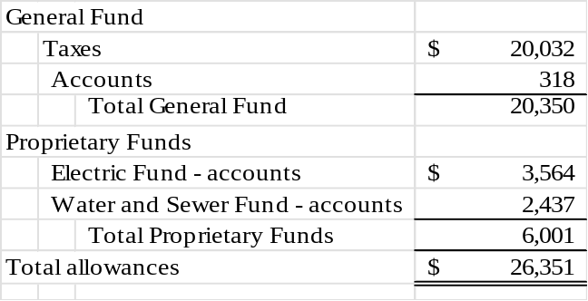

4. Leases Receivable

In a previous year, the City’s Water and Sewer Enterprise Fund entered into a 10-year lease as the lessor. The agreement is a cell tower license agreement with Reliable Wireless, LLC (Reliable), which allows Reliable to install, maintain, and operate radio operations equipment on the City’s tower at 1044 Dogwood Parkway. Reliable also has the right to construct and use an equipment storage area at the site. Reliable is required to make fixed annual payments. In fiscal year 2026, the city recognized $12,830 of lease revenue and $868 of interest revenue under the lease. The payment during the current fiscal year was $13,911. The payment amount will increase 3% in each subsequent year of the remaining 4-year term. The agreement does not contain a stated rate. Accordingly, the City’s estimated incremental borrowing rate of 1.5% was used to discount the minimum lease payments.

In April 2026, the city entered a lease with a coffee vendor. Under the lease, the coffee vendor pays the city $1,000 per month for sixty months in exchange for operating its business within a 100 square foot section in the lobby of the City Hall building. In months where the lessee’s gross revenue from the space exceeds $10,000, the lessee makes an additional variable payment equal to five percent of the excess revenue. The lease receivable is measured as the present value of the future minimum rent payments expected to be received during the lease term at a discount rate of 3%, which is the stated rate in the agreement.

In fiscal year 2026, the city recognized $2,790 of lease revenue and $398 of interest revenue under the lease. In addition, the city recognized $351 in variable lease revenue equal to five percent of the lessee’s reported excess revenue during the year.

5. Capital Assets

Capital asset activity for the year ended June 30, 2026, was as follows:

The remainder of this page left blank intentionally.

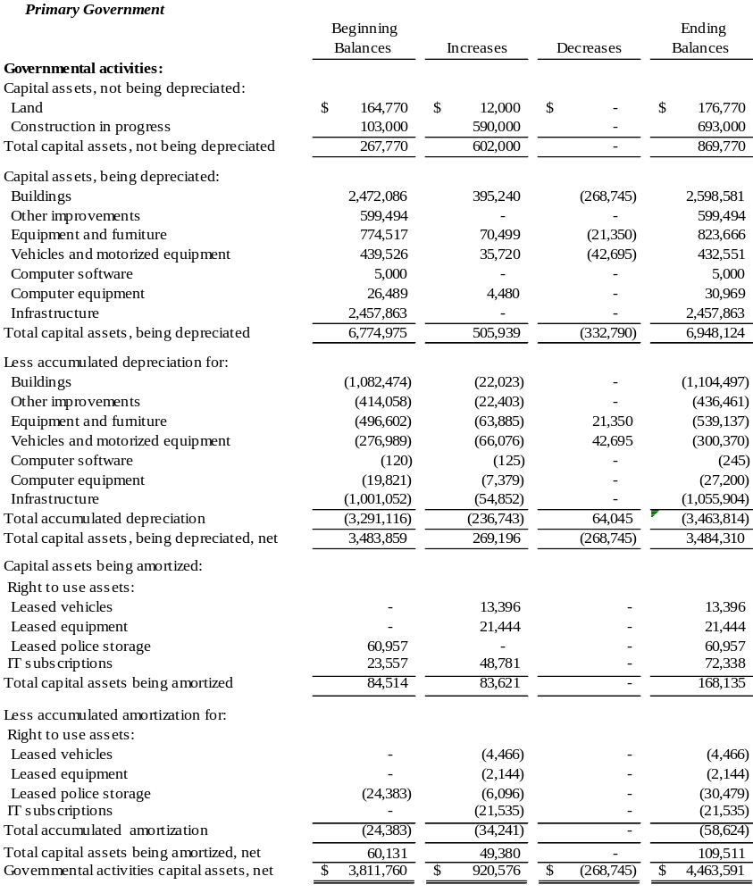

Depreciation and amortization expense was charged to functions or programs of the primary government as follows:

General government $47,590
Public safety 23,211
Transportation 87,158
Environmental protection 58,937
Culture & recreation 15,080
Internal Service Fund charged
to function based on usage 4,767
Total depreciation & amortization expense $236,743

The remainder of this page left blank intentionally.

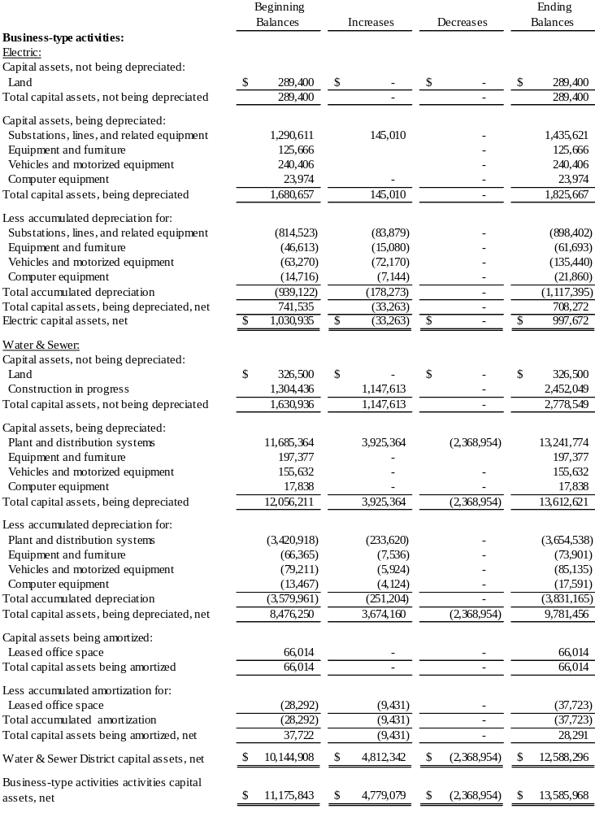
Construction commitments.
The government has active construction projects as of June 30, 2026. At year-end, the government’s commitments with contractors are as follows:

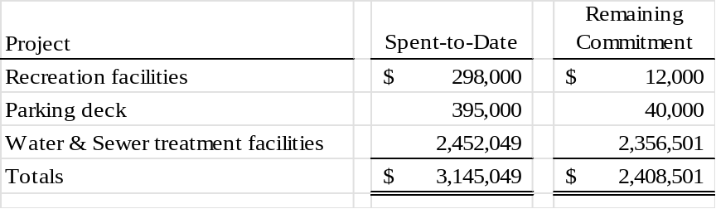

Discretely presented component unit.
Capital asset activity for the ABC Board for the year ended June 30, 2026, was as follows:

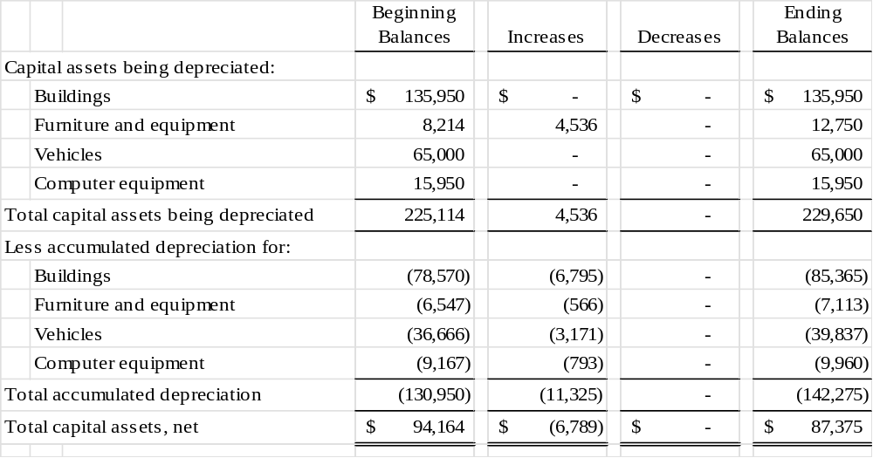

Note to preparer: If the unit is an operator in a public-private or public-public partnership and recognizes an intangible right-to-use asset under GASB Statement No. 94, separately disclose that asset and related accumulated amortization by major class of underlying partnership asset.

B. Liabilities

Note to preparer: See Note III.B.1 – Payables in Carolina County for an example of the detailed note required for units that choose not to disaggregate accounts payable on the face of their financial statements.

- Pension Plan and Other Post-Employment Obligations

Note to preparer: The financial statement amounts for the pension liability and OPEB liability/asset presented in the updated fiscal year-end 2026 illustrative statements were not changed from the amounts presented in the prior fiscal year. Since both the pension and OPEB GASB statements were implemented and updated in the Illustrated statements at least two years ago, financial statement preparers should now have experience with them. LGC staff has reverted to our historical practice of only changing amounts in the illustrative statements that are the result of any new accounting and reporting changes required for fiscal year 2026.

Conversion workbooks were updated to include the current fiscal year-end Pension and OPEB data. The pension data used in the development of the updated conversion workbooks was from the LGERS, ROD & TSERS JE Templates that are all available on the DST Financial Statement Resources listed by each Unit Type under Pension Resources.

- Local Governmental Employees' Retirement System

Plan Description. The City is a participating employer in the statewide Local Governmental Employees’ Retirement System (LGERS), a cost-sharing multiple-employer defined benefit pension plan administered by the State of North Carolina. LGERS membership is comprised of general employees and local law enforcement officers (LEOs) of participating local governmental entities. Article 3 of G.S. Chapter 128 assigns the authority to establish and amend benefit provisions to the North Carolina General Assembly. Management of the plan is vested in the LGERS Board of Trustees, which consists of 13 members – nine appointed by the Governor, one appointed by the State Senate, one appointed by the State House of Representatives, and the State Treasurer and State Superintendent, who serve as ex-officio members. The Local Governmental Employees’ Retirement System is included in the Annual Comprehensive Financial Report for the State of North Carolina. The State’s Annual Comprehensive Financial Report (ACFR) includes financial statements and required supplementary information for LGERS. That report may be obtained by writing to the Office of the State Controller, 1410 Mail Service Center, Raleigh, North Carolina 27699-1410, by calling (919) 981-5454, or at Public Information | NCOSC (www.osc.nc.gov).

Benefits Provided. LGERS provides retirement and survivor benefits. Retirement benefits are determined as 1.85% of the member’s average final compensation times the member’s years of creditable service. A member’s average final compensation is calculated as the average of a member’s four highest consecutive years of compensation. Plan members are eligible to retire with full retirement benefits at age 65 with five years of creditable service, at age 60 with 25 years of creditable service, or at any age with 30 years of creditable agency service. Plan members are eligible to retire with partial retirement benefits at age 50 with 20 years of creditable service or at age 60 with five years of creditable service (age 55 for firefighters). Survivor benefits are available to eligible beneficiaries of members who die while in active service or within 180 days of their last day of service and who have either completed 20 years of creditable service regardless of age (15 years of creditable service for firefighters and rescue squad members who are killed in the line of duty) or have completed five years of service and have reached age 60. Eligible beneficiaries may elect to receive a monthly Survivor’s Alternate Benefit for life or a return of the member’s contributions. The plan does not provide for automatic post-retirement benefit increases. Increases are contingent upon actuarial gains of the plan.

LGERS plan members who are LEOs are eligible to retire with full retirement benefits at age 55 with five years of creditable service as an officer, or at any age with 30 years of creditable service. LEO plan members are eligible to retire with partial retirement benefits at age 50 with 15 years of creditable service as an officer. Survivor benefits are available to eligible beneficiaries of LEO members who die while in active service or within 180 days of their last day of service and who also have either completed 20 years of creditable service regardless of age, or have completed 15 years of service as a LEO and have reached age 50, or have completed five years of creditable service as a LEO and have reached age 55, or have completed 15 years of creditable service as a LEO if killed in the line of duty. Eligible beneficiaries may elect to receive a monthly Survivor’s Alternate Benefit for life or a return of the member’s contributions.
Contributions. Contribution provisions are established by G.S. 128-30 and may be amended only by the North Carolina General Assembly. City employees are required to contribute 6% of their compensation. Employer contributions are actuarially determined and set annually by the LGERS Board of Trustees. The City’s contractually required contribution rate for the year ended June 30, 2026, was ____% of compensation for law enforcement officers and ____% for general employees and firefighters, actuarially determined as an amount that, when combined with employee contributions, is expected to finance the costs of benefits earned by employees during the year. Contributions to the pension plan from the City were $155,000 for the year ended June 30, 2026.

Refunds of Contributions. City employees who have terminated service as a contributing member of LGERS may apply for a refund of their contributions. By state law, refunds to members with at least five years of service include 4% interest. State law requires a 60-day waiting period after service termination before the refund may be paid. The acceptance of a refund payment cancels the individual’s right to employer contributions, or any other benefit provided by LGERS.

Pension Liabilities, Pension Expense, and Deferred Outflows of Resources and Deferred Inflows of Resources Related to Pensions. As of June 30, 2026, the City reported a liability of $654,766 for its proportionate share of the net pension liability. The net pension liability was measured as of June 30, 2025. The total pension liability used to calculate the net pension liability was determined by an actuarial valuation as of December 31, 2024. The total pension liability was then rolled forward to the measurement date of June 30, 2025, utilizing updated procedures incorporating the actuarial assumptions. The City’s proportion of the net pension liability was based on a projection of the City’s long-term share of future payroll covered by the pension plan, relative to the projected future payroll covered by the pension plan of all participating LGERS employers, actuarially determined. On June 30, 2025 (measurement date), the City’s proportion was 0.023%, which was a decrease of 0.003% from its proportion measured as of June 30, 2024.

For the year ended June 30, 2026, the city recognized pension expense of $190,762. At June 30, 2026, the city reported deferred outflows of resources and deferred inflows of resources related to pensions from the following sources:

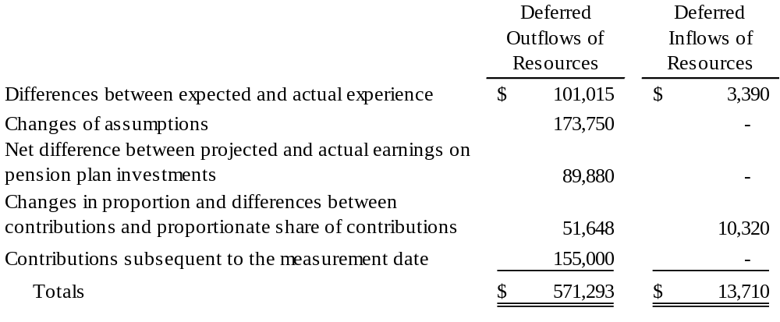

The $155,000 reported as deferred outflows of resources related to pensions resulting from City contributions subsequent to the measurement date will be recognized as a decrease of the net pension liability in the year ended June 30, 2027. Other amounts reported as deferred inflows of resources related to pensions will be recognized in pension expense as follows:

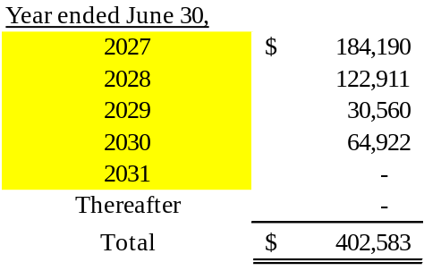

Actuarial Assumptions. The total pension liability in the December 31, 2025, actuarial valuation was determined using the following actuarial assumptions, applied to all periods included in the measurement:
Inflation 3.00%
Salary increases 3.50% to 8.10%, including inflation and productivity factor
Investment rate of return 7.00%, net of investment expense, including inflation

The plan currently uses mortality tables that vary by age, gender, employee group (i.e., general, law enforcement officer), and health status (i.e., disabled and healthy). The current mortality rates are based on published tables and on studies that cover significant portions of the U.S. population. The healthy mortality rates also contain a provision to reflect future mortality improvements.
The actuarial assumptions used in the December 31, 2025, valuation was based on the results of an actuarial experience study for the period January 1, 2013, through December 31, 2017.
Future ad hoc Cost-of-Living Adjustment (COLA) amounts are not considered to be substantively automatic and are therefore not included in the measurement.

The projected long-term investment returns and inflation assumptions are developed through a review of current and historical capital markets data, sell-side investment research, consultant whitepapers, and historical performance of investment strategies. Fixed income returns projections reflect current yields across the U.S. Treasury yield curve and market expectations of forward yields projected and interpolated for multiple tenors and over multiple year horizons. Global public equity return projections are established through analysis of the equity risk premium and the fixed income return projections. Other asset categories and strategies’ return projections reflect the foregoing and historical data analysis. These projections are combined to produce the long-term expected rate of return by weighting the expected future real rates of return by the target asset allocation percentage and by adding expected inflation. The target allocation and best estimates of arithmetic real rates of return for each major asset class as of June 30, 2026, are summarized in the following table:

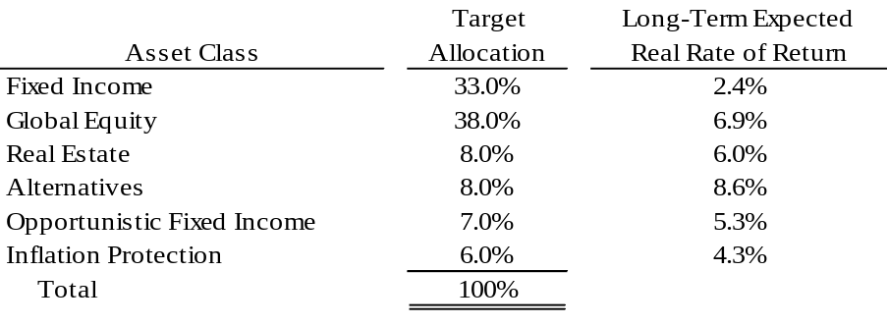

The information above is based on 30-year expectations developed with an investment consulting firm’s 2026 long-term capital market assumptions. The long-term nominal rates of return underlying the real rates of return are arithmetic annualized figures. The real rates of return are calculated from nominal rates by multiplying by a long-term inflation assumption of 2.38%. All rates of return and inflation are annualized figures. Source data is provided in the 2026 Annual Comprehensive Financial Report (ACFR) published on the website of the Office of the State Controller.

Discount rate. The discount rate used to measure the total pension liability was 7.00%. The projection of cash flows used to determine the discount rate assumes that contributions from plan members will be made at the current contribution rate and that contributions from employers will be made at statutorily required rates, actuarially determined. Based on these assumptions, the pension plan’s fiduciary net position was projected to be available to make all projected future benefit payments of the current plan members. Therefore, the long-term expected rate of return on pension plan investments was applied to all periods of projected benefit payments to determine the total pension liability.

Sensitivity of the City’s proportionate share of the net pension liability to changes in the discount rate. The following presents the City’s proportionate share of the net pension liability calculated using the discount rate of 7.00%, as well as what the City’s proportionate share of the net pension asset or net pension liability would be if it were calculated using a discount rate that is one percentage point lower (6.00%) or one percentage point higher (8.00%) than the current rate:

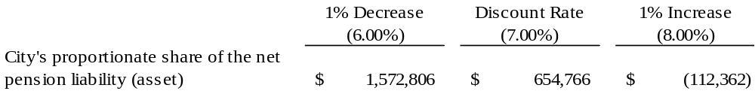

Pension plan fiduciary net position. Detailed information about the pension plan’s fiduciary net position is available in the separately issued ACFR for the State of North Carolina.

- Law Enforcement Officers Special Separation Allowance

Note to preparer: Notes for the Law Enforcement Officers’ Special Separation Allowance should be based on data specific to your unit. Assumptions, measurement dates, and other information requiring disclosure will not be uniform across all units in the state. Please refer to your actuarial valuation report for specifics for your LEOSSA note and to GASB Statement No. 73 for specific disclosure requirements.

Plan Description. The City administers a public employee retirement system (the Separation Allowance), a single employer defined benefit pension plan that provides retirement benefits to the City’s qualified sworn law enforcement officers under the age of 62 who have completed at least 30 years of creditable service or have attained 55 years of age and have completed five or more years of creditable service. Effective July 1, 2025, per Session Law 2025-8, eligible officers must make an irrevocable election for the benefit to be paid either a) based upon final salary times years of service, payable until age 62, or b) based on salary at 30 years times 30 years of service, payable for the number of years between age 30-year milestone and age 62. The Separation Allowance is equal to 0.85% of the annual equivalent of the base rate of compensation most recently applicable to the officer for each year of creditable service. The retirement benefits are not subject to any increases in salary or retirement allowances that may be authorized by the General Assembly. Article 12D of G.S. Chapter 143 assigns the authority to establish and amend benefit provisions to the North Carolina General Assembly.

All full-time City law enforcement officers are covered by the Separation Allowance.
On December 31, 2024, the valuation date, the Separation Allowance’s membership consisted of:

Retirees receiving benefits 4
Terminated plan members entitled to but not yet receiving benefits 0
Active plan members 6
Total 10

Summary of Significant Accounting Policies. Basis of Accounting. The City has chosen to fund the Separation Allowance on a pay as you go basis. Pension expenditures are made from the General Fund, which is maintained on the modified accrual basis of accounting. Benefits are recognized when due and payable in accordance with the terms of the plan.

The Separation Allowance has no assets accumulated in a trust that meets the criteria which are outlined in GASB Statement No. 73.

Actuarial Assumptions. The entry age actuarial cost method was used in the December 31, 2024, valuation. The total pension liability in the December 31, 2024, actuarial valuation was determined using the following actuarial assumptions, applied to all periods included in the measurement:

Inflation 2.50%
Salary increases Salary increases 3.50% to 8.10%
Discount rate 2.98%

Note to preparer: Please use the most authoritative source for the current year's actuarial assumptions found here: Valuations and Annual Comprehensive Financial Reports | My NC Retirement. The following link includes information on Benefits Paid to Law Enforcement Officers | My NC Retirement.

The discount rate is based on the yield of the S&P Municipal Bond 20-Year High Grade Rate Index as of December 31, 2024. Mortality rates are based on the RP-2000 Mortality tables with adjustments for mortality improvements based on Scale AA.

Contributions. The City is required by Article 12D of G.S. Chapter 143 to provide these retirement benefits and has chosen to fund the amounts necessary to cover the benefits earned on a pay-as-you-go basis through appropriations made in the General Fund operating budget. There were no contributions made by employees. The City’s obligation to contribute to this plan is established and may be amended by the North Carolina General Assembly. Administration costs of the Separation Allowance are financed through investment earnings. The city paid $16,031 as benefits came due for the reporting period.

Pension Liabilities, Pension Expense, and Deferred Outflows of Resources and Deferred Inflows of Resources Related to Pensions. On June 30, 2026, the City reported a total pension liability of $219,382. The total pension liability was measured as of December 31, 2025, based on a December 31, 2024, actuarial valuation. The total pension liability was then rolled forward to the measurement date of December 31, 2025, utilizing update procedures incorporating the actuarial assumptions. For the year ended June 30, 2026, the city recognized pension expense of $15,914.

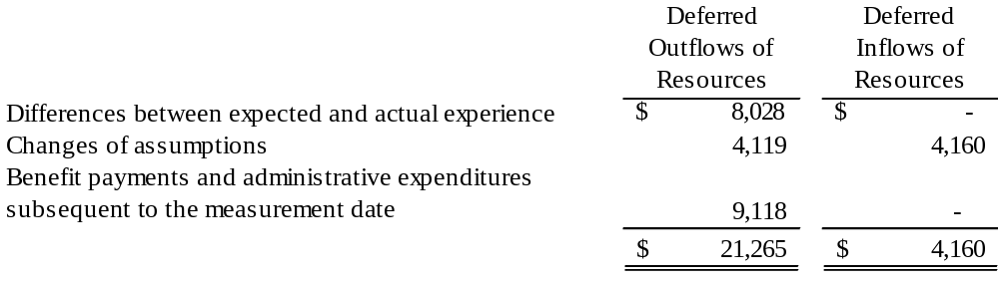

$9,118 paid as benefits came due after the measurement date have been reported as deferred outflows of resources. Other amounts reported as deferred outflows and deferred inflows of resources related to pensions will be recognized in pension expense as follows:

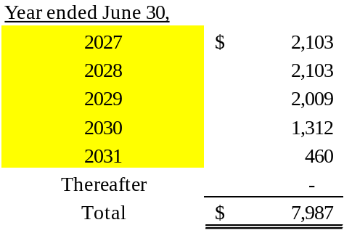

Sensitivity of the City’s total pension liability to changes in the discount rate. The following presents the City’s total pension liability calculated using the discount rate of 2.98%, as well as what the City’s total pension liability would be if it were calculated using a discount rate that is one percentage point lower (1.98%) or one percentage point higher (3.98%) than the current rate:

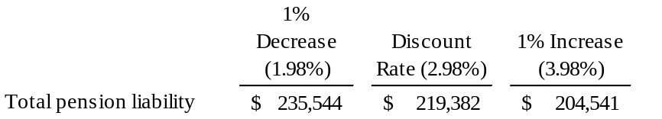

Schedule of Changes in Total Pension Liability – Law Enforcement Officers’ Special Separation Allowance
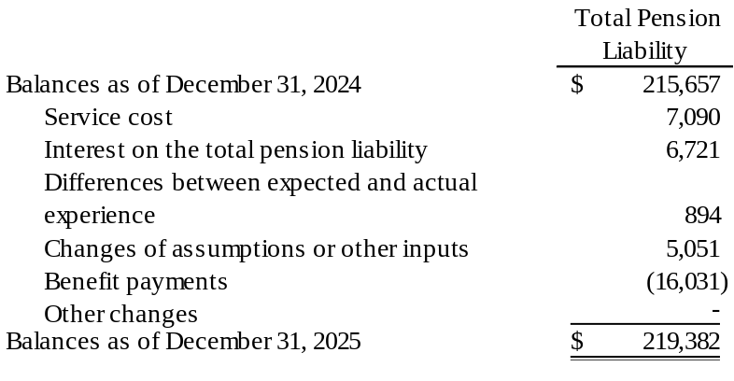

The plan currently uses mortality tables that vary by age, and health status (i.e., disabled and healthy). The current mortality rates are based on published tables and based on studies that cover significant portions of the U.S. population. The healthy mortality rates also contain a provision to reflect future mortality improvements.

The actuarial assumptions used in the December 31, 2024, valuation were based on the results of an actuarial experience study for the period January 1, 2012, through December 31, 2016.
c. Pension Liabilities (Assets), Pension Expense, and Deferred Outflows of Resources and Deferred Inflows of Resources Related to Pensions

The City’s proportion of the net pension liability was based on the City’s share of contributions to the pension plan relative to the contribution of all participating entities. The following is information related to the proportionate share and pension expense:

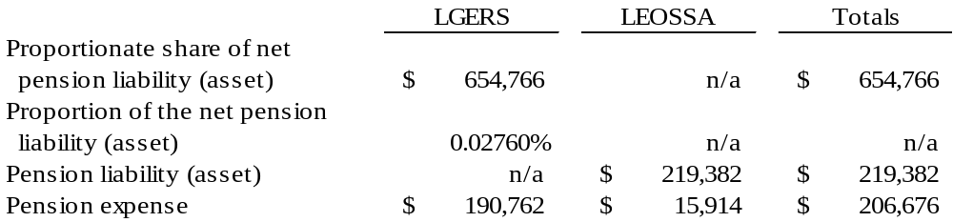

At June 30, 2026, the City reported deferred outflows of resources and deferred inflows of resources related to pensions from the following sources:

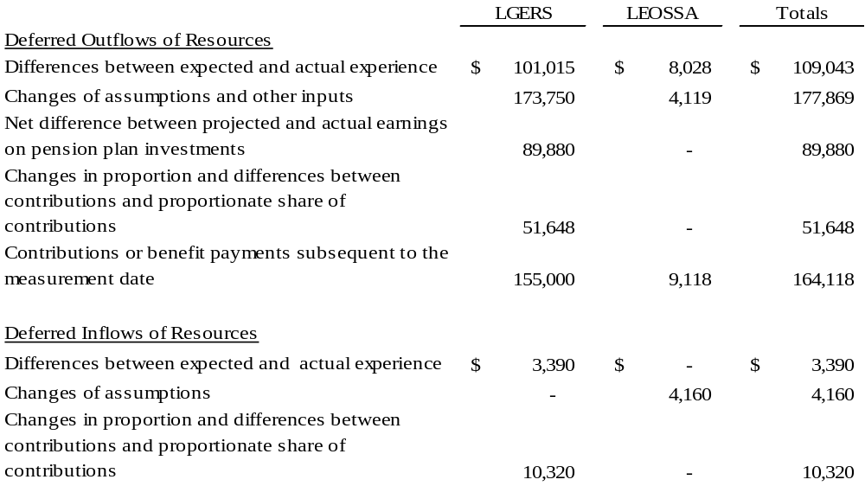

d. Supplemental Retirement Income Plan for Law Enforcement Officers

Plan Description. The city contributes to the Supplemental Retirement Income Plan (the Plan), a defined contribution pension plan administered by the Department of State Treasurer and a Board of Trustees. The Plan provides retirement benefits to law enforcement officers employed by the city. Article 5 of G.S. Chapter 135 assigns the authority to establish and amend benefit provisions to the North Carolina General Assembly. The Plan is included in the Annual Comprehensive Financial Report (ACFR) for the State of North Carolina. The State’s ACFR includes the pension trust fund financial statements for the Internal Revenue Code Section 401(k) plan that includes the Plan. That report may be obtained by writing to the Office of the State Controller, 1410 Mail Service Center, Raleigh, North Carolina 27699-1410, or at Public Information | NCOSC.

Funding Policy. Article 12E of G.S. Chapter 143 requires the city to contribute 5.00% of each officer's salary, and all amounts contributed are vested immediately. The law enforcement officers may also make voluntary contributions to the plan. The City made contributions of $20,000 for the reporting year. No amounts were forfeited.

Note to preparer: If a local government or public authority has elected to contribute to the Supplemental Retirement Income Plan for general employees as well as for law enforcement officers, that information should be disclosed here.

- Firefighters’ and Rescue Squad Workers’ Pension Fund

Note to preparer: Memo 2027-01 Memorandum 2027-01: Firefighters’ and Rescue Squad Workers’ Pension Fund Disclosure Amounts on the DST website provides the information to make the required Firefighters’ Plan disclosures. The information below uses the format $x,xxx and x.xx% to present dollars and percentages. The information must be updated from the appropriate sources to complete the disclosure each year.

Plan Description. The State of North Carolina contributes on behalf of the City to the Firefighters’ and Rescue Squad Workers’ Pension Fund (FRSWPF), a cost-sharing multiple-employer defined benefit pension plan with a special funding situation administered by the State of North Carolina. FRSWPF provides pension benefits for eligible fire and rescue squad workers who have elected to become members of the fund. Article 86 of G.S. Chapter 58 assigns the authority to establish and amend benefit provisions to the North Carolina General Assembly. Management of the plan is vested in the LGERS Board of Trustees, which consists of 13 members – nine appointed by the Governor, one appointed by the state Senate, one appointed by the state House of Representatives, and the State Treasurer and State Superintendent, who serve as ex-officio members. The FRSWPF is included in the Annual Comprehensive Financial Report (ACFR) for the State of North Carolina. The State’s ACFR includes financial statements and required supplementary information for the Firefighters’ and Rescue Squad Workers’ Pension Fund. That report may be obtained by writing to the Office of the State Controller, 1410 Mail Service Center, Raleigh, North Carolina 27699-1410, or at Public Information | NCOSC (www.osc.nc.gov).

Benefits Provided. FRSWPF provides retirement and survivor benefits. The present retirement benefit is $170 per month. Plan members are eligible to receive the monthly benefit if they are at least 55 years old with 20 years of creditable service as a firefighter or rescue squad worker and have terminated duties as a firefighter or rescue squad worker. Eligible beneficiaries of members who die before beginning to receive the benefit will receive the amount paid by the member and contributions paid on the member’s behalf into the plan. Eligible beneficiaries of members who die after beginning to receive benefits will be paid the amount the member contributed minus the benefits collected.

Contributions. Plan members are required to contribute $15 per month to the plan. The State, a non-employer contributor, funds the plan through appropriations. The city does not contribute to the plan. Contribution provisions are established by G.S. 58-86 and may be amended only by the North Carolina General Assembly. For the fiscal year ending June 30, 2026, the State contributed $20,134,708 ($445.73 per employee) to the plan. The City’s proportionate share of the State’s contribution is $x,xxx.

Refunds of Contributions. Plan members who are no longer eligible or choose not to participate in the plan may apply for a refund of their contributions. Refunds include the member’s contributions and contributions paid by others on the member’s behalf. No interest will be paid on the amount of the refund. The acceptance of a refund payment cancels the individual’s right to employer contributions, or any other benefit provided by FRSWPF.

Pension Liabilities, Pension Expense, and Deferred Outflows of Resources and Deferred Inflows of Resources Related to Pensions. On June 30, 2026, the City reported no liability for its proportionate share of the net pension liability, as the State provides 100% pension support to the City through its appropriations to the FRSWPF. The net pension liability/(asset) was ($29,930,606). The net pension liability was measured as of June 30, 2026. The total pension liability used to calculate the net pension liability was determined by an actuarial valuation as of December 31, 2024. The total pension liability was then rolled forward to the measurement date of June 30, 2026, utilizing update procedures incorporating the actuarial assumptions. The City’s proportion of the net pension liability was based on a projection of the City’s long-term share of contributions to the pension plan relative to the projected contributions of all participating employers. As the City is not projected to make any future contributions to the plan, its proportionate share on June 30, 2026, was 0%.

For the year ended June 30, 2026, the city recognized pension expense of $x,xxx and revenue of $x,xxx for support provided by the State. On June 30, 2026, the city reported no deferred outflows of resources, and no deferred inflows of resources related to pensions.

Actuarial Assumptions. The total pension liability in the December 31, 2024, actuarial valuation was determined using the following actuarial assumptions, applied to all periods included in the measurement:

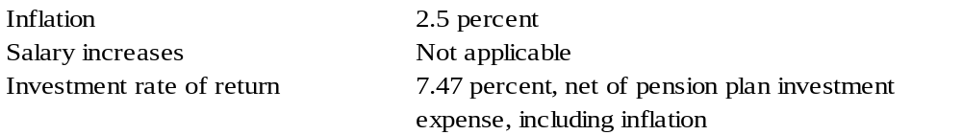

For more information regarding actuarial assumptions, including mortality tables, the actuarial experience study, the consideration of future ad hoc COLA amounts, the development of the projected long-term investment returns, and the asset allocation policy, refer to the discussion of actuarial assumptions for the LGERS plan in Section a. of this note.

Discount rate. The discount rate used to measure the total pension liability was 6.50%. The projection of cash flows used to determine the discount rate assumes that contributions from plan members will be made at the current contribution rate and that contributions from employers will be made at statutorily required rates, actuarially determined. Based on these assumptions, the pension plan’s fiduciary net position was projected to be available to make all projected future benefit payments of the current plan members. Therefore, the long-term expected rate of return on pension plan investments was applied to all periods of projected benefit payments to determine the total pension liability.

Pension plan fiduciary net position. Detailed information about the pension plan’s fiduciary net position is available in the separately issued ACFR for the State of North Carolina.

Note to preparer: If the State’s contribution on behalf of the unit of government is immaterial, no reference to the pension plan is needed – note disclosures and RSI can be excluded. The FRSWP Schedule of Employer Contributions has been excluded from RSI for City of Dogwood because the City of Dogwood makes no contributions to the plan.

f. Other Postemployment Benefit Healthcare Benefits

Note to preparer: The following note disclosure presents City of Dogwood’s pay-as-you-go funded single-employer defined benefit post-employment healthcare plan. Each local government has unique parameters, based on its Board-approved benefits, the participation by its members, the plan’s funding, etc. Therefore, the OPEB note must be tailored for the unique criteria of each local government’s plan. For those governments that fund their post-employment benefits, please refer to Carolina County.

Plan Description. Under the terms of a city resolution, the City administers a single employer defined benefit Healthcare Benefits Plan (the HCB Plan). The City Board has the authority to establish and amend the benefit terms and financing requirements. No assets are accumulated in a trust that meets the criteria in paragraph 4 of GASB Statement No. 75.

Benefits Provided. Before July 1, 2007, retirees qualified for benefits similar to those of employees after a minimum of five years of creditable service with the City. The City pays the full cost of coverage for employees’ benefits through private insurers, and employees have the option of purchasing dependent coverage at the City’s group rates. Employees hired on or after July 1, 2007, who retire with a minimum of 20 years of creditable service also have the option of purchasing coverage for themselves and dependents at the City’s group rate. Employees hired on or after July 1, 2007, who retire with less than 20 years of service are not eligible for post-employment coverage. Retirees who qualify for coverage receive the same benefits as active employees. Coverage for all retirees who are eligible for Medicare will be transferred to a Medicare Supplemental plan after qualifying for Medicare. The City Council may amend the benefit provisions. A separate report was not issued for the plan.

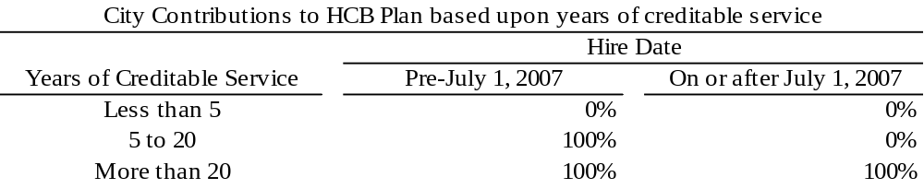

Note to preparer: Please include specific details regarding who is and who is not covered under the plan, any employer cap to contributions, when or if Medicare assumes coverage, what benefits are included, etc.
Plan Membership. At December 31, 2025, the HCB Plan membership consisted of the following:
Retirees and dependents receiving benefits 1
Terminated plan members entitled to but not yet
receiving benefits 3
Active plan members 14
Total 18

Total OPEB Liability. The City’s total OPEB liability of $1,197,321 was measured as of December 31, 2025, and was determined by an actuarial valuation as of that date.

Actuarial Assumptions and Other Inputs. The total OPEB liability in the December 31, 2025, actuarial valuation was determined using the following actuarial assumptions and other inputs, applied to all periods included in the measurement unless otherwise specified:

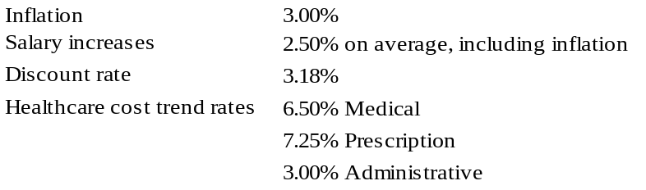

The discount rate is based on the yield of the S&P Municipal Bond 20 Year High Grade Rate Index as of the measurement date.

Changes in the Total OPEB Liability

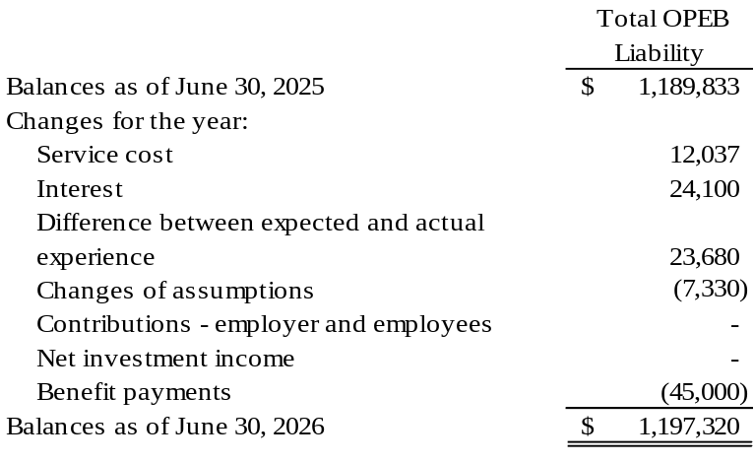

Changes in assumptions and other inputs reflect a change in the discount rate from 3.17% to 3.18%.

Mortality rates were based on the RP-2014 Total Data Set for Healthy Annuitants Mortality Table.

The actuarial assumptions used in the December 31, 2025; valuation was based on the results of an actuarial experience study for the period January 2011 through December 2015.

Sensitivity of the total OPEB liability to changes in the discount rate. The following presents the total OPEB liability of the City, as well as what the City’s total OPEB liability would be if it were calculated using a discount rate that is one percentage point lower (2.18%) or one percentage point higher (4.18%) than the current discount rate:

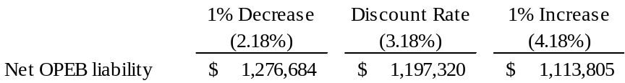

Sensitivity of the total OPEB liability to changes in the healthcare cost trend rates. The following presents the total OPEB liability of the City, as well as what the City’s total OPEB liability would be if it were calculated using healthcare cost trend rates that are one percentage point lower or one percentage point higher than the current healthcare cost trend rates:

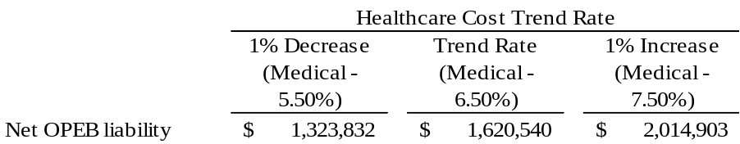

For the year ended June 30, 2026, the city recognized OPEB expense of $83,840. On June 30, 2026, the city reported deferred outflows of resources and deferred inflows of resources related to OPEB from the following sources:

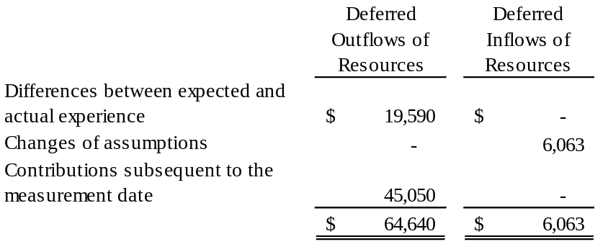

$45,050 reported as deferred outflows of resources related to OPEB resulting from contributions made subsequent to the measurement date will be recognized as a decrease of the total pension liability in the year ended June 30, 2027.

Other amounts reported as deferred inflows of resources related to pensions will be recognized in pension expense as follows:

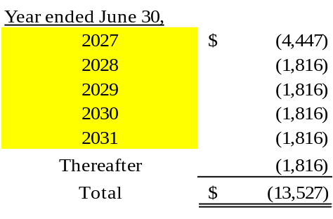

g. Other Employment Benefits

The City has elected to provide death benefits to employees through the Death Benefit Plan for Members of the Local Governmental Employees' Retirement System (the Death Benefit Plan), a multiple-employer, State-administered, cost-sharing plan funded on a one-year term cost basis. The beneficiaries of those employees who die in active service after one year of contributing membership in the System, or who die within 180 days after retirement or termination of service and have at least one year of contributing membership service in the System at the time of death, are eligible for death benefits. Lump sum death benefit payments to beneficiaries are equal to the employee's 12 highest months’ salary in a row during the 24 months before the employee's death, but the benefit may not exceed $50,000 or be less than $25,000. Because all death benefit payments are made from the Death Benefit Plan and not by the City, the City does not determine the number of eligible participants. The City has no liability beyond the payment of monthly contributions. The contributions to the Death Benefit Plan cannot be separated between the post-employment benefit amount and the other benefit amount. Contributions are determined as a percentage of monthly payroll based upon rates established annually by the State. Separate rates are set for employees not engaged in law enforcement and for law enforcement officers. The city considers these contributions to be immaterial.

Note to preparer: In the disclosure above, the Board opted to provide the Local Governmental Employees’ Retirement System (LGERS) as the only group-term life insurance available to an employee. This insurance has a maximum limit of $50,000. If your unit provides additional group-term life insurance, please include a description of the policy in the above note. In addition, please note that the benefits in excess of $50,000 are considered taxable to the employee as a fringe benefit. Please see Memorandum #1048: W-2 Treatment of Cost of Group Term Life Insurance for further discussion.

- Risk Management

Note to preparer: This section concerning risk and insurance pools should comply with GASB Statement No. 30 and provide details relevant to your government. Coverage will vary between governments.

Note to preparer: The carrying of a performance bond of the Finance Officer’s position and a blanket bond for all others who have access to the local government’s assets over $100 is required by G.S. 159-29 as revised. Please disclose the amounts of the fidelity bond and blanket bond separately. In cases in which an individual serves as Finance Officer for two separate entities (a city and a Tourism Development Authority, for example), a separate bond is required to protect each unit. See Memorandum #2023-06: Revised Fidelity Bond Requirements and Other Modifications to G.S. 159-29 and Memorandum #2014-08: Operation of and Accounting for Discretely Presented Component Units, Including Tourism Development Authorities for further guidance. A performance bond for a lower amount than required must be disclosed under Stewardship, Compliance, and Accountability as Significant Violations of Finance-Related Legal and Contractual Provisions; as a finding in any Compliance Reports issued; and as a Financial Performance Indicator of Concern (FPIC).

The City is exposed to various risks of loss related to torts; theft of, damage to, and destruction of assets, errors and omissions; injuries to employees; and natural disasters. The city participates in three self-funded risk-financing pools administered by the North Carolina League of Municipalities. Through these pools, the City obtains general liability and auto liability coverage of $1 million per occurrence, property coverage up to the total insured values of the property policy, workers’ compensation coverage up to statutory limits, and employee health coverage. The liability and property exposures are reinsured through commercial carriers for claims in excess of retentions as selected by the Board of Trustees each year. Excess insurance coverage is purchased by the Board of Trustees to protect against large workers’ compensation claims that exceed certain dollar cost levels. Medical stop-loss insurance is purchased by the Board of Trustees to protect against large medical claims that exceed certain dollar cost levels. Specific information on the limits of the reinsurance, excess, and stop loss policies purchased by the Board of Trustees can be obtained by contacting the Risk Management Services Department of the NC League of Municipalities. The pools are audited annually by certified public accountants, and the audited financial statements are available to the City upon request. The City carries commercial coverage for all other risks of loss. There have been no significant reductions in insurance coverage from the prior year, and settled claims have not exceeded insurance coverage in any of the past three fiscal years.

Per G.S. 159-29, the City’s employees who have access to $100 or more at any given time of the City’s funds are performance bonded through a commercial surety bond. The finance officer is individually bonded for $1,000,000. The remaining employees who have access to funds are bonded under a blanket bond for $250,000.

The City carries flood insurance through the National Flood Insurance Plan (NFIP). Because the City is in an area of the State that has been mapped and designated an “A” area (an area close to a river, lake, or stream) by the Federal Emergency Management Agency, the City is eligible to purchase coverage of $500,000 per structure through the NFIP. The City is also eligible to and has purchased commercial flood insurance for another $1,500,000 of coverage per structure.

Note to preparer: The carrying of flood insurance by the unit to avoid possible significant loss should be included in the note disclosure above. If the unit does not hold any flood insurance, a statement to that effect should be noted. The unit may then add a statement explaining their position for not securing the flood insurance.

3. Claims, Judgments, and Contingent Liabilities

On June 30, 2026, the city was a defendant in various lawsuits. In the opinion of the City's management and the City attorney, the ultimate effect of these legal matters will not have a material adverse effect on the City's financial position.

4. Short-Term Debt

The City did not have any short-term debt outstanding at the beginning of the year. The following short-term debt was issued during the year and remains outstanding at the end of the year.

Bond Anticipation Notes
Water and Sewer Notes issued June 29, 2026, and due on
November 30, 2026, with interest at 3.00%. The notes will
be retired from proceeds of a $750,000 bond issue in the
following fiscal year. $675,000

5. Long-Term Obligations

a. Leases

The City has entered into agreements to lease storage space and certain equipment. The lease agreements qualify as other than short-term leases under GASB Statement No. 87 and, therefore, have been recorded at the present value of the future minimum lease payments as of the date of their inception.

The City entered into a lease for storage space for the Police Department's Property and Evidence unit. The initial term of the lease was 120 months, with a term of 60 months remaining on June 30, 2026. The city was required to make monthly fixed payments of $541 during fiscal year 2026. The monthly required payments increase by 2% each subsequent year. The lease does not contain a stated interest rate. Accordingly, the City’s estimated incremental borrowing rate of 1.5% was used to discount the remaining minimum lease payments. The liability balance as of June 30, 2026, is $33,235.

The City entered into two lease agreements during the past fiscal year. The first agreement was executed on July 1, 2025, to lease maintenance vehicles and requires 36 monthly payments of $417. There are no variable payment components of the lease. The lease liability is measured at a discount rate of 8%, which is the stated rate in the lease agreement. The liability balance as of June 30, 2026, is $9,220.

The second agreement was executed on January 1, 2026, to lease a copy machine and requires 60 monthly payments of $403. There are no variable payment components of the lease. The lease liability is measured at a discount rate of 5%, which is the stated rate in the lease agreement. The liability balance as of June 30, 2026, is $19,451.

The future minimum lease obligations and the net present value of these minimum lease payments as of June 30, 2026, were as follows:

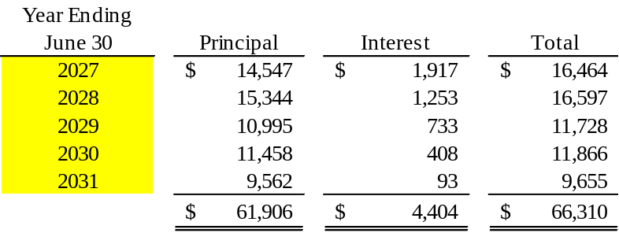

Note to preparer: Per paragraph 19 of GASB Statement No. 87, Leases, contracts that transfer ownership of the underlying asset and do not contain termination options are reported as financed purchases, not leases. If both conditions exist in a contract or a group of contracts, then the liability is subject to the requirements of GASB Statement No. 88, Certain Disclosures Related to Debt, including Direct Borrowings and Direct Placements. Contracts of this nature will need to be assessed to determine how GASB 88 debt disclosures should be addressed.

b. Installment Financing

In January 2026, the City entered a $200,000 direct placement contract to finance parking improvements for a municipal park. The property is pledged as collateral for the debt while the debt is outstanding. The financing contract requires principal payments beginning in fiscal year 2027 with interest rates ranging from 4.50% to 4.95%.

Annual debt service principal and interest payments for the installment purchase as of June 30, 2026, are as follows:

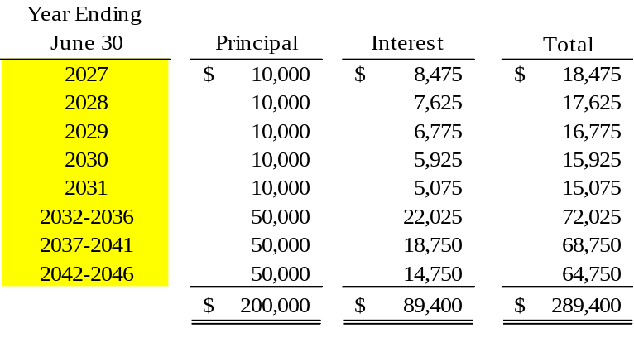

c. General Obligation Indebtedness

The City's general obligation bonds, serviced by the governmental funds, were issued for the acquisition of public safety equipment. Those general obligation bonds issued to finance the construction of facilities utilized in the operations of the water and sewer system, and which are being retired by its resources, are reported as long-term debt in the Water and Sewer Fund. All general obligation bonds are collateralized by the full faith, credit, and taxing power of the City. Principal and interest requirements are appropriate when due.

Bonds payable on June 30, 2026, are comprised of the following individual issues:

Serviced by the General Fund:
$100,000 2020 Public Safety serial bonds due on January 1
and July 1 in installments of $5,000 plus interest through
July 1, 2031, with interest at 4.00%. $60,000

Serviced by the Water and Sewer Fund:
$3,301,450 2012 USDA Water and Sewer serial bonds.
Annual installments of $109,725 plus interest were paid
through January 1, 2023. The remainder at annual installments
of $149,022 plus interest from January 1, 2024, through
January 1, 2040, with interest at 3.50%. 1,908,614

$1,350,000 2021 Water and Sewer refunding bonds. Interest
due on June 30 and December 31 and principal due in
annual installments of $150,000 through December 31, 2031,
with interest at 3.00%. 1,050,000
Total $2,958,614

Annual debt service requirements to maturity for general obligation bonds are as follows:

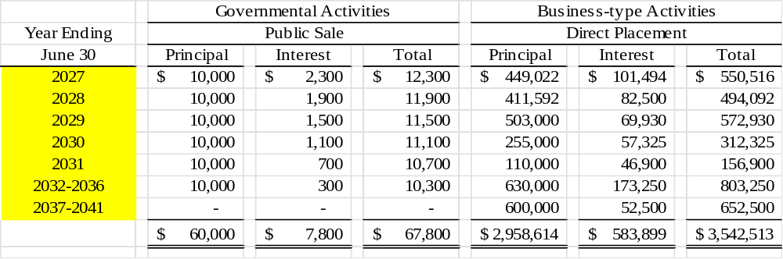

On June 30, 2026, the City of Dogwood had bonds authorized but unissued of $1,000,000 and a legal debt margin of $10,847,306.

d. Revenue Bond

Note to preparer: An auditor working with a local government unit that has outstanding bonds should include in the notes to the audited financial statements, whether required by the revenue bond documents or not, a calculation demonstrating compliance with the revenue bond rate covenant. Additionally, the auditor should be aware that any other bond compliance statements or additional reports required in the authorizing bond documents need to be submitted to the LGC simultaneously with the local government's audited financial statements, unless otherwise specified in the bond documents.

Revenue bond covenants are subject to variability. The following calculation and note disclosures are presented for illustrative purposes only. Consult a copy of the bond order or other documents for the exact covenants and the additional reporting requirements.

$1,000,000 Water and Sewer Revenue Bonds, Series 2021, issued for
Water and Sewer system improvements. Principal installments are due
Annually on June 1 with semiannual interest payments due on
December 1 and June 1, with interest at 5.25%. $906,923

Revenue bond debt service requirements to maturity are as follows:

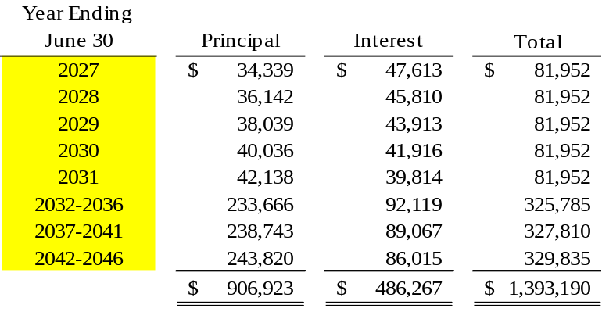

The City is in compliance with covenants as to rates, fees, rentals, and charges in Section 704 of the Bond Order, authorizing the issuance of the Water and Sewer Revenue Bonds, Series 2021. Section 704(a) of the Bond Order requires the debt service coverage ratio to be no less than 1.0 times as defined. The debt service coverage ratio calculation for the year ended June 30, 2026, is as follows:

Operating revenues | $1,544,284
Operating expenses* | 916,343
Operating income | 367,306
Nonoperating revenues (expenses)** | 12,167
Income available for debt service | 379,473
Debt service, principal and interest paid (Revenue bond only) | $ 75,952
Debt service coverage ratio | 4.99

* Per rate covenants, this does not include the depreciation expense of $260,635.
** Per rate covenants, this does not include revenue bond interest paid of $49,326.

The City has pledged future water and sewer customer revenues, net of specified operating expenses, to repay $1 million in water and sewer system revenue bonds issued in December 2021. Proceeds from the bonds provided financing for the extension to the second water and sewer plant on Cardinal Lane. The bonds are payable solely from water and sewer customer net revenues and are payable through 2045. Annual principal and interest payments on the bonds are expected to require less than 6% of operating revenues. The total principal and interest remaining to be paid on the bonds is $1,393,190. Principal and interest paid for the current year, and total customer operating revenues were $75,952 and $1,544,284, respectively.

Note to preparer: GASB Statement No. 102 risk disclosure criteria should be assessed for the primary government and all other reporting units that report a liability for revenue debt. Memorandum #2026-03

e. Subscriptions

A SBITA was entered into during fiscal year 2023. The SBITA was for a Learning Management System that aids the City in onboarding new employees and provides educational opportunities for employees to enhance their professional development. The initial term of the agreement was three years. The remaining term on June 30, 2026, is eighteen months. The SBITA does not have a stated interest rate. Accordingly, the City’s estimated incremental borrowing rate of 1.25% was used to discount the subscription payments. The liability balance on June 30, 2026, was $11,852.

During the current year, the City entered into a SBITA for a web-based strategy and performance management solution, which will allow the City to track its objectives, measures, initiatives, and action items across the entire organization. The term of the agreement is five years. The Subscription does not have a stated interest rate. Accordingly, the City’s estimated incremental borrowing rate of 1.25% was used to discount the subscription payments. The initial liability for the subscription was $48,781. The liability balance remaining on June 30, 2026, was $38,781.

The future minimum subscription obligations and the net present value of these minimum payments as of June 30, 2026, were as follows:

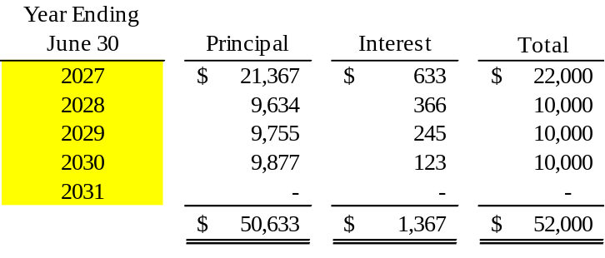

f. Current Refunding Bonds

On July 1, 2025, the City defeased certain general obligation bonds by placing the proceeds of new bonds in an irrevocable trust to provide for all future debt service payments on the old bonds. Accordingly, the trust account assets and the liability for the defeased bonds are not included in the City’s financial statements. On June 30, 2026, there were $1,000,000 of bonds outstanding that are considered defeased.

Note to preparer: Dogwood assumes that the refunding transaction does not require any disclosures necessary to comply with GASB Statement No. 86. Units are encouraged to review any refunding transactions to determine if additional disclosures are necessary.

Note to preparer: All installment purchase agreements that are used to finance the acquisition of capital assets for general government use are to be included as debt on the Statement of Net Position

- Long-Term Obligation Activity

The following is a summary of changes in the City’s long-term obligations for the fiscal year ended June 30, 2026:

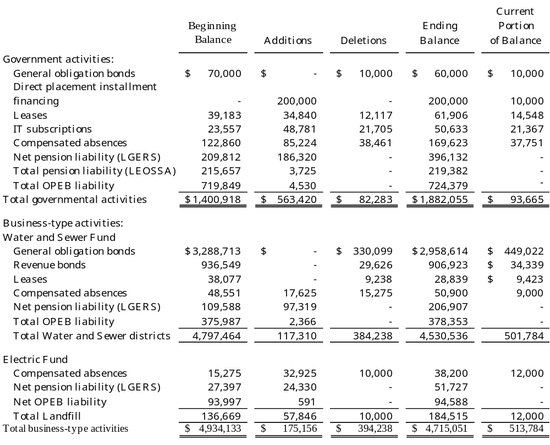

Long-term debt activity for the ABC Board for the year ended June 30, 2026, was as follows:

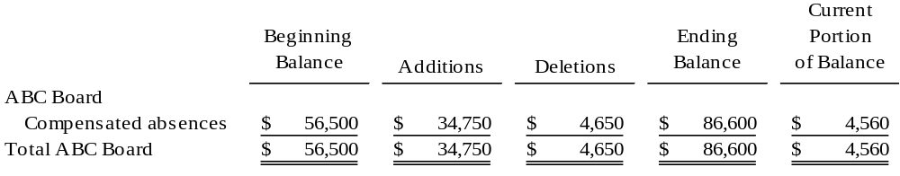

Compensated absences for governmental activities have typically been liquidated in the General Fund.

C. Interfund Balances and Transfer Activity

Note to preparer: The purpose of each interfund balance and transfer must be disclosed. Understanding interfund balances plays a significant role in the determination of fiscal health. The justification and a repayment schedule should be disclosed for balances that are not expected to be repaid within the current fiscal year. Do not simply cut and paste the sample note for transfers and due to/from / advances to/from. This note disclosure should provide a thorough explanation of the purpose of the transfers and /or loans, including terms of repayment for any loans.

Balances due to/from other funds at June 30, 2026, consist of the following:

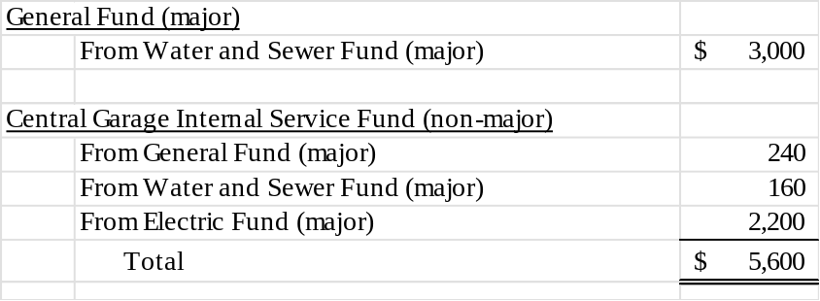

The General Fund due from is for payments in lieu of taxes.
The Central Garage Fund due from amounts are for cost allocations.

Internal balances reported in the government-wide statements consists of $300 due from the Central Garage Internal Service Fund (governmental activities) to the Proprietary Funds (business-type activities).

Interfund loan - On June 30, 2026, the Water and Sewer Fund borrowed $30,000 from the General Fund to fund an equipment purchase. The terms of the arrangement require the Water and Sewer Fund to repay the General Fund over ten years with an interest rate of 1.50%. In the Water and Sewer Fund, $3,000 that will be due within the next year is presented as a due to the General Fund with the remaining $27,000 presented as an advance from the General Fund.

The interfund balances were the result of the time lag between the dates that (1) interfund goods and services are provided or reimbursable expenditures occur, (2) transactions are recorded in the accounting system, and (3) payments between funds are made.

Note to preparer: NC GS 159B-39, specifies approved uses of Electric Fund revenue for cities and towns that are members of the North Carolina Eastern Municipal Power Agency. Specify the components of Electric Fund transfers, for example, payments in lieu of taxes, and others.

Transfers to other funds on June 30, 2026, consist of the following:

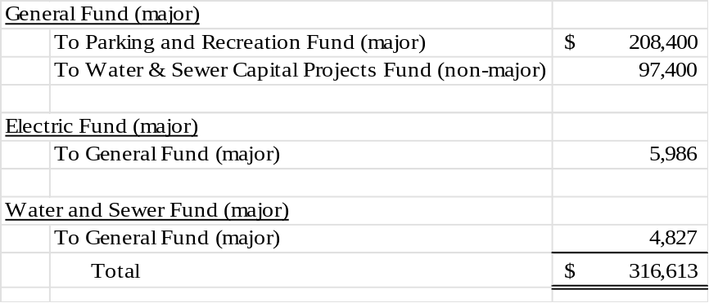

Transfers are used to move unrestricted revenues to finance various programs that the government must account for in other funds by budgetary authorizations, including amounts provided for matching funds for various grant programs.

During the 2026 fiscal year, the City made a one-time transfer from the General Fund of $208,400 to the Parking and Recreation Fund as per the terms of a matching grant and of $97,400 to the Water and Sewer Capital Projects Fund for expansion of water and sewer lines in the new construction of the City’s Park.

Note to preparer: All interfund transactions throughout the year are considered essential to fair presentation at the basic financial statement level and should be included in the notes to the financial statements. For interfund transfers, amounts transferred from other funds by individual major fund, non-major governmental funds in the aggregate, non-major enterprise funds in the aggregate, internal service funds in the aggregate, and fiduciary fund type; a general description of the principal purposes of interfund transfers; and purposes for and amounts of non-routine transfers and/or transfers inconsistent with the activities of the fund making the transfers should be disclosed in the notes. These provisions should be applied only to material items. LGC staff prefers that interfund transfers be listed by individual fund names.

D. Unusual or Infrequent Item

On July 2, 2025, the city experienced a record flood and the collapse of the Cardinal Point Dam. The wastewater aerating facility was severely damaged. For the Water and Sewer operation, the city received $3,650,000 in an insurance recovery to offset the asset impairment loss of $2,368,954, resulting in a gain of $1,281,046 which is shown as an unusual or infrequent item as it was both unusual in nature and infrequent in occurrence. The restoration cost of $3,800,000 has been capitalized in the Water and Sewer Fund. Also, the Tarheel Municipal Building was damaged. The city received $325,000 in insurance recovery to offset the asset impairment loss of $268,745, increasing miscellaneous revenue by $56,255. The restoration cost of $395,240 has been capitalized for governmental activities.

Note to preparer: The impairment loss and resulting insurance gain for governmental activities have not been shown as an unusual or infrequent item in the Statement of Activities due to immateriality. For an example of an impairment shown as a program expense, see Carolina County.

E. On-Behalf Payments for Fringe Benefits and Salaries

Note to preparer: Payments made by the State of North Carolina on behalf of the City of Dogwood have been addressed in the FRSWP note. The amount presented in the supplemental schedule includes on-behalf payments for the Firemen’s Relief Fund.

The City has recognized as a revenue and an expenditure on-behalf payments for fringe benefits and salaries of $1,540 for the salary supplement and stipend benefits paid to eligible firemen by the local board of trustees of the Firemen’s Relief Fund during the fiscal year ended June 30, 2026. Under State law, the local board of trustees for the Fund receives an amount each year, which the board may use at its own discretion for eligible firemen or their departments. See Note VI., Joint Ventures, for additional discussion of the City’s involvement with the Fireman’s Relief Fund.

Note to preparer: For employees and volunteers of governmental fire departments, the independent auditor may have to contact the local board of trustees to determine the amount of money the board has paid out for salary supplements and stipends. If payment from the Firemen’s Relief Fund is not made to the government unit, the on-behalf payments paragraph can be excluded from the audit report.

F. Net Investment in Capital Assets

Note to preparer: If the net investment in capital assets is not easily determinable based on the amounts presented in the basic financial statements, please submit a calculation. It may be submitted in a document separate from the audit submission. Additional Worksheet Tools - Net Investment In Capital Assets | NC Treasurer
G. Fund Balance

The following schedule provides management and citizens with information on the portion of the General Fund balance that is available for appropriation:

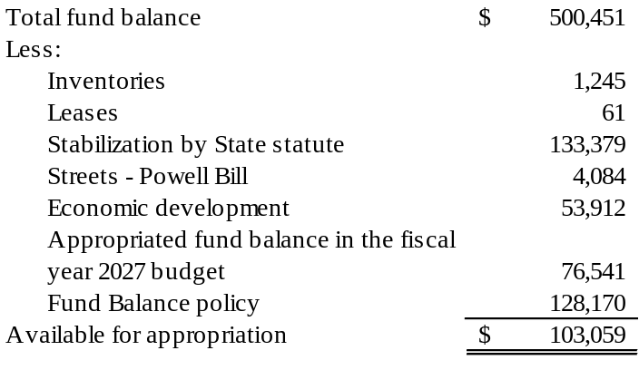
The City has adopted a minimum fund balance policy for the General Fund which instructs management to conduct the business of the City in such a manner that available fund balance is at least equal to or greater than 5% of budgeted expenditures.

Outstanding encumbrances as of June 30, 2026, consisted of $10,450 in the General Fund.

Note to Preparer: The above schedule is prepared from the General Fund Balance Sheet as presented in the basic financial statements. Each restriction, commitment, and assignment of fund balance should be included in the calculation above.

The unit should also include any other items that the board authorized, even if it is included in unassigned fund balance on the Balance Sheet. This is where the unit can disclose any fund balance policies and subtract them from the remaining amount. In this example, the fund balance policy is included in the unassigned fund balance. In unusual circumstances, fund balance policies can be included in Committed Fund Balance. For more information on GASB Statement No. 54 components of fund balance, please review Memorandum #2010-35: GASB Statement No. 54 Fund Balance Reporting and Governmental Fund type Definitions - Part 2– Components of Fund Balance on the DST website.

The unit is also required to disclose the dollar amount of outstanding encumbrances for all major funds and non-major funds in the aggregate. Outstanding encumbrances are not shown on the face of the statement but are included in Stabilization by State Statute (RSS); however, in funds other than the General Fund they might be shown as some other restricted amount. In either case, the amount of significant outstanding encumbrances must be disclosed for each major fund and in the aggregate for non-major funds. Outstanding encumbrances are amounts needed to pay any commitments related to purchase orders and contracts that remain unperformed at year-end.

Note to preparer: General Fund encumbrances should include those for the legally adopted general fund as well as any funds consolidated into the general fund for a GAAP presentation in accordance with GASB Statement No. 54.

IV. Segment Information

Note to preparer: If a non-major proprietary fund has revenue-backed debt, this section may apply. Segment information is only required for enterprise funds with revenue-backed debt outstanding if the fund is not presented as major or when the segment does not encompass the entire fund. In disclosing segment information, present the type of goods or services; a condensed statement of net position; a condensed statement of revenues, expenses, and changes in net position; and a condensed statement of cash flows. See paragraph 122 of GASB Statement No. 34 for more details.

V. Jointly Governed Organization

The City, in conjunction with twenty other local governments, is a member of the North Carolina City Electric Agency (Electric Agency). The Electric Agency was formed to enable municipalities that own electric distribution systems to finance, construct, own, operate, and maintain generation and transmission facilities. Each participating government appoints one commissioner to the Electric Agency's governing board. The twenty-one members, who receive power from the Electric Agency, have signed power sales agreements to purchase a specified share of the power generated by the Electric Agency. Except for the power sales purchase requirements, no local government participant has any obligation, entitlement, or residual interest. The City's purchases of power for the fiscal year ended June 30, 2026, were $2,379,120.

The City, in conjunction with five counties and thirty-eight other municipalities established the Red Bird Council of Governments (Council). The participating governments established the Council to coordinate various funding received from federal and State agencies. Each participating government appoints one member to the Council's governing board. The city paid membership fees of $5,000 to the Council during the fiscal year ended June 30, 2026.

VI. Joint Ventures

The City, in conjunction with Carolina County, participates in a regional airport. Each participating government appoints three members to the six-member board. The Airport is a joint venture established to facilitate economic expansion within the County and improve the quality of life for its citizens. The Airport has been in existence for five years, but it is not yet self-sustaining. The City has an ongoing financial responsibility for the Airport because it and the County are legally obligated under the intergovernmental agreement that created the Airport to honor any deficiencies in the event proceeds from other default remedies are insufficient. The city contributed $51,876 to the Airport during the fiscal year ended June 30, 2026. The participating governments do not have any equity interest in the joint venture, so no equity interest has been reflected in the financial statements on June 30, 2026. Complete financial statements for the Airport can be obtained from the Airport's administrative offices at 0000 Runway Avenue, Dogwood, North Carolina 00000.

The City also participates in a joint venture to operate a regional library with five other local governments. Each participating government appoints one board member to the six-member board of the library. The City has an ongoing financial responsibility for the joint venture because the library’s continued existence depends on the participating governments' continued funding. None of the participating governments has any equity interest in the library, so no equity interest has been reflected in the financial statements as of June 30, 2026. Following the intergovernmental agreement between the participating governments, the city appropriated $15,860 to the library to supplement its activities. Complete financial statements for the library can be obtained from the library’s offices at 0001 Periodical Road, Dogwood, North Carolina 00000.

The City and the members of the City’s fire department each appoint two members to the five-member local board of trustees for the Firemen’s Relief Fund. The State Insurance Commissioner appoints one additional member to the local board of trustees. The Firemen’s Relief Fund is funded by a portion of the fire and lightning insurance premiums that insurers remit to the State. The State passes this money to the local board of the Firemen’s Relief Fund. The funds are used to assist firefighters in various ways. The City obtains an ongoing financial benefit from the Fund for the on-behalf of payments for salaries and fringe benefits made to members of the City’s fire department by the board of trustees. During the fiscal year ended June 30, 2026, the City reported revenues and expenditures for the payments of $1,540 made through the Firemen’s Relief Fund. The participating governments do not have any equity interest in the joint venture, so no equity has been reflected in the financial statements on June 30, 2026. The Firemen’s Relief Fund does not issue separate audited financial statements. Instead, the local board of trustees files an annual financial report with the State Firemen’s Association. This report can be obtained from the Association at 323 West Jones Street, Suite 401, Raleigh, North Carolina 27603.

VII. Related Organization

The five-member board of the City of Dogwood Housing Authority is appointed by the mayor of the City of Dogwood. The City is accountable for the Housing Authority because it appoints the governing board; however, the City is not financially accountable for the Housing Authority. The City of Dogwood is also disclosed as a related organization in the notes to the financial statements for the City of Dogwood Housing Authority. Complete financial statements for the Housing Authority can be obtained from the Authority’s offices at 789 Shelter Way, Dogwood, North Carolina 00000.

VIII. Related Party Transactions

Note to preparer: Disclose significant transactions with elected officials, employees, discretely presented component units, and related organizations. Disclosures should include the nature of the relationship, a description, and the dollar amount of any transaction, the amount(s) due to or from the related parties, and any other significant details.

IX. Summary Disclosure of Significant Contingencies

Federal and State Assisted Programs

The city has received proceeds from several federal and State grants. Periodic audits of these grants are required, and certain costs may be questioned as not being appropriate expenditures under the grant agreements. Such audits could result in the refund of grant money to the grantor agencies. Management believes that any required refunds will be immaterial. No provision has been made in the accompanying financial statements for the refund of grant monies.

X. Significant Effects of Subsequent Events

Note to preparer: Events that occur after the date of the financial statements but before the date the financial statements are available to be issued that have a significant effect on the unit should be disclosed (see GASB Statement 105).

XI. Changes in Accounting Principles

For the year ended June 30, 2026, GASB Statement No. 103, Financial Reporting Model Improvements, was implemented. The objective of this Statement is to improve key components of the financial reporting model to enhance its effectiveness in providing information that is essential for decision making and assessing a government’s accountability. The Statement changes the Management’s Discussion and Analysis to limit discussion areas while requiring detailed analysis to explain why balances and results of operations changed. The Statement clarifies items reported as Unusual or Infrequent Items, formerly reported as Special or Extraordinary Items, as well as reporting requirements. Changes are required to the reporting format of the proprietary fund Statement of Revenues, Expenses, and Changes in Fund Net Position. The Statement requires changes to the reporting of major and nonmajor component units. Also, all budgetary comparison information is now required to be presented as Required Supplementary Information. No restatements were required as a result of implementation.

For the year ended June 30, 2026, GASB Statement No. 104, Disclosure of Certain Capital Assets, was implemented. The Statement requires separate disclosure of certain lease assets, public-private and public-public partnership right-to-use assets, subscription assets, other intangible assets, and capital assets held for sale. The Statement was applied retroactively. Implementation changed the presentation and disaggregation of the capital-assets note but did not affect beginning net position or amounts reported in the basic financial statements (Note III.A.5).

For the year ended June 30, 2026, GASB Statement No. 105, Subsequent Events, was implemented. The objective of this Statement is to improve the financial reporting requirements for subsequent events, thereby enhancing consistency in their application and better meeting the information needs of financial statements users (Note X).

Note to Preparer: Units may have implementation amounts that their evaluation results showed as immaterial for restatement.

Note to preparer: Significant or material instances of accounting changes and error corrections should be disclosed in this section as required by GASB Statement No. 100. Other significant accounting changes and error corrections are changes made in accounting principles, changes made within the financial reporting entity, and changes in accounting estimates. In addition, information should be included in the MD&A, RSI/SI, and should be restated for all periods in which financial statements are presented for error corrections.

Required Supplementary Information

- General Fund, Budgetary Comparison Schedule
- Economic Development Fund, Budgetary Comparison Schedule
- Emergency Telephone System Fund, Budgetary Comparison Schedule
- Notes to Budgetary Comparison Schedules
- Schedule of City’s Proportionate Share of Net Pension Liability (Asset) for the Local Governmental Employees’ Retirement System

- Schedule of City Contributions to the Local Governmental Employees’ Retirement System

- Schedule of the City’s Proportionate Share of Net Pension Liability and City Contributions for the Firefighters' and Rescue Squad Workers' Pension Fund

- Schedule of Changes in Total Pension Liability for the Law Enforcement Officers' Special Separation Allowance

- Schedule of Total Pension Liability as a Percentage of Covered Payroll for the Law Enforcement Officers' Special Separation Allowance

- Schedule of Changes in the Total OPEB Liability and Related Ratios and Total OPEB Liability as a Percentage of Covered Payroll for the Healthcare Benefits Plan

