Management’s Discussion and Analysis

As management of Carolina County, we offer readers of the County’s financial statements this management discussion and analysis (MD&A). The MD&A provides a narrative overview and analysis of the financial statements of Carolina County for the fiscal year ended June 30, 2026, focusing on why amounts changed from the prior year. We encourage readers to consider the information presented here in conjunction with additional information that we have furnished in this report.

Note to preparer: The MD&A is an opportunity for management to proactively address any issues that might be affecting the unit’s financial status including the effects of the coronavirus, Hurricane Helene, uses of American Rescue Plan Act (ARPA), Opioid Settlement Funds, and other items that may answer questions that might be posed by readers of the financial statements. MD&A provides an objective and easily readable analysis of the government’s financial activities based on currently known facts, decisions, or conditions and presents comparisons between the current year and the prior year. GASB 103 requires that the information presented in MD&A be limited to the related topics discussed in five sections: (1) Overview of the Financial Statements, (2) Financial Summary, (3) Detailed Analyses, (4) Significant Capital Asset and Long-Term Financing Activity, and (5) Currently Known Facts, Decisions, or Conditions. GASB 103 also stresses that the detailed analyses should explain why balances and results of operations changed rather than simply presenting the amounts or percentages by which they changed. GASB 103 emphasizes that the analysis provided in MD&A should avoid unnecessary duplication by not repeating explanations that may be relevant to multiple sections and that “boilerplate” discussions should be avoided by presenting only the most relevant information, focused on the primary government.

Overview of the Financial Statements

This discussion and analysis is intended to serve as an introduction to Carolina County’s basic financial statements. The County’s basic financial statements consist of three components: 1) government-wide financial statements, 2) fund financial statements, and 3) notes to the financial statements. This report also includes supplementary information intended to furnish additional detail to support the basic financial statements themselves.

Government-wide Financial Statements. The government-wide financial statements are designed to provide readers with a broad overview of the County’s finances, in a manner similar to private sector business. The government-wide financial statements include the County’s governmental activities, the business-type activities, and discretely presented component units.

The statement of net position presents financial information on all of the County’s assets, liabilities, and deferred inflows/outflows of resources, with the difference reported as net position. Over time, increases or decreases in net position may serve as a useful indicator of whether the financial position of the County is improving or deteriorating.

The statement of activities presents information showing how the County’s net position changed during the most recent fiscal year. All changes in net position are reported as soon as the underlying event giving rise to the change occurs regardless of the timing of related cash flows. Thus, revenues and expenses are reported for some items that will only result in cash flows in future fiscal years (e.g. uncollected taxes and earned but unused vacation leave).

Both government-wide financial statements distinguish functions of Carolina County that are principally supported by taxes and intergovernmental revenues (governmental activities) from other functions that are intended to recover all or a significant portion of their costs through user fees and charges (business-type activities). The governmental activities of the County include general government, public safety, transportation, economic & physical development, health & human services, cultural and recreation, and education. The business-type activities of the County include a landfill operation and two water & sewer operations.

The government-wide financial statements include not only Carolina County itself (known as the primary government), but also a legally separate hospital, an ABC Board operation (liquor sales), and a tourism development authority, for which the County is financially accountable. Financial information for these component units is reported separately from the financial information presented for the primary government itself. The Other Post-employment Benefits Trust and the Industrial Facility and Pollution Control Financing Authority, although also legally separate, functions for all practical purposes as departments of the County and therefore have been included as integral parts of the primary government.

Fund Financial Statements. A fund is a grouping of related accounts that is used to maintain control over resources that have been segregated for specific activities or objectives. Carolina County, like other state and local governments, uses fund accounting to ensure and demonstrate compliance with finance-related legal requirements. All of the funds of the County can be divided into three categories: governmental funds, proprietary funds, and fiduciary funds.

Governmental Funds – Governmental funds are used to account for essentially the same functions reported as governmental activities in the government-wide financial statements. However, unlike the government-wide financial statements, governmental fund financial statements focus on near-term inflows and outflows of spendable resources available at the end of the fiscal year. Such information may be useful in assessing a government’s near-term financing requirements.

Because the focus of governmental funds is narrower than that of the government-wide financial statements, it is useful to compare the information presented for governmental funds with similar information presented for governmental activities in the government-wide financial statements. By doing so, readers may better understand the long-term impact of the government’s near-term financing decisions. Both the governmental fund balance sheet and the governmental fund statement of revenues, expenditures, and changes in fund balances provide a reconciliation to facilitate this comparison between governmental funds and governmental activities.

The County maintains eleven individual governmental funds. Information is presented separately in the governmental fund balance sheet and in the governmental fund statement of revenues, expenditures, and changes in fund balances for the General Fund, the American Rescue Plan Fund, and the Opioid Settlement Fund, which are considered to be major funds. Data from the other governmental funds are combined into a single aggregated presentation. Individual fund data for each of these nonmajor governmental funds is provided in the form of combining statements in the combining and individual fund statements and schedules section of this report.

Proprietary Funds – Carolina County has one kind of proprietary fund. Enterprise funds are used to report the same functions presented as business-type activities in the government-wide financial statements. The County uses enterprise funds to account for its landfill operation and its water and sewer activity.

Proprietary funds provide the same type of information as the government-wide financial statements, only in more detail. The proprietary fund financial statements provide separate information for the Landfill Fund, as well for the Water & Sewer District No. 1 and the Water & Sewer District No. 2 (blended component units reported as the water funds). The Landfill Fund and the Water & Sewer District No. 1 Fund are major funds of the County.

Fiduciary Funds – Fiduciary funds are used to account for resources for which Carolina County acts as a trustee or custodian. Resources held in fiduciary funds are not available to support the County’s own programs and therefore are not reported in the government-wide financial statements. The accounting used for fiduciary funds is much like that used for proprietary funds.

The County maintains two types of fiduciary funds. Pension (and other employee benefit) trust funds are used to report resources held in trust for retirees and beneficiaries covered by the Other Post Employment Benefit (OPEB) Trust Fund (a blended component unit). Custodial funds report resources, not in a trust, which are held by the County for other parties outside of the County’s reporting entity.

Notes to the Financial Statements. The notes provide additional information that is necessary to acquire a full understanding of the data provided in the financial statements. Carolina County uses notes to present information in greater detail than is possible within the financial statements themselves, explain the nature of amounts reported in the financial statements and how those amounts were determined, and report certain information that does not meet the requirements for inclusion in the financial statements (such as certain contingencies).

Other Information. In addition to the basic financial statements and accompanying notes, this report includes certain required supplementary information. Carolina County presents budgetary comparison schedules for the General Fund and the Opioid Settlement Fund, as well as the County’s progress in funding its obligations to provide pension and OPEB benefits to its employees.

The combining statements referred to earlier in connection with nonmajor governmental funds and pension (and other employee benefit) trust funds are presented immediately following the required supplementary information on budgetary comparisons, and pensions and OPEB.

Financial Summary and Detailed Analysis

Note to preparer: GASB 103 states that the MD&A should discuss the current-year balances and
results of operations in comparison with the prior year, with emphasis on the current year. This analysis should be fact based and should discuss the activities that have had either a significant positive impact or a significant negative impact on the government’s balances and results of operations in comparison with the prior year. The analysis should assist users in understanding why balances and results of operations reported in the current year’s financial statements changed from the prior year rather than simply presenting the amounts or percentages by which they changed. The use of charts, graphs, and tables is encouraged to enhance the understandability of the information.

Net position. As noted earlier, net position may serve over time as a useful indicator of a government’s financial position. Carolina County’s assets and deferred outflows of resources exceeded liabilities and deferred inflows of resources by $25.9 million at the close of the most recent fiscal year, a decrease of $4.3 million.

Carolina County’s Net Position
Figure 1

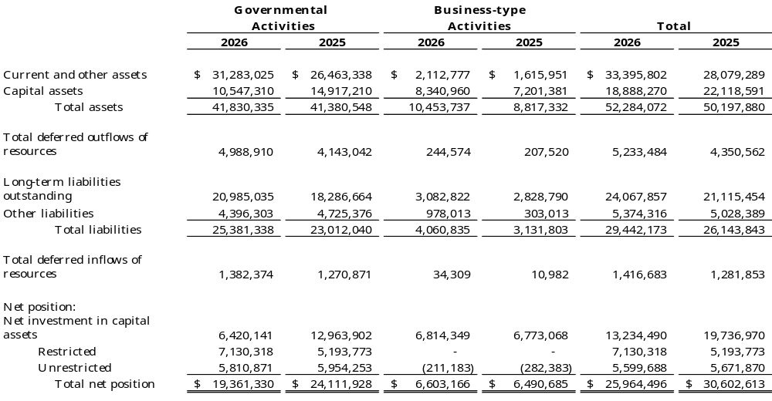

The largest portion of Carolina County’s net position, $13,234,490, reflects its investment in capital assets (e.g., land, buildings, machinery, equipment, vehicles, and infrastructure), net of accumulated depreciation/amortization and less any related outstanding debt that was used to acquire those assets. The County uses these capital assets to provide a variety of services to citizens. Accordingly, these assets are not available for future spending. Although the County’s investment in capital assets is reported net of related debt, it should be noted that the resources used to repay this debt must be provided from other sources, since the capital assets themselves cannot be used to liquidate these liabilities.

An additional portion of the County’s net position, $7,130,318, represents resources that are subject to external restrictions on how they may be used. As of the end of the current fiscal year, the County’s unrestricted net position was $5,599,688. That amount has been reduced by $7.7 million of postemployment liabilities and pensions plans, and by $1.2 million of school debt. The following sections analyze the finances of the governmental activities and business-type activities separately.

Governmental activities. Current and other assets increased by $4.8 million from the prior year. The General Fund accounted for approximately $2.1 million from positive operating results. The issuance of $5.2 million of new debt resulted in an increase of cash in the same amount. Those increases were offset by the use $1.5 million of American Rescue Plan (advanced) grant funds.

Capital Assets decreased by $4.4 million due to an asset impairment from Hurricane Irene which increased accumulated depreciation of the related facilities.

Long-term liabilities, which consist of bonds, notes, leases, subscription-based IT arrangements, compensated absences and postemployment benefit obligations, increased by $2.7 million from the previous year. The net pension increased $2.0 million due to the performance of the local government employees retirement system administered by the State. Net outstanding long-term debt increased by a net $1.1 million after $5.2 million of new debt issuance and $4.1 million of principal payments.

Business-type activities. Current and other assets increased by $0.5 million from water & sewer favorable operating results and a developer capital contribution. Capital assets increased by $1.1 million from the addition of water & sewer construction in progress of $0.7 million and water & sewer capital asset additions of $0.6 million. Other liabilities increased $0.7 million from the issuance of the same amount of bond anticipation notes.

Changes in Net Position. Carolina County’s overall net position decreased $4.3 million. The reasons for this overall decrease are discussed in the following sections for governmental activities and business-type activities.

Changes in Net Position
Figure 2
(next page)
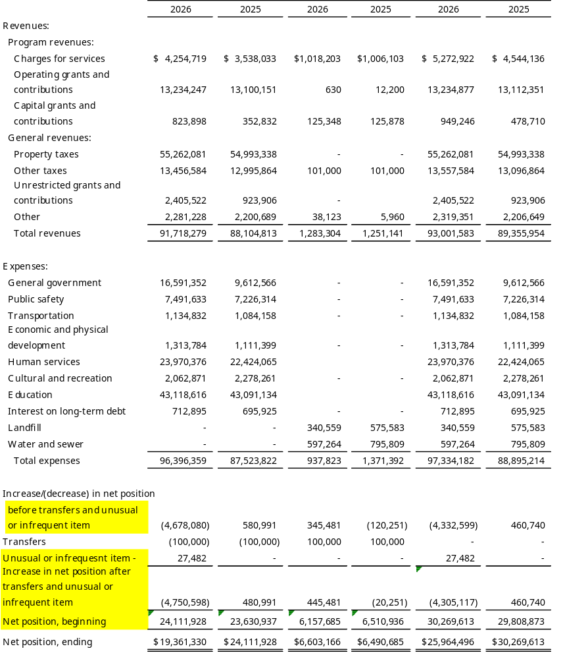

Governmental activities. During the current fiscal year, net position for governmental activities decreased by $4.7 million. The main factor was from a $4.4 million asset impairment from Hurricane Irene which increased accumulated depreciation of the related facilities and was recorded as a general government expense.

Note to preparer: List here anything you wish to highlight – fee revenue or tax revenue increases due to economic growth, reductions in spending, savings from debt refunding, new operating grants received, etc. The following language is an example based on Carolina County. Also, please note the statewide tax collection average changes annually. The management of cash, taxes and fund balance available reports provide comparative cash and investment, fund balance available, and tax levy information for local governments in North Carolina. Information and averages presented in these reports are based on data reported by local governments to the Local Government Commission as of the date of the report. To access the report server, please visit our Financial Analysis Tools and Reports webpage. A link to generate this report is offered in the “Reports” section of the webpage. Accessing the report online allows you to generate the desired report by selecting the audit year and the unit type (either county or municipality).

Business-type activities. Business-type activities increased the County’s net position by $445,481. The increase is attributable to a water & sewer rate increase of 5.0 percent and from capital contributions of $121,348 from developer installed assets.

Note to preparer: List here anything you wish to highlight with regards to business-type activities as reasons for changes in net position. The following language is an example based on Carolina County.

Detailed Analysis of Governmental Funds

Note to preparer: GASBS 34 ¶11.d provides for, at a minimum, inclusion of “an analysis of balances and transactions of individual funds. The analysis should address the reasons for significant changes in fund balances or fund net assets and whether restrictions, commitments, or other limitations significantly affect the availability of fund resources for future use.”

As noted earlier, Carolina County uses fund accounting to ensure and demonstrate compliance with finance-related legal requirements. The County reports three major funds individually in the governmental fund financial statements, the General Fund, the American Rescue Plan Fund (a special revenue fund), and the Opioid Settlement Fund (a special revenue fund).

General Fund. The General Fund is the chief operating fund of Carolina County. At the end of the current fiscal year, unassigned fund balance of the General Fund was $12,281,239, while total fund balance increased to $20,767,304. The County Board of Commissioners has determined that the county should maintain a minimum available fund balance of 16% of General Fund expenditures in case of unforeseen needs or opportunities, in addition to meeting the cash flow needs of the County. The County currently has an unassigned fund balance of 14.23% of general fund expenditures, while total fund balance represents 24.06% of that same amount.

The total fund balance of the General Fund increased by $2,127,732 or 11.49%. This increase resulted from improved tax collections and a staff reorganization that eliminated redundancy and increased efficiency. Another significant contributing factor to the fund balance increase in the General Fund was a transfer from the American Rescue Plan Special Revenue Fund of $1,500,000. These funds were used to reimburse the General Fund for premium pay and lost revenues and completed American Rescue Plan expenditures reducing fund balance of the American Rescue Plan Fund to zero.

Note to preparer: “Additional Worksheet Tools” at the following link are provided to assist with the calculation of Fund Balance Available for Appropriation (FBA) and Restricted for Stabilization by State Statute: https://www.nctreasurer.com/state-and-local-government-finance-division/local-government-commission/municipalities-financial-statement-resources#additional-worksheet-tools

One other governmental fund of note is the School Capital Projects (non-major) Fund. Revenues and other financing sources of the fund exceeded expenditures and other financing uses by $231,820 which resulted in an increase in total fund balance of 69%. While a positive outcome for the year, $558,550 of the total fund balance of $568,820 is restricted for specific purposes of the fund which mainly include spending for various property improvements for use by the Carolina County Board of Education.

Note to preparer: Budgetary highlights and budget analysis are in Required Supplementary Information per GASB Statement 103.

Detailed Analysis of Enterprise Funds.

Carolina County reports three enterprise funds in the proprietary fund financial statements, the Landfill Fund (major), the Water and Sewer District No. 1 Fund (major), and the Water and Sewer District No. 2 Fund (nonmajor). The enterprise funds provide the same type of information found in the government-wide statements but in more detail.

At the end of the fiscal year, unrestricted net position of the Landfill Fund was a deficit of $105,535, and a deficit of $107,265 for the Water and Sewer District No.1 Fund. The total changes in net position for each of the major proprietary fund were ($12,547) and $450,662, respectively. Other factors concerning the finances of these funds have already been addressed in the discussion of the County’s business-type activities.

Note to preparer: If there were significant changes to any of the following, they should be discussed: operating revenues, operating expenses, operating income or loss, noncapital subsidies, other nonoperating revenues and expenses, capital contributions, or net position.

Note to preparer: Discussions should be limited to major funds of the primary government.

Significant Capital Asset and Long-term Financing Activity

Note to preparer. GASBS 34 ¶11.f. provides for, at a minimum, inclusion of “[a] description of significant capital asset and long-term debt activity during the year, including a discussion of commitments made for capital expenditures, changes in credit ratings, and debt limitations that may affect the financing of planned facilities or services.”

Capital assets. Carolina County’s capital assets for its governmental and business – type activities as of June 30, 2026, total $18,884,220 (net of accumulated depreciation/amortization). The investment in capital assets include land, buildings, machinery and equipment, vehicles, parks, vehicles, and right to use other entities’ assets (intangibles), a landfill, and water and sewer plants and facilities.

Capital Assets
(net of depreciation/amortization)
Figure 3
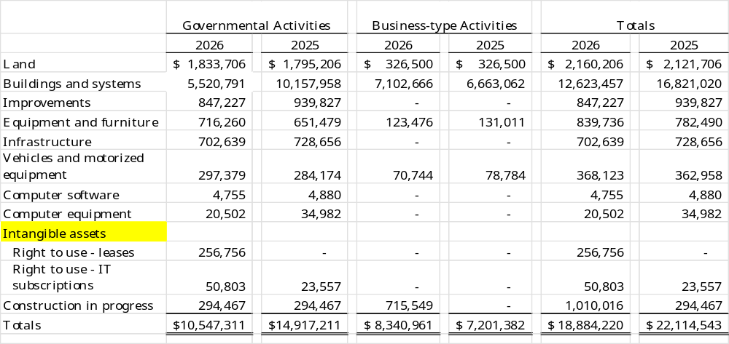

Major capital asset events during the year included the following:

Note to preparer: List of major activities including a summary of acquisitions and disposals by activity.

Governmental Activities
- Purchased new equipment for the Public Safety Department at a cost of $226,433.
- Purchased new vehicles for various departments at $138,900.
- Disposed of old equipment in the Public Safety Department at $125,058.
- Recognition of an asset impairment of $4,000,000 (Note IV.A.5).

Business-type Activities
- Addition of construction in progress for Water and Sewer plant facilities of $715,549.
- Addition of treatment plant improvements of $628,675.

Both leases and software subscriptions (SBITA) are intangible, right to use assets. The County does not own these assets but rather has the right to use them in operations as specified in their respective contracts. When entering into a lease or SBITA contract, a liability is also recognized, which is included in the long-term financings discussion below.

Additional information on the County’s capital assets can be found in Note IV.A.5 of the Basic Financial Statements.

Long-term financing. As of June 30, 2026, Carolina County had total long-term financing liabilities of $15,543,711, composed of general obligation bonds, installment financings, lease liabilities, and subscription liabilities. Changes in long-term financing liabilities are as follows:
Figure 4
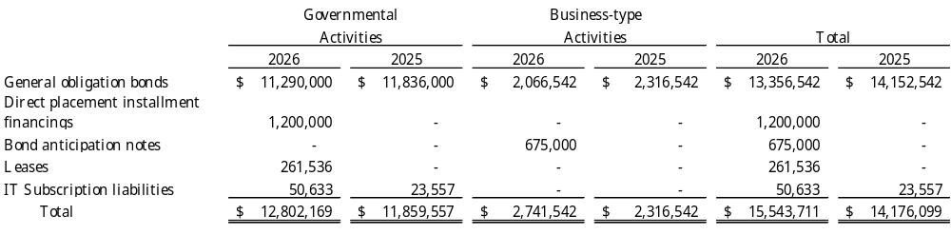
During the current year, long-term financing liabilities increased by $1.4 million due to the issuance of an installment financing of $1.2 million.

Carolina County maintained for the 15th consecutive year, its Aa1 bond rating from Moody’s Investor Service and AA+ rating from Standard and Poor’s Corporation and Fitch Ratings. This bond rating is a clear indication of the sound financial condition of the County. This achievement is a primary factor in keeping interest costs low on the County’s outstanding debt.

State law limits the amount of general obligation and installment financing debt that a unit of government can issue to 8% of the total assessed value of taxable property located within that government’s boundaries. The legal debt margin for Carolina County is $506,399,216. The County has $1,250,000 in bonds authorized but unissued at June 30, 2026.

Additional information regarding Carolina County’s long-term debt can be found in Note IV.B.8 of this report.

Currently known facts, decisions, or conditions

Carolina County was aware of the following items that will impact future finances and were considered in developing the 2027 fiscal year budget.

Note to preparer: GASBS 103 ¶8.e requires a description of currently known facts, decisions, or conditions that are expected to have a significant effect on financial position (net position) or that are expected to produce significant differences from current-period results of operations (revenues, expenses, and other changes in net position). Information about any additional types of currently known facts, decisions, or conditions that are expected to have a significant effect on financial position or to produce significant differences from current-period results of operations should be provided.

- Economic developments
  - The County reached a new low unemployment rate of 4.3%, lower than the state average of 5.1%.
  - Commercial vacancy rates are low, having stayed in the 5% to 10% range all year. Management has included programs in the 2027 budget that will allow it to capitalize on manufacturing growth and believes the commercial vacancy rates will remain low in the near future.
  - New manufacturing jobs were created in the last year bringing 2,500 new jobs to the County, a trend expected to continue through 2027.
  - The County is home to a diversified business base as many different sectors of business reside in Carolina County. This diversity has helped buffer the effects of the economic recession that has affected other regions in the State.
  - Hurricane Helene came through the western part of the State and had a major effect on the County in the following ways, _________________
- Healthcare and postemployment benefits
  - _____________
  - _____________
- New revenue sources
  - The County has placed a referendum on the November 2026 ballot for approval of the Article 46 sales tax, at 0.25% which is not levied on unprepared food, gasoline, and prescriptions. If approved the tax is expected to generate $3.5 million per year of additional revenue for Carolina County.

Note to preparer: This is also an opportunity to discuss the ongoing impact of events such as COVID-19 or Hurricane Helene. Consider describing the financial and economic effects that the hurricane and coronavirus continue to have on your County during the year and any action taken to moderate the impact. UNC School of Government ARPA Resources may be found here. A microsite for NC Emergency Management Hurricane Helene resources and be found here Hurricane Helene Resources | UNC School of Government.

At the end of the current fiscal year, the available fund balance in the General Fund was $11.4 million. The County has appropriated only $255,000 of this amount for spending in the 2027 fiscal year budget. This action was taken as a measure to increase the level of that fund balance.

Requests for Information

This report is designed to provide a general overview of the County’s finances for all those with an interest in the government’s finances. Questions concerning any of the information found in this report or requests for additional information should be directed to Sara Spartan, Director of Finance, Carolina County, 123 Dogwood Lane, Dogwood, North Carolina 00000. You can also call (000)-000-0000, visit our website www.carolinacounty.gov or send an email to samplecounty@carolina.gov for more information.

