Notes to the Financial Statements

Notes to the Financial Statements for the Fiscal Year Ended June 30, 2026

Summary of Significant Accounting Policies

The accounting policies of Carolina County and its component units conform to generally accepted accounting principles as applicable to governments. The following is a summary of the more significant accounting policies.

Reporting Entity

The County, which is governed by a seven-member board of commissioners, is one of the 100 counties established in North Carolina under North Carolina General Statute (G.S.) 153A-10. As required by generally accepted accounting principles, these financial statements present the County and its component units, legally separate entities for which the County is financially accountable. Carolina County’s Water District Number 1 and Water District Number 2 exist to provide and maintain water systems for the County residents within the districts. These Districts are blended component units and, as such, are reported as enterprise funds of the County.

The Other Post-Employment Benefit Trust Fund accounts for healthcare coverage provided to qualified retirees (the healthcare Benefits Plan) and for contributions made to finance future benefits, which are held in a qualifying irrevocable trust. The County performs the activities of the Trust, and the governing board has appointed the County Manager, the Finance Director, and the Human Resources Director as the Trust trustees, thus appointing the voting majority of the governing board of the Trust. The Trust is reported as a Pension (and Other Employee Benefit) Trust Fund.

Carolina County Industrial Facility and Pollution Control Financing Authority (the Authority) exists to issue and service revenue bond debt of private businesses for economic development purposes. The Authority has no financial transactions or account balances; therefore, it is not presented in the basic financial statements. The Carolina County Hospital (the Hospital), which has a September 30 year-end, and the Carolina County ABC Board (the ABC Board), which has a June 30 year end, are discretely presented component units and are reported in a separate column in the government-wide financial statements to emphasize they are both legally and substantively separate from the County. The Carolina County Tourism Development Authority (the TDA), which has a June 30 year end, is also a discretely presented component unit. The TDA does not issue separate financial statements. Accordingly, all relevant information required by generally accepted accounting principles (fund statements and reconciliations to government-wide statements) is presented as supplementary information. The Hospital is a major component unit due to financial significance to the County. The ABC Board and the TDA are major component units due to the significant nature of services provided.

Component Unit | Reporting Method | Criteria for Inclusion | Separate Financial Statements
Water District No. 1 | Blended | Under State law [G.S. 162A-89], the County’s  board of commissioners also serves as the governing board for the District. | None issued
Water District No. 2 | Blended | Under State law [G.S. 162A-89], the County’s board of commissioners also serves as the governing board for the District. | None issued.
Other Post-Employment Benefit Trust Fund | Blended | The Trust is governed by Trust trustees which are appointed by County position by the County commissioners. The County commissioners may remove and replace Trust trustees at will. The Trust exists to serve current County employees and retirees. | None issued.
Tourism Development Authority | Discrete | The TDA exists to promote tourism within the county. The County commissioners appoint the governing board of the TDA. At least one-half of the members are required to be active in the promotion of travel and tourism within the County or must be affiliated with businesses that collect the occupancy taxes, which are levies by the County. The County has final approval of the appointees to the governing board. The county finance officer is the ex officio finance officer of the TDA. | None issued.
Carolina County Industrial Facility and Pollution Control Financing Authority | Discrete | The Authority is governed by a seven-member board of commissioners that is appointed by the county commissioners. The County can remove any commissioner of the Authority with or without cause. The Authority has no financial transactions or financial balances. | None issued
Carolina County Hospital | Discrete | The Hospital is a public hospital operated by a not-for-profit corporation which has leased the Hospital facilities from the County for a period of 99 years. The County appoints the board of trustees for the Hospital. The County has also issued general obligation debt on behalf of the Hospital. | Carolina County Hospital 123 Medical Drive  Dogwood, NC 00000
Carolina County ABC Board | Discrete | The members of the ABC Board’s governing board are appointed by the County. The ABC Board is required by State Statute to distribute its surpluses to the General Fund of the County. | Carolina County ABC Board  456 Party Avenue  Dogwood, NC 00000
Note to preparer: In this example, the disclosures pertaining to the ABC Board have been streamlined to include only the material items of cash, inventory, and capital assets. Hospital disclosures include material items – cash and investments, capital assets, debt, accounts receivable and accounts payable, risk management, subsequent events. Since the TDA does not issue separate financial statements, the County’s report package includes financial statements, note disclosures, and budgetary schedule for the TDA. The TDA is also presented as a major component unit in the government-wide financial statements.

Basis of Presentation, Basis of Accounting

Basis of Presentation, Measurement Focus – Basis of Accounting

Government-Wide Statements: The statement of net position and the statement of activities display information about the primary government net position (the County) and its component units. These statements include the financial activities of the overall government, except for fiduciary activities. Eliminations have been made to minimize the double counting of internal activities. These statements distinguish between the governmental and business-type activities of the County. Governmental activities generally are financed through taxes, intergovernmental revenues, and other non-exchange transactions. Business-type activities are financed in whole or in part by fees charged to external parties.

The statement of activities presents a comparison between direct expenses and program revenues for the different business-type activities of the County and for each function of the County’s governmental activities. Direct expenses are those that are specifically associated with a program or function and, therefore, are clearly identifiable to a particular function. Indirect expense allocations that have been made in the funds have been reversed for the statement of activities. Program revenues include (a) fees and charges paid by the recipients of goods or services offered by the programs and (b) grants and contributions that are restricted to meeting the operational or capital requirements of a particular program. Revenues that are not classified as program revenues, including all taxes, are presented as general revenues.

Fund Financial Statements: The fund financial statements provide information about the County’s funds, including its fiduciary funds and blended component units. Separate statements for each fund category – governmental, proprietary, and fiduciary – are presented. The emphasis of fund financial statements is on major governmental and enterprise funds, each of which is displayed in a separate column. All remaining governmental and enterprise funds are aggregated and reported as non-major funds.

Proprietary fund operating revenues, such as charges for services, result from exchange transactions associated with the principal activity of the fund. Exchange transactions are those in which each party receives and gives up essentially equal values. Non-operating revenues, such as subsidies, result from non-exchange transactions or ancillary activities. The County reports the following major governmental funds:

General Fund. This is the County’s primary operating fund. It accounts for all financial resources of the general government, except those required to be accounted for in another fund. The Tax Revaluation Fund is a legally budgeted fund under North Carolina General Statutes and is consolidated into the General Fund in accordance with Governmental Accounting Standards Board (GASB) Statement No. 54.

American Rescue Plan Special Revenue Fund. This fund accounts for the transactions related to the American Rescue Plan Act (ARPA) funds.

Opioid Settlement Fund. This fund reports revenues for amounts paid by a number of corporations to settle various opioid lawsuits. These amounts are restricted to be spent for certain opioid abatement and remediation activities.
The County reports the following major enterprise funds:

Landfill Fund. This fund accounts for the operation, maintenance, and development of various landfills and disposal sites. The Landfill Closure and Postclosure Reserve Fund (non-major) has been consolidated into the Landfill Fund for reporting purposes.

Water and Sewer District No. 1 Fund. This fund is used to account for the operations of the Water and Sewer District No.1 within the County. The Water and Sewer District No. 1 Capital Project Fund has been consolidated into this fund for reporting purposes.

The County reports the following fund types:

Other Employee Benefit Trust Fund. Trust funds are used to report resources that are required to be held in trust for the members and beneficiaries of defined benefit pension plans, defined contribution plans, or other post-employment benefit plans. The Other Post-Employment Benefits Trust Fund (OPEB Trust Fund) accounts for the County’s contributions for healthcare coverage provided to qualified retirees and for contributions made to finance future benefits, which are held in a qualifying irrevocable trust (Note B.2.f).

Custodial Funds. Custodial funds are used to report fiduciary activities that are not required to be reported in pension (and other employee benefit) trust funds, investment trust funds, or private- purpose trust funds. Custodial funds are used to account for assets the County holds on behalf of others that meet certain criteria. The County maintains the following custodial funds: the Municipal Tax Fund, which accounts for ad valorem and vehicle property taxes that are billed and collected by the County for various municipalities within the County but that are not revenues to the County, and the Jail Inmate Pay Fund, which holds cash deposits made to inmates as payment for work performed while incarcerated as well as cash collections for the benefit of inmates from their friends and families.

Non-major Funds. The County maintains twelve legally budgeted non-major funds. The Emergency Telephone System Fund, the Fire District Fund, the Representative Payee Fund, the Fines and Forfeitures Fund, and Deed of Trust Fund, are reported as non-major special revenue funds. The Northwest Capital Projects Fund and the School Capital Projects Fund are reported as capital projects funds. The Capital Reserve Fund is consolidated in the School Capital Projects Fund in accordance with GASB Statement No. 54. Water and Sewer District No. 1 is reported as a non-major enterprise fund. The Water and Sewer District No. 1 Capital Projects Fund is consolidated into the Water and Sewer District No. 1 Fund. The Water and Sewer District No. 2 Fund is reported as a non-major enterprise fund. The Water and Sewer District No. 2 Capital Projects Fund is consolidated into the Water and Sewer District No. 2 Fund.

Note to Preparer: Under GASB Statement No. 54 several legally adopted funds were consolidated into other funds for presentation purposes; the above discussion on non-major funds was necessary to communicate the presentation of the non-major funds. As a result of the implementation of GASB Statement No. 84, Fiduciary Activities, Carolina County added three new special revenue funds that were formerly accounted for as fiduciary agency funds.

During the course of operations, the County has activity between funds for various purposes. Any residual balances outstanding at year end are reported as due from/to other funds. Activity occurs during the year involving transfers of resources between funds, which are reported at gross amounts as transfers in/out. While these balances are reported in the fund financial statements, certain eliminations are made for the preparation of the government‐wide financial statements. Balances between the funds included in governmental activities (governmental and internal service funds) are eliminated so that only the net amount is included as internal balances in the governmental activities column. Similarly, balances between the funds included in business‐type activities (enterprise funds) are eliminated so that only the net amount is included as internal balances in the business‐type activities column. Transfers between the funds included in governmental activities are eliminated so that only net amounts are included as transfers in the governmental activities column. Similarly, balances between the funds included in business‐type activities are eliminated so that only net amounts are included as transfers in the business‐type activities column. In accordance with North Carolina General Statutes (NCGS), all funds of the County are maintained during the year using the modified accrual basis of accounting.

Government-Wide, Proprietary, and Fiduciary Fund Financial Statements. The government-wide, proprietary, and fiduciary fund financial statements are reported using the economic resources measurement focus and the accrual basis of accounting. Revenues are recorded when earned and expenses are recorded at the time liabilities are incurred, regardless of when the related cash flows take place. Non-exchange transactions, in which the County gives (or receives) value without directly receiving (or giving) equal value in exchange, include property taxes, grants, entitlements, and donations. On an accrual basis, revenue from property taxes is recognized in the fiscal year for which the taxes are levied. Revenue from grants, entitlements, and donations is recognized in the fiscal year in which all eligibility requirements have been satisfied.

Note to Preparer: In the Municipal Tax Fund, a fiduciary custodial fund, ad valorem taxes related to the various municipalities for which the County bills and collects should be recorded as a receivable in the period when the taxes are levied. An allowance for uncollectible accounts should also be recorded.

Amounts reported as program revenues include 1) charges to customers or applicants for goods, services, or privileges provided, 2) operating grants and contributions, and 3) capital grants and contributions, including special assessments. Internally dedicated resources are reported as general revenues rather than as program revenues. Likewise, general revenues include all taxes.

Proprietary funds distinguish operating revenues and expenses from non-operating items. Operating revenues and expenses generally result from providing services and producing and delivering goods in connection with a proprietary fund’s principal ongoing operations. The principal operating revenues of the County enterprise funds are charges to customers for sales and services. The County also recognizes as operating revenue the portion of tap fees intended to recover the cost of connecting new customers to the water and sewer system. Operating expenses for enterprise funds include the cost of sales and services, administrative expenses, and depreciation/amortization on capital assets. All revenues and expenses not meeting this definition are reported as non-operating revenues and expenses.

Governmental Fund Financial Statements. Governmental funds are reported using the current financial resources measurement focus and the modified accrual basis of accounting. Under this method, revenues are recognized when measurable and available. Expenditures are recorded when the related fund liability is incurred, except for principal and interest on general long-term debt, (including lease and subscription liabilities), claims and judgments, and some types of compensated absences, which are recognized as expenditures to the extent they have matured. General capital asset acquisitions are reported as expenditures in governmental funds. Issuances of general long-term debt and acquisitions from leases and information technology subscriptions are reported as other financing sources.

The County considers all revenues available if they are collected within 90 days after year-end, except for property taxes. Ad valorem property taxes are not accrued as revenue because the amount is not susceptible to accrual. At June 30, taxes receivable for property other than motor vehicles are materially past due and are not considered to be an available resource to finance the operations of the current year. Since September 1, 2013, the State of North Carolina has been responsible for billing and collecting the property taxes on registered motor vehicles on behalf of all municipalities and special tax districts. These property taxes are due when vehicles are registered. Motor vehicle property tax revenues are applicable to the fiscal year in which they are received.

Note to preparer: Any motor vehicle property taxes collected by the State prior to June 30 which are not remitted to the County until after the fiscal year-end should be reported as collected property taxes at year end by the County. The amounts of tax moneys due from the State should be reported as an intergovernmental receivable. LGC staff anticipates that any receivables from limited registration plates will be immaterial. They have been included in the note for illustrative purposes.

Sales taxes and certain intergovernmental revenues, such as the beer and wine tax, collected and held by the State at year-end on behalf of the County, are recognized as revenue. Intergovernmental revenues and sales and services are not susceptible to accrual because generally, they are not measurable until received in cash. All taxes, including those dedicated for specific purposes, are reported as general revenues rather than program revenues. Expenditure-driven grants are recognized as revenue when the qualifying expenditures have been incurred, and all other grant requirements have been satisfied.

Under the terms of grant agreements, the County funds certain programs by a combination of specific cost-reimbursement grants, categorical block grants, and general revenues. Thus, when program expenses are incurred, there are both restricted and unrestricted net position available to finance the program. It is the County’s policy to first apply cost-reimbursement grant resources to such programs, followed by categorical block grants, and then general revenues.

Note to Preparer: The prior year section 1.D has been moved to the Required Supplementary Information Notes to the Budgetary Schedules per GASB 103.

Assets, Liabilities, Deferred Inflows and Outflows of Resources, and Fund Equity

    - Deposits and Investments

All deposits of the County, the Hospital, the TDA, and the ABC Board are made in board-designated official depositories and are secured as required by G.S. 159-31. The County, the Hospital, the TDA, and the ABC Board may designate as an official depository any bank or savings association whose principal office is located in North Carolina. Also, the County, the Hospital, the TDA and the ABC Board may establish time deposit accounts such as NOW and SuperNOW accounts, money market deposit accounts, and certificates of deposit.

State law [G.S. 159-30(c)] authorizes the County, the Hospital, the TDA, and the ABC Board to invest in obligations of the United States or obligations fully guaranteed both as to principal and interest by the United States; obligations of the State of North Carolina; bonds and notes of any North Carolina local government or public authority; obligations of certain non-guaranteed federal agencies; certain high-quality issues of commercial paper and bankers' acceptances; and the North Carolina Capital Management Trust (NCCMT).

G.S. 159-30.1 allows the County to establish and fund an irrevocable trust for the purpose of paying other post-employment benefits (OPEB) for which the County is liable. The County OPEB Trust is managed by the staff of the Department of State Treasurer and operated in accordance with state laws and regulations. The Trust is not registered with the SEC. G.S. 159-30(g) allows the County to make contributions to the Trust. The State Treasurer in his discretion may invest the proceeds in equities of certain publicly held companies and long or short-term fixed income investments as detailed in G.S. 147-69.2(b) (1-6) and (8). Funds submitted are managed in three different sub-funds: the State Treasurer’s Short Term Investment Fund (STIF), consisting of short to intermediate treasuries, agencies, and corporate issues authorized by G.S. 147-69.1, the Bond Index Fund (BIF), consisting of high-quality debt securities eligible under G.S. 147-69.2(b)(1)-(6), and the Equity Index Fund (EIF) authorized under G.S 147-69.2(b)(8).

Note to preparer: This paragraph first assumes that the government has submitted deposits to the State OPEB Trust. Secondly, its discussion of investments pertains to those investments that 1) have been in the OPEB Trust for a period of time and 2) have investments in all three parts. If your County only had investments in the State OPEB Trust Fund on the last day of the year and only in the STIF account, replace the last sentence with “Funds submitted are held in the State Treasurer’s Short-Term Investment Fund (STIF). Allowable STIF investments are detailed in G.S. 147-69.1”.

The majority of the County, the Hospital, the TDA, and the ABC Board’s investments are stated at fair value. Non-participating interest-earning investment contracts are accounted for at cost.
      - The North Carolina Capital Management Trust (NCCMT) Government Portfolio is an SEC-registered money market mutual fund that is certified by the Local Government Commission under the provisions of G.S. 159-30(c)(8) and the North Carolina Administrative Code. The Government Portfolio is a 2a7 fund that invests in treasuries, government agencies, and repurchase agreements collateralized by treasuries. It is rated AAAm by S&P and AAA-mf by Moody's Investor Services and reported at fair value.

      - Ownership of the STIF is determined on a fair market valuation basis as of fiscal year-end in accordance with STIF operating procedures. STIF investments are valued by the custodian using Level 2 inputs. Level 2 inputs in this case involves inputs — other than quoted prices — included within Level 1 that are either directly or indirectly observable for the asset or liability.

      - Ownership of the BIF is determined monthly at fair value using the same Level 2 inputs as the STIF and is based upon units of participation. Units of participation are calculated monthly based upon inflows and outflows as well as allocations of net earnings.

      - The EIF, authorized under G.S. 147-69.2(b)(8), is a common trust fund considered to be commingled in nature. The Fund’s fair value is the number of shares times the net asset value as determined by a third party. Fair value is determined using Level 1 inputs which are directly observable, quoted prices (unadjusted) in active markets for identical assets or liabilities.

Note to Preparer: Specific disclosures for the NCCMT, STIF, BIF, and EIF are provided in Memo #2027-02 - Retirement and Investment Disclosures for Fiscal Year Ended June 30, 2026 on the DST website.

Cash and Cash Equivalents

The County pools monies from several funds, excluding the OPEB Trust Fund, to facilitate disbursement and investment and to maximize investment income. Therefore, all cash and investments are considered cash and cash equivalents. The Hospital, the TDA, and the ABC Board consider demand deposits and investments with a maturity date of 90 days or less at the time of purchase to be cash and cash equivalents.

Restricted Assets

The unexpended bond proceeds of the Water and Sewer District's Serial Bonds are classified as restricted assets within the Water and Sewer Districts No. 1 and No. 2 Funds because their use is completely restricted to the purpose for which the bonds were originally issued. Customer deposits held by the County before any services are supplied are restricted to the service for which the deposit was collected. Money in the Tax Revaluation Fund is classified as restricted assets because its use is restricted per G.S. 153A-150.

The amount of unspent resources obtained from the Opioid Settlement are restricted to use for specific purposes (i.e., opioid remediation). Accordingly, the assets from the settlement that remain on hand are reported as restricted assets. The ARPA established the Coronavirus State and Local Fiscal Recovery Funds to support urgent COVID-19 response efforts and replace lost revenue for the eligible state, local, territorial, and tribal governments. These funds are limited to specific purposes. Until the amounts are assigned to be used for a specific purpose they are reported as restricted assets.

Money in the School Capital Projects Fund is classified as restricted assets because its use is restricted per G.S. 159-18 through 22. Cash and cash equivalents in the Other Post-Employment Benefits Trust Fund is considered restricted because it can only be used to pay other post-employment benefit obligations.

Ad Valorem Taxes Receivable

In accordance with NCGS [G.S. 105-347 and G.S. 159-13(a)], the County levies ad valorem taxes on property other than motor vehicles on July 1, the beginning of the fiscal year. The taxes are due on September 1 (lien date); however, penalties and interest do not accrue until the following January 6. These taxes are based on the assessed values as of January 1, 2025. As allowed by State law, the County has established a schedule of discounts that apply to taxes that are paid prior to the due date. In the County's General Fund, ad valorem tax revenues are reported net of such discounts.

5. Lease Receivable

The County’s lease receivable is measured at the present value of lease payments expected to be received during the lease term. There are no variable components under the lease agreement. A deferred inflow of resources is recorded for the lease. The deferred inflow of resources is recorded at the initiation of the lease in an amount equal to the initial recording of the lease receivable. The deferred inflow of resources is amortized on a straight-line basis over the term of the lease.

6. Allowances for Doubtful Accounts

All receivables that historically experience uncollectible accounts are shown net of an allowance for doubtful accounts. This amount is estimated by analyzing the percentage of receivables that were written off in prior years. For the Opioid Settlement receivable, the County has estimated an uncollectable allowance using the term over which the amounts are to be paid and the possibility of bankruptcies or going concern issues of the corporations’ party to the settlement. The initial allowance estimate has been established as 10.00% of the present value of the outstanding receivable balance discounted at 3.00%.

7. Inventories and Prepaid Items

The inventories of the County, the Hospital, and the ABC Board are valued at cost (first-in, first- out), which approximates market. The County's General Fund inventory consists of expendable supplies that are recorded as expenditures when purchased. If significant, the amount of inventory on hand at year end is reported on the balance sheet in the governmental funds. However, in the Government-Wide Statement Activities the cost of these inventories is expensed as the items are used.

The inventory of the County's enterprise funds as well as those of the Hospital and the ABC Board consists of materials and supplies held for consumption or resale and is reported at lower of cost or market. The cost of these inventories is expensed when consumed rather than when purchased. Certain payments to vendors reflect costs applicable to future accounting periods and are recorded as prepaid items in both government-wide and fund financial statements.

Prepaid items for the County’s governmental funds are treated using the consumption method.

Note to preparer: If your unit uses the consumption method or purchases method of accounting for prepaid expenses, disclose the method here.

8. Capital Assets

Capital assets are defined by the County as assets with an initial individual cost of more than a certain cost and an estimated useful life in excess of two years. Minimum capitalization costs are as follows: land, $10,000; buildings, improvements, and plant and distribution systems, $15,000; infrastructure, $20,000; equipment and furniture, $5,000; vehicles and motorized equipment, $10,000; computer software, $5,000; and computer equipment, $500. Donated capital assets received prior to July 1, 2015, are recorded at their estimated fair value at the date of donation. Donated capital assets received after July 1, 2015, are recorded at acquisition value. All other purchased or constructed capital assets are reported at cost or estimated historical cost. General infrastructure assets acquired prior to July 1, 2003, consist of the road network and water and sewer assets that were acquired or that received substantial improvements subsequent to July 1, 1980, and are reported at estimated historical cost using deflated replacement cost. The cost of normal maintenance and repairs that do not add to the functionality of the asset or materially extend assets’ lives is not capitalized.

The County’s capital assets also include certain right to use assets. These right to use assets arise in association with agreements where the County reports a lease (only applies when the County is the lessee) or agreements where the County reports a Subscription Based Information Technology Agreement (SBITA).

The right to use lease assets are initially measured at an amount equal to the initial measurement of the related lease liability plus any lease payments made at or prior to the start of the lease term, less lease incentives received from the lessor at or prior to the start of the lease term, and plus ancillary charges necessary to place the lease asset into service. Right to use lease assets are amortized on a straight-line basis over the life of the related lease.

Right to use IT subscription assets are initially measured at an amount equal to the initial measurement of the subscription liability plus any subscription payments made at the start of the subscription term, if applicable, plus capitalizable initial implementation costs at the start of the subscription term, less any incentives received from the IT subscription vendor at the start of the subscription term. Subscription payments, as well as payments for capitalizable implementation costs made before the start of the subscription term should be reported as a prepayment (asset). Such prepayments should be reduced by any incentives received from the same vendor before the start of the subscription term if a right of offset exists. The net amount of the prepayments and incentives should be reported as an asset or liability, as appropriate, before the start of the subscription term at which time the amount should be included in the initial measurement of the subscription asset. Right to use subscription assets are amortized on a straight-line basis over the subscription term.

The County holds title to certain Carolina County Board of Education properties that have not been included in capital assets. The properties have been deeded to the County to permit installment purchase financing of acquisition and construction costs and to permit the County to receive refunds of sales tax paid for construction costs. Agreements between the County and the Board of Education give the Board of Education full use of the facilities, full responsibility for maintenance of the facilities, and provide that the County will convey title to the property back to the Board of Education after all restrictions of the financing agreements and all sales tax reimbursement requirements have been met. The properties are reflected as capital assets in the financial statements of the Carolina County Board of Education.

Capital assets of the County are depreciated on a straight-line basis over the following estimated useful lives:

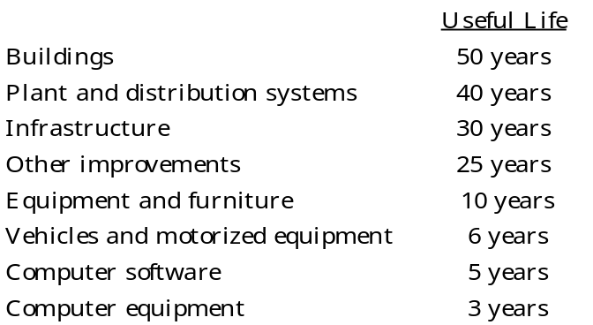

Note to Preparer: For more information, please refer to GASB Statement No. 51, Accounting and Financial Reporting for Intangible Assets. Statement No. 51 requires internally generated/modified computer software to be capitalized. Like other internally generated intangible assets, computer software should be expensed until the requirements listed in paragraph 8 occur.

Capital assets of the ABC Board are depreciated over their useful lives on a straight-line basis as follows:
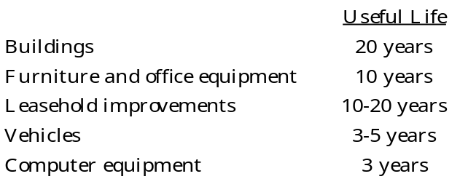

For capital assets of the Hospital, depreciation is computed by the straight-line method over the estimated useful lives of the assets as follows:
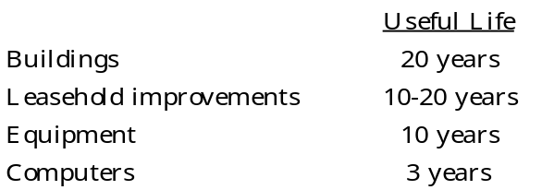

Deferred Outflows/Inflows of Resources

In addition to assets, the statement of financial position will sometimes report a separate section for deferred outflow of resources. This separate financial statement element, Deferred Outflows of Resources, represents a consumption of net position that applies to a future period and so will not be recognized as an expense or expenditure until then. The County has several items that meet this criterion: a deferred charge on a current refunding of debt, as well as pension and OPEB deferrals, including amounts for contributions made to the OPEB and pension plans in the current fiscal year. In addition to liabilities, the statement of financial position can also report a separate section for deferred inflows of resources. This separate financial statement element, Deferred Inflows of Resources, represents an acquisition of net position that applies to a future period and so will not be recognized as revenue until that time. The County has several items that meet the criterion for this category: prepaid taxes, leases, and other OPEB and pension related deferrals. In addition, certain unavailable revenues related to taxes, special assessments, and opioid settlement receivables are reported as deferred inflows of resources, but only on the balance sheet of the governmental funds.

Long-Term Obligations

In the government-wide financial statements and in the proprietary fund types in the fund financial statements, long-term debt and other long-term obligations are reported as liabilities on the statements of net position. In the fund financial statements for governmental fund types, the face amount of debt issued is reported as other financing sources.

Compensated Absences

The County recognizes a liability for compensated absences for leave time that (1) has been earned for services previously rendered by employees, (2) accumulates and is allowed to be carried over to subsequent years, and (3) is more likely than not to be used as time off or settled (for example, paid in cash to the employee or paid to an employee flex spending account) during or upon separation from employment. Based on the criteria above, two types of leave qualify for liability recognition for compensated absences – vacation and sick leave. The liability for compensated absences is recorded as incurred in the government-wide and proprietary fund financial statements. A liability for compensated absences is recorded in the governmental funds only if the liability has matured because of employee resignations or retirements. The liability for compensated absences includes salary-related benefits where applicable.

The vacation policies of the County, the Hospital, and the TDA provide for the accumulation of up to thirty days earned vacation leave with such leave being fully vested when earned. Vacation leave over thirty days is transferred to an employee’s sick leave balance at the end of each calendar year.

The sick leave policies of the County, the Hospital, and the TDA provide for an unlimited accumulation of earned sick leave. Sick leave does not vest, but any unused sick leave accumulated at the time of retirement may be used in the determination of length of service for retirement benefit purposes. Any unused sick leave accumulated for employees who leave the County, the Hospital, and the TDA prior to retirement is forfeited.

Note to Preparer: GASB concluded that gross presentation of compensated absences is less meaningful than for other long-term liabilities. To meet the long-term liabilities disclosure requirements of Statement 34, a government will have the option to present either the separate increases and decreases (gross presentation) or a net increase or a net decrease in its compensated absences liability. A government that discloses a net increase or a net decrease should indicate that it is a net amount. Statement 101 also eliminated the Statement 34 requirement to disclose which governmental funds typically have been used to liquidate the compensated absence liability. Preparers should refer to the guidance in Memorandum #2025-05 GASB Statement No. 101, Compensated Absences at State and Local Government Finance Division Memos | NC Treasurer

Opioid Settlement Funds

The County, through a Memorandum of Agreement (MOA) with the State, is a party to certain opioid lawsuit and bankruptcy settlements. The amounts received and to be received are treated as exchange-like transactions. Per the MOA, the County created a special revenue fund, the Opioid Settlement Fund, to account for all activity. Unspent funds are reported as restricted (Note VII).

Net Position/Fund Balances
Net Position
Net position in government-wide and proprietary fund financial statements is classified as net investment in capital assets, restricted, and unrestricted. Restricted net position represents constraints on resources that are either a) externally imposed by creditors, grantors, contributors, or laws or regulations of other governments or b) imposed by law through State statute.

Fund Balances
In the governmental fund financial statements, fund balance is composed of five classifications designed to disclose the hierarchy of constraints placed on how fund balance can be spent.

The governmental fund types classify fund balances as follows:

Nonspendable – This classification includes amounts that cannot be spent because they are either (a) not in spendable form or (b) legally or contractually required to be maintained intact.

Inventories – portion of fund balance that is not an available resource because it represents the year-end balance of ending inventories, which are not spendable resources.

Lease Receivable, Net – portion of fund balance that is not an available resource because it is not in spendable form. The reported amount is calculated by reducing the lease receivable by the related deferred inflow of resources.

Restricted Fund Balance – This classification includes revenue sources that are restricted to specific purposes externally imposed or imposed by law.

Note to Preparer: Restricted and Committed section of fund balance must be listed by purpose — not by name of restriction. For example, “Restriction by Grants” should be labeled “Restriction for Public Safety.” The following disclosure for Restricted for Stabilization by State Statute has been expanded to comply with a GASB comment.

Restricted for Stabilization by State Statute – G.S. 159-8 prohibits units of government from budgeting or spending a portion of their fund balance. This is one of several statutes enacted by the North Carolina State Legislature in the 1930s that were designed to improve and maintain the fiscal health of local government units. Restricted by State Statute (RSS) is calculated at the end of each fiscal year for all annually budgeted funds. The calculation in G.S. 159-8(a) provides a formula for determining what portion of fund balance is available for appropriation. The amount of fund balance not available for appropriation is what is known as “Restricted by State Statute,” defined as follows: “Appropriated fund balance in any fund shall not exceed the sum of cash and investments minus the sum of liabilities, encumbrances, and deferred revenues arising from cash receipts, as those figures stand at the close of the fiscal year next preceding the budget”. Per GASB guidance, RSS is considered a resource through which a restriction is imposed by law through constitutional provisions or enabling legislation is reduced by inventories and prepaids as they are classified as nonspendable. Outstanding encumbrances are included within RSS. RSS is included as a component of restricted net position and restricted fund balance on the face of the balance sheet.

Restricted for Register of Deeds – portion of fund balance that is restricted by revenue source to pay for the computer equipment and imaging technology for the Register of Deeds’ office.

Restricted for Fire Protection – portion of fund balance that is restricted by revenue source for fire protection expenditures.

Restricted for School Capital – portion of fund balance appropriated to be used for School Capital per G.S. 159-13(a).

Restricted for Health Services – portion of fund balance that can only be used to benefit beneficiaries under the Social Security Representative Payee Program.

Restricted for Education – portion of fund balance that is restricted for the Carolina County Board of Education.

Committed Fund Balance – Portion of fund balance that can only be used for specific purposes imposed by majority vote of Carolina County’s governing body (highest level of decision-making authority). Any changes or removal of specific purposes requires majority action by the governing body.

Committed for Tax Revaluation – portion of fund balance that can only be used for Tax Revaluation.

Committed for LEOSSA pension obligation – portion of fund balance that will be used for the Law Enforcement Officers’ Special Separation Allowance obligations.

Assigned Fund Balance – portion of fund balance that the Carolina County governing board has budgeted.

Subsequent year’s expenditures – portion of fund balance that is appropriated in the next year’s budget that is not already classified in restricted or committed. The governing body approves the appropriation; however, the budget ordinance authorizes the manager to modify the appropriations by resource or appropriation within funds up to $100,000.

Assigned for Recreation Capital – portion of fund balance that has been budgeted by the board for the construction of a new recreation center.

Assigned for Future School Capital – portion of fund balance that has been budgeted by the board for future school capital construction.

Unassigned Fund Balance – Portion of fund balance that has not been restricted, committed, or assigned to specific purposes or other funds.

Carolina County has a revenue spending policy that provides guidance for programs with multiple revenue sources. The Finance Officer will use resources in the following hierarchy: bond proceeds, federal funds, state funds, local non-county funds, and county funds. For purposes of fund balance classification, expenditures are to be spent from restricted fund balance first, followed in order by committed fund balance, assigned fund balance, and lastly, unassigned fund balance. The Finance Officer has the authority to deviate from this policy if it is in the best interest of the County.

Note to Preparer: Units should modify this language to specifically apply to their unit.

Carolina County has also adopted a minimum fund balance policy for the General Fund which instructs management to conduct the business of the County in such a manner that available fund balance is at least equal to or greater than 16% of budgeted expenditures. Any portion of the available balance in excess of 20% of budgeted expenditures may be appropriated for one-time expenditures and may not be used for any purpose that would obligate the County in a future budget.

Note to Preparer: Units are not required to have a fund balance policy; however, if they do have a board-approved fund balance policy, it should be disclosed in the notes.
Used properly, a fund balance policy can help the unit establish the expectation and the foundation for the ongoing fiscal strength and guide the governing board and management as they make financial decisions. A General Fund minimum balance policy reflects the unit’s commitment to continued fiscal strength and is favorably viewed by the three major credit rating agencies.
The fund balance policy language presented here for Carolina County is for illustrative purposes ONLY and should not be considered as a requirement.
For specific guidance on fund balance policy presentation, refer to GASB 54, Fund Balance Reporting and Governmental Fund Type Definitions.

Defined Benefit Pension and OPEB Plans

The County participates in two cost-sharing multiple-employer defined benefit pension plans that are administered by the State: the Local Governmental Employees’ Retirement System (LGERS) and the Registers of Deeds’ Supplemental Pension Fund (RODSPF) (collectively, the “state-administered defined benefit pension plans”). For purposes of measuring the net pension asset or liability, deferred outflows of resources and deferred inflows of resources related to pensions, and pension expense, information about the fiduciary net positions of the state-administered defined benefit pension plans and additions to/deductions from the state-administered defined benefit pension plans’ fiduciary net positions have been determined on the same basis as they are reported by the state-administered defined benefit pension plans. For this purpose, plan member contributions are recognized in the period in which the contributions are due. The County’s and TDA’s employer contributions are recognized when due, and the County and the TDA have a legal requirement to provide the contributions. Benefits and refunds are recognized when due and payable in accordance with the terms of the state-administered defined benefit pension plans. The County is required by State law to administer a public employee retirement system, a single employer defined benefit pension plan, to provide benefits to certain sworn law enforcement offices, the Law Enforcement Officers’ Special Separation Allowance (LEOSSA).

For purposes of measuring the net Healthcare Benefits Plan (OPEB: HCB) liability, deferred outflows and inflows of resources related to OPEB, and OPEB expense, information about the fiduciary net position of the Healthcare Benefit Plan (HCB) and additions to/deductions from the HCB’s fiduciary net position have been determined on the same basis as they are reported by the HCB. For this purpose, the HCB recognizes benefit payments when due and payable in accordance with the benefit terms. Investments for all plans are reported at fair value.

Reconciliation of Government-Wide and Fund Financial Statements

  - Explanation of certain differences between the governmental fund balance sheet and the government-wide statement of net position.

The governmental fund balance sheet includes a reconciliation between total fund balance for the governmental funds and net position for governmental activities as reported in the government- wide statement of net position. Details of reconciling items that are aggregated or net amounts are as follows:

The details for the item labeled “pension related deferrals, net” for $3,268,484 are as follows:

Deferred outflows of resources:
Differences between expected and actual experience-LGERS $915,414
Differences between expected and actual experience-LEOSSA 8,148
Differences between expected and actual experience-ROD 670
Difference between projected and actual investment earnings-LGERS 814,507
Difference between projected and actual investment earnings-ROD 12,117
Changes of assumptions -LGERS 1,574,550
Changes of assumptions -ROD 7,287
Changes in proportion and differences between County contributions
and proportionate share of contributions-LGERS 80,513
Deferred inflows of resources:
Differences between expected and actual experience-LGERS (30,716)
Differences between expected and actual experience-ROD (3,470)
Changes of assumptions -LGERS (4,439)
Changes of assumptions -LEOSSA (42)
Changes in proportion and differences between County contributions
and proportionate share of contributions-LGERS (104,413)
Changes in proportion and differences between County contributions
and proportionate share of contributions-ROD (1,642)
Net adjustment $3,268,484

Capital assets used in governmental activities are not financial resources and therefore are not reported in the funds. The details of this $10,547,310 are as follows:

Capital assets (including right to use assets) $ 22,379,356
Accumulated depreciation/amortization 11,530,046
Net adjustment $ 10,547,310

Some liabilities, including bonds payable and accrued interest, are not due and payable in the current period and therefore are not reported in the funds. Details for $(14,012,260) are as follows:
General obligation bonds ($11,290,000)
Leases payable (261,536)
IT subscriptions payable (50,633)
Installment financing (1,200,000)
Compensated absences (898,247)
Accrued interest payable (311,844)
Net adjustment ($14,012,260)

  - Explanation of certain differences between the governmental fund statement of revenues, expenditures and changes in fund balance and the government-wide statement of activities.

The governmental fund statement of revenues, expenditures, and changes in fund balances includes a reconciliation between the net change in fund balance for the governmental funds and the change in net position of governmental activities as reported in the government-wide statement of activities.

Details of reconciling items that are aggregated or net amounts are as follows:

Some expenses reported in the statement of activities do not require the use of current financial resources and, therefore, are not reported as expenditures in governmental funds. The details of this $1,064,890 are as follows:

Compensated absences $ 250,587
Amortization of deferred amounts on debt refunding 22,500
LGERS pension expense 1,471,593
LEOSSA pension expense 16,153
ROD pension expense 11,457
Deferred gain on refunding (315,000)
OPEB expense (65,804)
Expense in government-wide statements $1,064,890

- Stewardship, Compliance, and Accountability

- Significant Violations of Finance-Related Legal and Contractual Provisions

- Noncompliance with North Carolina General Statutes

The County's repurchase agreement is not in accordance with G.S. 159-30(c)(12), which requires that the security be delivered to the County or its safekeeping agent (other than the provider of the repurchase agreement) and that the security be in the County's name. The underlying security is held by the financial institution providing the transaction and is not in the County's name. The County has established a custodial agreement with a separate financial institution that will hold the security in the County’s name.

Transfers were made from the General Fund to the Capital Reserve Fund (consolidated into the School Capital Project Fund) and the Revaluation Fund (consolidated into the General Fund. These transfers violated G.S. 159-28(b) as the transfers were in excess of the appropriated budgets. Responsible staff have completed budget monitoring and control training.

Note to preparer: All budgetary violations are statutory violations to be shown in this footnote and must include a concise description of the actions taken to address the violation. If no action has been taken as of the date the financial statements are available to be issued, the disclosure should state such. For funds which have a Budgetary Comparison Schedule in the RSI, any excess of expenditures over appropriations are to be disclosed in the Required Supplementary Information Notes to the Budgetary Comparison Schedules per GASB 103.

Note to preparer: Other significant instances of noncompliance with the fiscal requirements of the General Statutes should be disclosed in this section. Items such as the following should be disclosed: failure to adopt an annual balanced budget for an enterprise fund, a performance bond for the Finance Officer or other employee that does not meet the revised requirements of G.S. 159-29, “Fidelity bonds,” or failure to timely file the semiannual report of cash and investments (LGC-203) per G.S. 159-33. A corrective action plan should be included for each statutory violation.

- Contractual Violations

Note to preparer: For those governmental units with outstanding revenue bonds, any failures of the unit to comply with reserve levels, coverage ratio requirements, or other terms of the bond documents should be disclosed here. Material contractual violations of lease arrangements or other contractual agreements should also be disclosed in this section. A corrective action plan should be included for each violation.

- Deficit Fund Balance of Individual Funds Not Appropriated in Subsequent Year’s Budget Ordinance

Note to preparer: Any individual funds with a deficit in fund balance should be disclosed along with the unit’s action to fund the deficit in the subsequent year as required by G.S. 159-13(b)(2). The full amount of any deficit in each fund should be appropriated.

IV. Detail Notes on All Funds

- Assets

- Deposits

All the County's, the Hospital's, TDA’s, and the ABC Board's deposits are either insured or collateralized by using one of two methods. Under the Dedicated Method, all deposits exceeding the federal depository insurance coverage level are collateralized with securities held by the County's, the Hospital's, TDA’s, or the ABC Board's agents in these units' names. Under the Pooling Method, which is a collateral pool, all uninsured deposits are collateralized with securities held by the State Treasurer's agent in the name of the State Treasurer. Since the State Treasurer is acting in a fiduciary capacity for the County, the Hospital, the TDA and the ABC Board, these deposits are held by their agents in the entities' names. The amount of the pledged collateral is based on an approved averaging method for non-interest-bearing deposits and the actual current balance for interest-bearing deposits. Depositories using the Pooling Method report to the State Treasurer the adequacy of their pooled collateral covering uninsured deposits. The State Treasurer does not confirm this information with the County, the Hospital, the TDA, the ABC Board, or with the escrow agent. Because of the inability to measure the exact amount of collateral pledged for the County, the Hospital, the TDA, or the ABC Board under the Pooling Method, the potential exists for under-collateralization, and this risk may increase in periods of high cash flows. However, the State Treasurer of North Carolina enforces strict standards of financial stability for each depository that collateralizes public deposits under the Pooling Method.

The State Treasurer enforces standards of minimum capitalization for all pooling method financial institutions. The County, the Hospital, and the TDA rely on the State Treasurer to monitor those financial institutions. The County analyzes the financial soundness of any other financial institution used by the County. The County complies with the provisions of G.S. 159-31 when designating official depositories and verifying that deposits are properly secured. The ABC Board has no formal policy regarding custodial credit risk for deposits.

Note to preparer: A county should disclose whether its Board of Commissioners has adopted a formal policy for any of the different deposit and investment risks it encounters. In addition, the county may include whether its management follows any internal practices to avoid applicable risks. Please see Memorandum #1056 for additional information. See Note III.A.1 of City of Dogwood for an example of when no formal policy has been adopted, but there are internal management policies in place. See Note III.A.1 of Carolina County Board of Education for an example of when neither a formal policy has been adopted, nor an internal management policy is followed.

June 30, 2026, the County’s deposits had a carrying amount of $1,384,458 and a bank balance of $1,426,017. Of the bank balance, $400,000 was covered by federal depository insurance, $32,868 was covered by collateral held under the Dedicated Method, and $56,000 in non-interest-bearing deposits and $895,950 in interest-bearing deposits were covered by collateral held under the Pooling Method.

At June 30, 2026, the County had $2,500 cash on hand.

At June 30, 2026, the TDA’s deposits had a carrying amount of $168,963 and a bank balance of $204,532. All of the bank balance was covered by federal depository insurance.

At June 30, 2026, the carrying amount of deposits for Carolina County ABC Board was $31,012 and the bank balance was $49,217. All of the bank balance was covered by federal depository insurance.

At September 30, 2025, the Hospital’s deposits had a carrying amount of $1,386,576 and a bank balance of $1,802,852. Of the bank balance, $400,000 was covered by federal depository insurance, $74,263 was covered by collateral held under the Dedicated Method, and $62,242 in non-interest-bearing deposits and $950,071 in interest-bearing deposits were covered by collateral held under the Pooling Method.

Restricted cash and cash equivalents consisted of the following as of June 30, 2026:

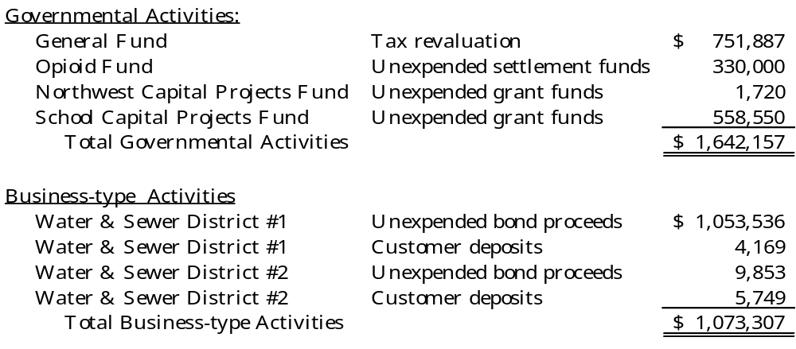

Investments

As of June 30, 2026, the County had the following investments and maturities:

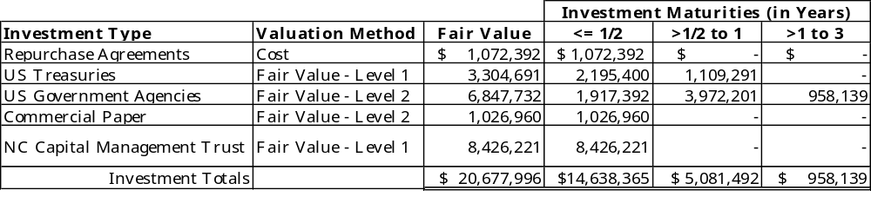

As of June 30, 2026, the TDA had the following investments and maturities:

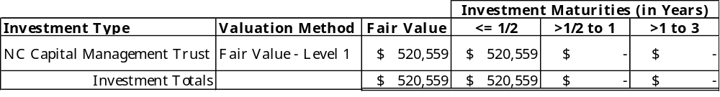

Because the NCCMT Government Portfolio has a weighted average maturity of less than 60 days, it is presented as an investment with a maturity of less than 6 months. The NCCMT Government Portfolio has an AAAm rating from S&P and an AAA-mf rating from Moody's Investors Service.

All investments of the County and TDA are measured using the market approach: using prices and other relevant information generated by market transactions involving identical or comparable assets or a group of assets.

Level of fair value hierarchy: Level 1: Debt securities valued using directly observable, quoted prices (unadjusted) in active markets for identical assets. Level Two: Debt securities are valued using a matrix pricing technique. Matrix pricing is used to value securities based on the securities’ relationship to benchmark quoted prices.

Interest Rate Risk. As a means of limiting its exposure to fair value losses arising from rising interest rates, the County’s investment policy limits at least half of the County’s investment portfolio to maturities of less than 12 months. Also, the County’s investment policy requires purchases of securities to be tiered with staggered maturity dates and limits all securities to a final maturity of no more than three years.

Credit Risk. The County and the TDA limits investments to the provisions of G.S. 159-30 and restricts the purchase of securities to the highest possible ratings whenever particular types of securities are rated. State law limits investments in commercial paper to the top rating issued by nationally recognized statistical rating organizations (NRSROs). As of June 30, 2026, the County’s investments in commercial paper were rated P1 by S&P, F1 by Fitch Ratings, and A1 by Moody's Investors Service. The County’s and the TDA’s investments in the NCCMT Government Portfolio carried a credit rating of AAA-mf by S&P and a rating of AAA-mf from Moody’s as of June 30, 2026. The County’s investments in US Agencies (Federal Home Loan Bank) are rated AAA by S&P and Aaa by Moody's Investors Service. The TDA has no policy on credit risk. These amounts are included within cash on the statement of net position.

Custodial Credit Risk. Custodial credit risk is the risk that in the event of the failure of the counterparty, the County will not be able to recover the value of its investments or collateral securities that are in the possession of an outside party. The County’s $1,072,392 investments in repurchase agreements are uninsured and unregistered investments for which the securities are held by the counterparty or by its trust department, but not in the County’s name. The County’s formal policy indicates that the County shall utilize a third-party custodial agent for book-entry transactions, all of which shall be a trust department authorized to do trust work in North Carolina who has an account with the Federal Reserve. Certificated securities must be in the custody of the Finance Director.

Note to preparer: Proceeds from installment financing held in escrow by a bank or its trust department will be a Category 3 investment if the trust department/escrow agent purchases and holds the securities, which is often common with these financing arrangements. This will meet the exception standard of disclosing Category 3 investments for custodial credit risk.

Concentration of Credit Risk. The County places a limit of 10% on the amount that the County may invest in any one issuer of commercial paper or banker’s acceptances. More than 5% of the County’s investments are in Cargill Corporation’s commercial paper and the Federal Home Loan Bank securities. These investments are 6% and 30.5%, respectively, of the County’s total investments. The County has adopted a policy of maximum exposure of 60% in US Government Agencies.

Note to preparer: Concentration risk is only included if one of the issuers is 5% or greater of the total investment portfolio (excludes deposits). It should be omitted if no holdings meet the 5% rule. Governments should provide information about the concentration of credit risk associated with their investments by disclosing, by amount and issuer, investments in any one issuer that represent 5% or more of total investments. Investments issued or explicitly guaranteed by the U.S. government (United States Treasuries) and investments in mutual funds (NCCMT) and other pooled investments (STIF and Long-term Fund) are excluded from this requirement. Repurchase agreements are omitted because underlying securities (Treasuries and GNMA) are exempt. If the unit has a concentration of credit risk, then it will need to disclose whether it has a formal policy or internal management policy. For an example disclosure of an internal management practice without a formal Board-adopted policy, see the City of Dogwood illustrative financial statements.

OPEB Trust Fund. At June 30, 2026, the County’s Healthcare Benefit Plan (HCB) had $917,893 invested in the State Treasurer’s Ancillary Government Participant Investment Program (AGPIP) pursuant to G.S. 159-30.1. The State Treasurer’s AGPIP may invest in public equities and both long-term and short-term fixed income obligations as determined by the State Treasurer pursuant to the NCGS. At year-end, the County’s HCB AGPIP was invested as follows: State Treasurer’s STIF XX%; State Treasurer’s BIF XX% and BlackRock’s MSCI ACWI EQ Index Non-Lendable Class B Fund XX% (the equities were split with 63% in domestic securities and 37% in international securities).

Note to preparer: Each unit chooses its own % amounts for each of the available (AGPIP) investments in the State Treasurer’s Local Government Other Post-Employment Benefits (OPEB) Trust. In the blank spaces above, please enter your unit’s applicable percentages found in your unit’s individual report from the NC State Treasurer Investment management division (IMD). The domestic and international security split is provided annually by IMD.

The County does not have a formal investment policy regarding credit risk for the HCB Plan Fund. The STIF is unrated and authorized under G.S. 147-69.1. The State Treasurer’s STIF is invested in highly liquid fixed income securities consisting primarily of short to intermediate term treasuries, agencies, and money market instruments. The BIF is unrated and authorized under G.S. 147-69.1 and G.S. 147-69.2. The State Treasurer’s BIF is invested in high quality debt securities eligible under G.S. 147-69.2(b)(1)-(6).

The STIF portfolio is unrated and had a weighted average maturity on June 30, 2026, of 2.2 years. Level 2 inputs in this case involves inputs — other than quoted prices — included within Level 1 that are either directly or indirectly observable for the asset or liability. The STIF is valued at $1 per share. The BIF, which does not have a credit rating, was valued at $1 per unit and had an average maturity of 8.1 years on June 30, 2026. The EIF is a common trust fund considered to be commingled in nature. On June 30, 2026, the net asset value was $ 54.978091 per share. Fair value for this Fund is determined using Level 1 inputs

Note to preparer: The three previous paragraphs should be included if a government has made contributions to the State OPEB Trust. If the government only had investments in the State OPEB Trust on the last day of the year and only in the STIF account, the paragraphs should be revised for only references to the STIF account.

Note to preparer: Memo #2027-02 on the DST website (State and Local Government Finance Division Memos | NC Treasurer) provides the weighted average maturities for the STIF and BIF.

At June 30, 2026, the ABC Board's investments consisted of $281,226 in the NCCMT Government Portfolio, which carried a credit rating of AAAm by S&P and a rating of AAA-mf from Moody’s. The ABC Board has no policy on credit risk.

At September 30, 2025, the Hospital's investments consisted of the following:

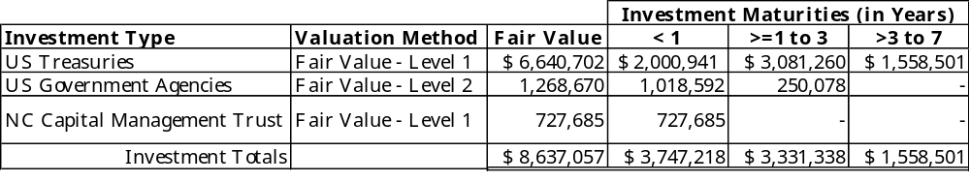

All investments are measured using the market approach: using prices and other relevant information generated by market transactions involving identical or comparable assets or a group of assets.

Level of fair value hierarchy: Level 1: Debt securities valued using directly observable, quoted prices (unadjusted) in active markets for identical assets.

Interest Rate Risk. As a means of limiting its exposure to fair value losses arising from rising interest rates, the Hospital’s investment policy limits at least 35% of the Hospital’s investment portfolio to maturities of less than one year. Also, the Hospital’s investment policy requires purchases of securities to be tiered with staggered maturity dates and limits all securities to a final maturity of no more than seven years.

Credit Risk. The Hospital’s investments in the NCCMT Government Portfolio carried a credit rating of AAAm by S&P and a rating of AAA-mf from Moody’s as of September 30, 2025. The Hospital’s investments in US Government Agencies (Fannie Mae) are rated AAA by Standard & Poor’s and Aaa by Moody’s . The Hospital has no policy on credit risk.

Property Tax - Use Value Assessment on Certain Lands

In accordance with the general statutes, agriculture, horticulture, and forestland may be taxed by the County at the present-use value as opposed to market value. When the property loses its eligibility for use value taxation, the property tax is recomputed at market value for the current year and the three preceding fiscal years, along with the accrued interest from the original due date. This tax is immediately due and payable. The following are property taxes that could become due if present-use value eligibility is lost. These amounts have not been recorded in the financial statements.

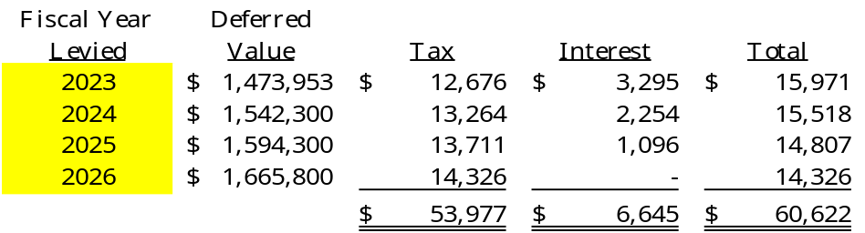

Receivables

Receivables at the government-wide level at June 30, 2026, were as follows:

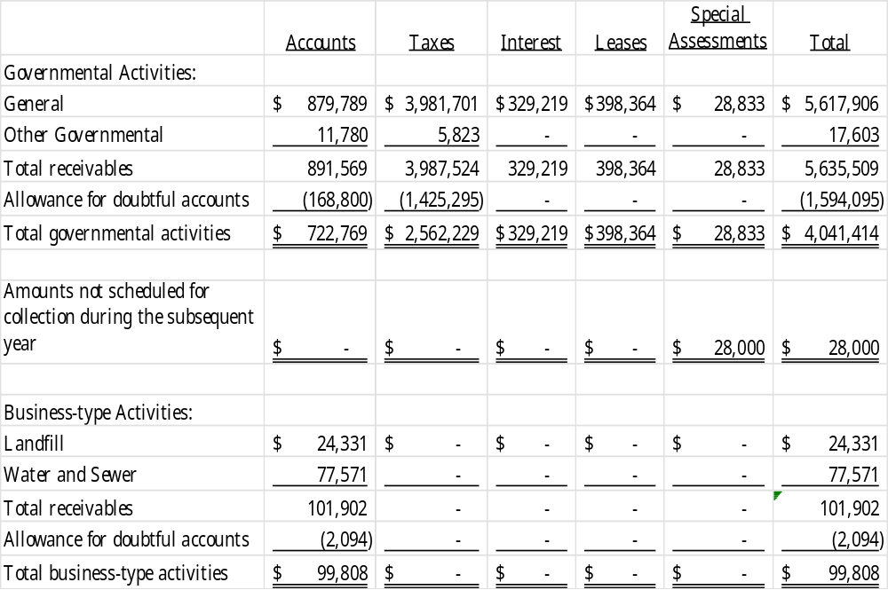

In January 2026, the County entered a lease with a local YMCA. Under the lease, the YMCA pays the County $5,000 per month for 120 months in exchange for use of the County’s parks and recreation facilities consisting of a swimming pool and gymnasium located adjacent to County Hall. There are no variable components in the lease. The lease receivable is measured as the present value of the future minimum rent payments expected to be received during the lease term at a discount rate of 8%, which is the stated rate in the agreement.

In fiscal year 2026, the County recognized $20,605 of lease revenue and $16,257 of interest revenue under the lease.

Due from other governments reported by governmental activities consists of the following:

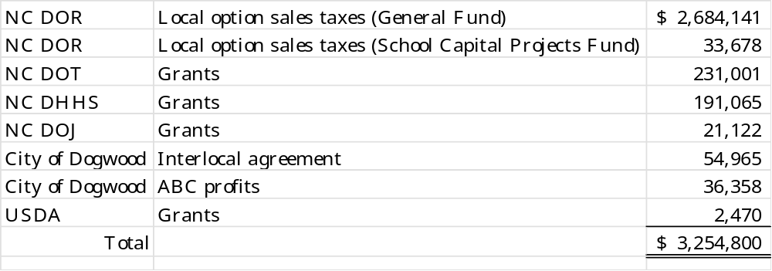

The Hospital’s accounts receivable is presented net of the allowance for uncollectible accounts of $2,388,192.

The TDA’s receivables consist of occupancy taxes from local hotels of $34,441 and sales tax refunds of $2,083 due from the North Carolina Department of Revenue. Management expects all accounts receivable to be collected; therefore, no allowance for doubtful accounts has been recorded.

- Capital Assets
Capital asset activity for the year ended June 30, 2026, was as follows:
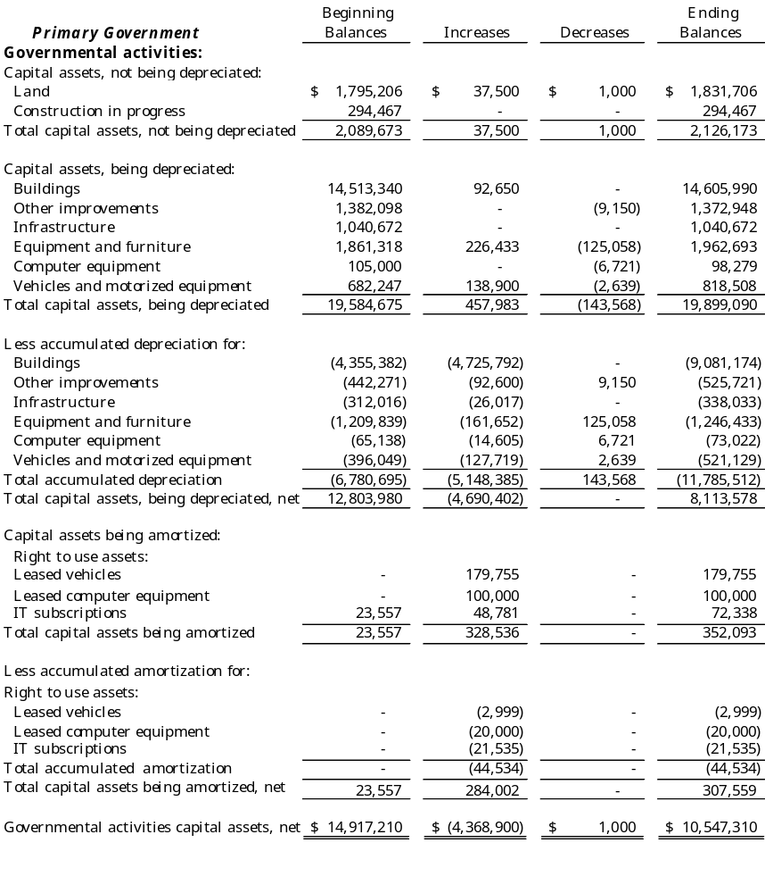
Depreciation and amortization expense was charged to functions/programs of the primary government as follows:
General government $ 292,806
General government – asset impairment 4,000,000
Public safety 370,353
Transportation -
Economic and physical development 8,006
Human services 405,649
Cultural and recreational 71,571
Total depreciation expense – governmental activities $5,148,385

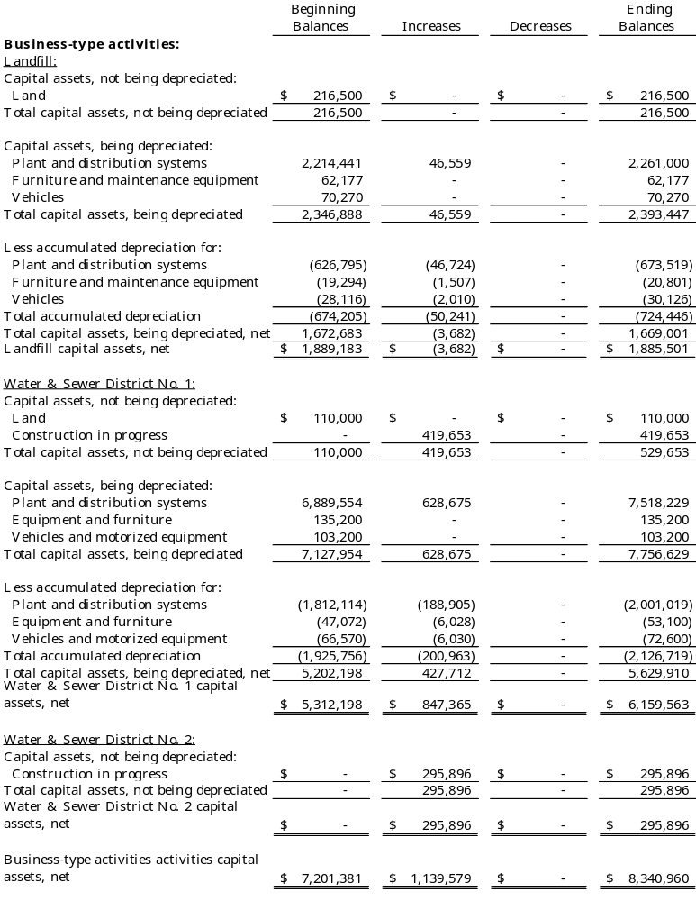

Construction commitments.

The government has active construction projects as of June 30, 2026. The projects include the Northwest project (which includes park renovations and an outdoor theatre), school construction, and water district projects. At June 30, 2026, the government’s commitments with contractors are as follows:

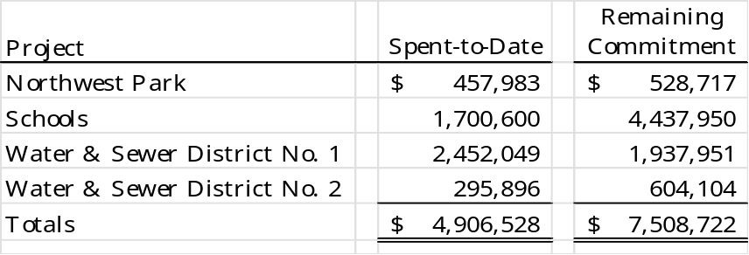

Capital Asset Impairment.

In September 2025, Hurricane Irene caused significant damage to County facilities. These assets are essential for the provision of basic services to residents and businesses.

Management evaluated the condition and service utility of the affected capital assets and determined that the impairment criteria of GASB Statement No. 42, Accounting and Financial Reporting for Impairment of Capital Assets and for Insurance Recoveries, were met. An impairment loss of $4,000,000 was recognized by increasing the accumulated depreciation of buildings in the Statement of Net Position and recording a General Government expense in the Statement of Activities for the year ended June 30, 2026.

The County has submitted applications for reimbursement under insurance coverage and to the Federal Emergency Management Agency disaster assistance programs. As of the date of issuance of these financial statements, no reimbursements have been approved or received. Claims remain under review, and future recoveries are estimated to be sufficient to restore the facilities.

Note to preparer: In Carolina County the asset impairment is classified as a program expense (depreciation in general government). For an example of treatment as an unusual or infrequent item, see the City of Dogwood financial statements.

Note to preparer: If the government is an operator in a public-private or public-public partnership and has recognized an intangible right-to-use asset under GASB Statement No. 94, disclose that asset and related amortization separately by major class of the underlying partnership asset.

Discretely presented component units.
Capital Asset activity for the ABC Board for the year ended June 30, 2026, was as follows:

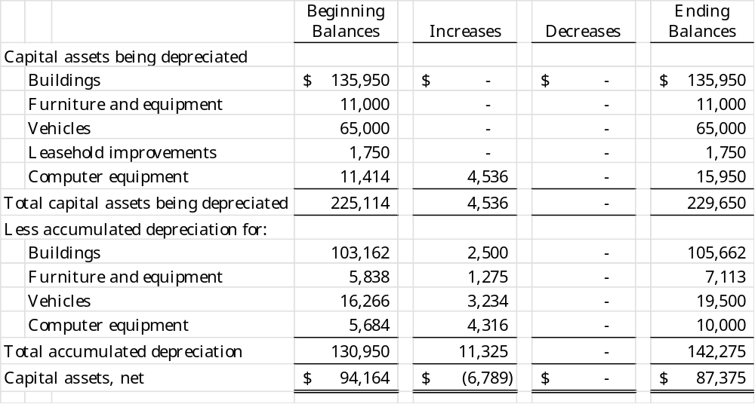

Capital Asset activity for the Hospital for the year ended September 30, 2025, was as follows:
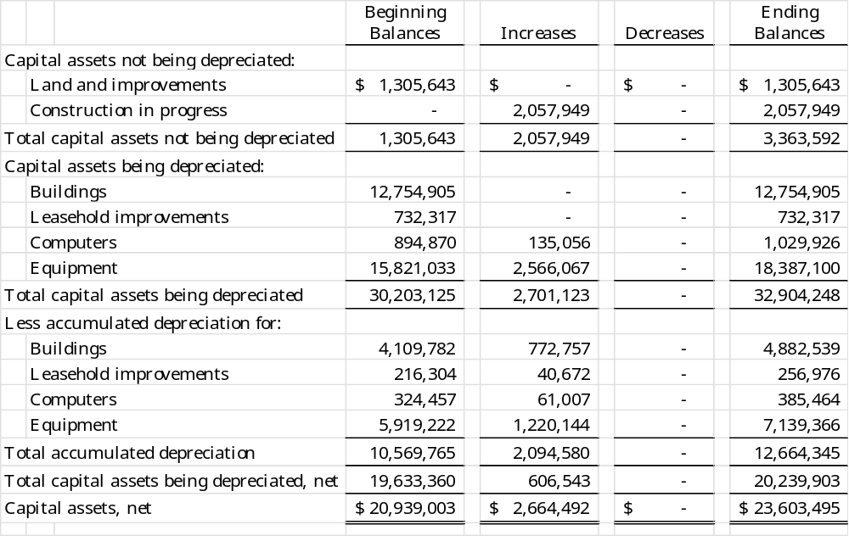

Liabilities

- Payables

Payables at the government-wide level at June 30, 2026, were as follows:
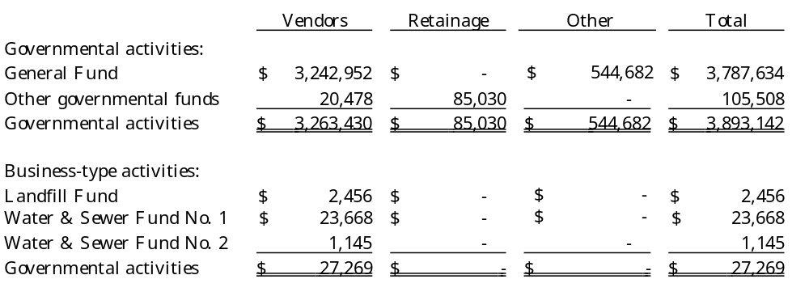
As of June 30, 2026, the Tourism Development Authority’s payables consisted of vendor payables.

Pension Plan and Other Post-Employment Obligations

Note to Preparer: The financial statement amounts for the pension liability and OPEB liability / asset presented in the updated fiscal year-end 2024 illustrative statements were not changed from the amounts presented in the prior fiscal year. Since both the pension and OPEB GASB statements were implemented and updated in the illustrative statements at least three years ago, financial statement preparers should have now had experience with them. LGC Staff is reverting to our historical practice of only changing amounts in the illustrative statements that are the result of any new accounting and reporting changes required for FYE 2025 forward.

Conversion workbooks were updated to include the current fiscal year-end Pension and OPEB data. The pension data used in development of the updated conversion workbooks was from the LGERS, ROD & TSERS JE Templates that are all available on the NC DST Pension Resources Municipalities | NC Treasurer listed by each Unit Type under Pension Resources. The Firefighters' and Rescue Squad Workers' Pension Fund disclosure amounts should be updated based upon Memo 2027-01 at State and Local Government Finance Division Memos | NC Treasurer .

- Local Governmental Employees' Retirement System

Plan Description. The County, the Hospital, and the TDA are participating employers in the statewide Local Governmental Employees’ Retirement System (LGERS), a cost- sharing multiple-employer defined benefit pension plan administered by the State of North Carolina. LGERS membership is comprised of general employees and local law enforcement officers (LEOs) of participating local governmental entities. Article 3 of G.S. Chapter 128 assigns the authority to establish and amend benefit provisions to the North Carolina General Assembly. Management of the plan is vested in the LGERS Board of Trustees, which consists of 13 members – nine appointed by the Governor, one appointed by the state Senate, one appointed by the state House of Representatives, and the State Treasurer and State Superintendent, who serve as ex-officio members. The Local Governmental Employees’ Retirement System is included in the Annual Comprehensive Financial Report for the State of North Carolina. The State’s Annual Comprehensive Financial Report includes financial statements and required supplementary information for LGERS. That report may be obtained by writing to the Office of the State Controller, 1410 Mail Service Center, Raleigh, North Carolina 27699-1410, by calling (919) 981-5454, or at www.osc.nc.gov.

Benefits Provided. LGERS provides retirement and survivor benefits. Retirement benefits are determined as 1.85% of the member’s average final compensation times the member’s years of creditable service. A member’s average final compensation is calculated as the average of a member’s four highest consecutive years of compensation. Plan members are eligible to retire with full retirement benefits at age 65 with five years of creditable service, at age 60 with 25 years of creditable service, or at any age with 30 years of creditable service. Plan members are eligible to retire with partial retirement benefits at age 50 with 20 years of creditable service or at age 60 with five years of creditable service (age 55 for firefighters). Survivor benefits are available to eligible beneficiaries of members who die while in active service or within 180 days of their last day of service and who have either completed 20 years of creditable service regardless of age (15 years of creditable service for firefighters and rescue squad members who are killed in the line of duty) or have completed five years of service and have reached age 60. Eligible beneficiaries may elect to receive a monthly Survivor’s Alternate Benefit for life or a return of the member’s contributions. The plan does not provide for automatic post-retirement benefit increases. Increases are contingent upon actuarial gains of the plan.

LGERS plan members who are LEOs are eligible to retire with full retirement benefits at age 55 with five years of creditable service as an officer, or at any age with 30 years of creditable service. LEO plan members are eligible to retire with partial retirement benefits at age 50 with 15 years of creditable service as an officer. Survivor benefits are available to eligible beneficiaries of LEO members who die while in active service or within 180 days of their last day of service and who also have either completed 20 years of creditable service regardless of age, or have completed 15 years of service as a LEO and have reached age 50, or have completed five years of creditable service as a LEO and have reached age 55, or have completed 15 years of creditable service as a LEO if killed in the line of duty. Eligible beneficiaries may elect to receive a monthly Survivor’s Alternate Benefit for life or a return of the member’s contributions.

Contributions. Contribution provisions are established by G.S. 128-30 and may be amended only by the North Carolina General Assembly. County employees are required to contribute 6% of their compensation. Employer contributions are actuarially determined and set annually by the LGERS Board of Trustees. The County’s, Hospital’s, and TDA’s contractually required contribution rate for the year ended June 30, 2026, was 13.04% of compensation for law enforcement officers and 12.10% for general employees and firefighters, actuarially determined as an amount that, when combined with employee contributions, is expected to finance the costs of benefits earned by employees during the year. Contributions to the pension plan from the County were $1,285,342 for the year ended June 30, 2026. Contributions to the pension plan from the Hospital were $1,500,000 for the year ending September 30, 2025. Contributions to the pension plan from the TDA were $8,672.

Refunds of Contributions – County, Hospital, and TDA employees who have terminated service as a contributing member of LGERS may file an application for a refund of their contributions. By state law, refunds to members with at least five years of service include 4% interest. State law requires a 60-day waiting period after service termination before the refund may be paid. The acceptance of a refund payment cancels the individual’s right to employer contributions, or any other benefit provided by LGERS.

Please see the separately issued financial report of Carolina County Hospital for a complete description of the Hospital pension plan.

Pension Liabilities, Pension Expense, and Deferred Outflows of Resources and Deferred Inflows of Resources Related to Pensions

The County
At June 30, 2026, the County reported a liability of $6,245,903 for its proportionate share of the net pension liability. The net pension liability was measured as of June 30, 2025. The total pension liability used to calculate the net pension liability was determined by an actuarial valuation as of December 31, 2024. The total pension liability was then rolled forward to the measurement date of June 30, 2025, utilizing update procedures incorporating the actuarial assumptions. The County’s proportion of the net pension liability was based on a projection of the County’s long-term share of future payroll covered by the pension plan, relative to the projected future payroll covered by the pension plan of all participating LGERS employers, actuarially determined. At June 30, 2026, the County’s proportion was .263% (measured as of June 30, 2025), which was a decrease of
.00272% from its proportion as of June 30, 2025 (measured as of June 30, 2024).

For the year ended June 30, 2026, the County recognized pension expense of $1,746,027. At June 30, 2026, the County reported deferred outflows of resources and deferred inflows of resources related to pensions from the following sources:

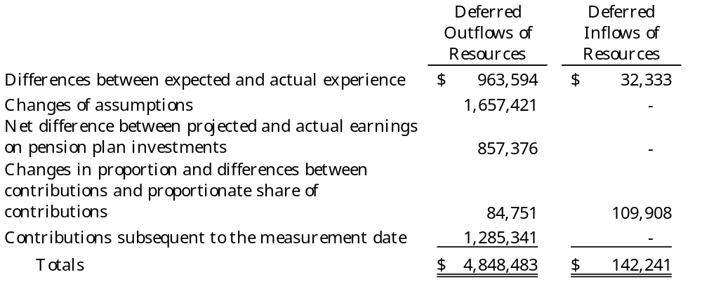

$1,285,341 reported as deferred outflows of resources related to pensions resulting from County contributions subsequent to the measurement date will be recognized as a decrease of the net pension liability in the year ended June 30, 2027. Other amounts reported as deferred outflows and inflows of resources related to pensions will be recognized in pension expense as follows:
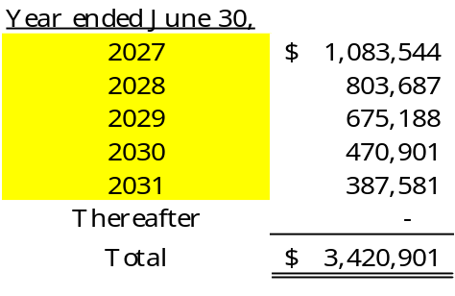
Carolina County Hospital
At September 30, 2025, the Hospital reported a liability of $1,526,802 for its proportionate share of the net pension liability. The net pension liability was measured as of June 30, 2025. The total pension liability used to calculate the net pension liability was determined by an actuarial valuation as of December 31, 2024. The total pension liability was then rolled forward to the measurement date of June 30, 2025, utilizing update procedures incorporating the actuarial assumptions. The Hospital’s proportion of the net pension liability was based on a projection of the Hospital’s long-term share of future payroll covered by the pension plan, relative to the projected future payroll covered by the pension plan of all participating LGERS employers, actuarially determined. At September 30, 2025, the Hospital’s proportion was .340%, which was a decrease of .026% from its proportion measured as of June 30, 2024.

For the year ended September 30, 2025, the Hospital recognized pension expense of $818,899. At September 30, 2025, the Hospital reported deferred outflows of resources and deferred inflows of resources related to pensions from the following sources:

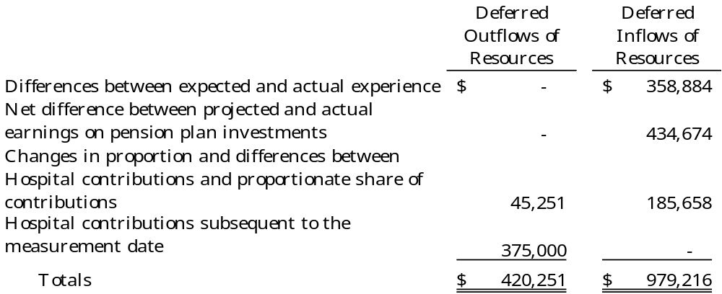

$375,000 reported as deferred outflows of resources related to pensions resulting from Hospital contributions subsequent to the measurement date will be recognized as a decrease of the net pension liability in the year ended September 30, 2026. Other amounts reported as deferred outflows and inflows of resources related to pensions will be recognized in pension expense as follows:

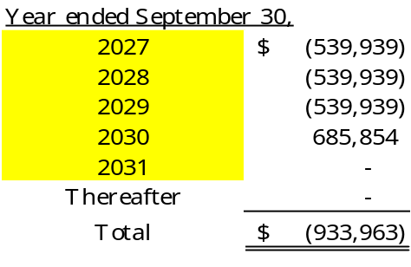

Tourism Development Authority
At June 30, 2026, the TDA reported a liability of $42,565 for its proportionate share of the net pension liability. The net pension liability was measured as of June 30, 2025. The total pension liability used to calculate the net pension liability was determined by an actuarial valuation as of December 31, 2024. The total pension liability was then rolled forward to the measurement date of June 30, 2025, utilizing update procedures incorporating the actuarial assumptions. The TDA’s proportion of the net pension liability was based on a projection of the TDA’s long-term share of future payroll covered by the pension plan, relative to the projected future payroll covered by the pension plan of all participating LGERS employers, actuarially determined. At June 30, 2026, the TDA’s proportion was .053% (measured as of June 30, 2025), which was a decrease of .0027% from its proportion as of June 30, 2025 (measured as of June 30, 2024).

For the year ended June 30, 2026, the TDA recognized pension expense of $24,045. At June 30, 2026, the TDA reported deferred outflows of resources and deferred inflows of resources related to pensions from the following sources:

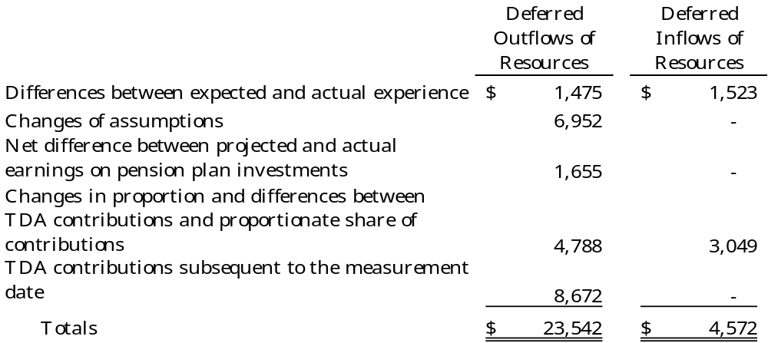

$8,672 reported as deferred outflows of resources related to pensions resulting from the TDA’s contributions subsequent to the measurement date will be recognized as a decrease of the net pension liability in the year ended June 30, 2027. Other amounts reported as deferred outflows and inflows of resources related to pensions will be recognized in pension expense as follows:

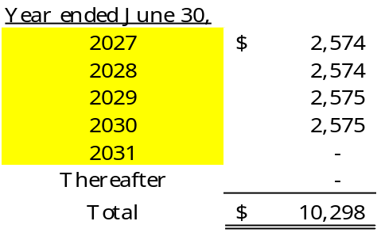

Actuarial Assumptions. The total pension liability in the December 31, 2025, actuarial valuation was determined using the following actuarial assumptions, applied to all periods included in the measurement:

Inflation 3.0%
Salary increases 3.50%
Investment rate of return 7.00%, net of pension plan investment
expense, including inflation

The plan actuary currently uses mortality rates based on the RP-2019+ Total Data Set for Healthy Annuitants Mortality Table that vary by age, gender, employee group (i.e., general, law enforcement officer) and health status (i.e., disabled and healthy). The current mortality rates are based on published tables and based on studies that cover significant portions of the U.S. population. The healthy mortality rates also contain a provision to reflect future mortality improvement.

The actuarial assumptions used in the December 31, 2025, valuation were based on the results of an actuarial experience study as of December 31, 2019.

Future ad hoc COLA amounts are not considered to be substantively automatic and are therefore not included in the measurement.

The projected long-term investment returns and inflation assumptions are developed through review of current and historical capital markets data, sell-side investment research, consultant whitepapers, and historical performance of investment strategies. Fixed income return projections reflect current yields across the U.S. Treasury yield curve and market expectations of forward yields projected and interpolated for multiple tenors and over multiple year horizons. Global public equity return projections are established through analysis of the equity risk premium and the fixed income return projections. Other asset categories and strategies’ return projections reflect the foregoing and historical data analysis. These projections are combined to produce the long-term expected rate of return by weighting the expected future real rates of return by the target asset allocation percentage and by adding expected inflation. The target allocation and best estimates of arithmetic real rates of return for each major asset class as of June 30, 2026, are summarized in the following table:

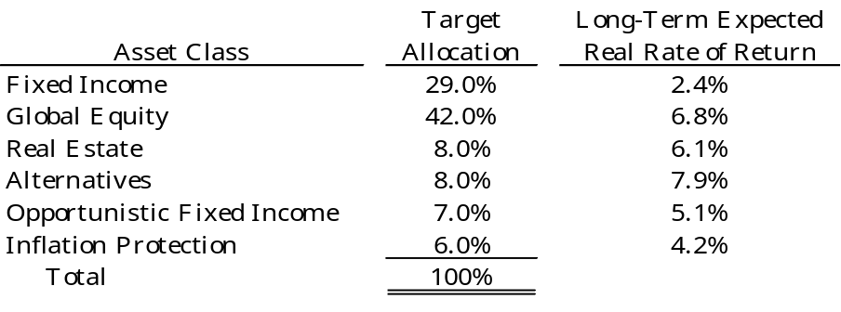

The information above is based on 30-year expectations developed with an investment consulting firm’s 2025 long term capital market assumptions. The long-term nominal rates of return underlying the real rates of return are arithmetic annualized figures. The real rates of return are calculated from nominal rates by multiplicatively subtracting a long-term inflation assumption of 2.38%. All rates of return and inflation are annualized figures. Source data is provided in the Annual Comprehensive Financial Report (ACFR) published on the NC Office of State Controller website.

Discount rate. The discount rate used to measure the total pension liability was 6.5%. The projection of cash flows used to determine the discount rate assumed that contributions from plan members will be made at the current contribution rate and that contributions from employers will be made at statutorily required rates, actuarially determined. Based on these assumptions, the pension plan’s fiduciary net position was projected to be available to make all projected future benefit payments of the current plan members. Therefore, the long-term expected rate of return on pension plan investments was applied to all periods of projected benefit payments to determine the total pension liability.

Sensitivity of the County’s proportionate share of the net pension liability to changes in the discount rate. The following presents the County’s, Hospital’s, and TDA’s proportionate shares of the net pension liability calculated using the discount rate of 7.00%, as well as what their proportionate shares of the net pension asset or net pension liability would be if it were calculated using a discount rate that is one percentage point lower (6.00%) or one percentage point higher (8.00%) than the current rate:

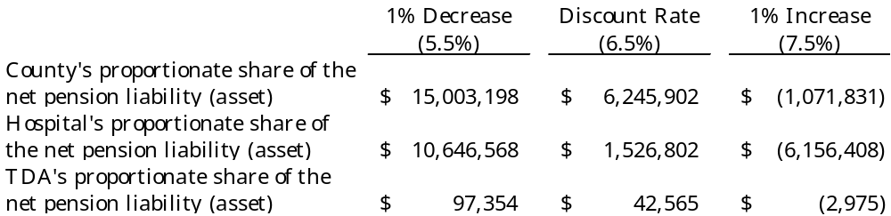

Pension plan fiduciary net position. Detailed information about the pension plan’s fiduciary net position is available in the separately issued ACFR for the State of North Carolina.

Law Enforcement Officers' Special Separation Allowance

Note to preparer: Notes for the Law Enforcement Officers’ Special Separation Allowance should be based on data specific to your unit. Assumptions, measurement dates, and other information requiring disclosure will not be uniform across all units in the state. Please refer to your actuarial valuation report for specifics for your LEOSSA note and to GASB Statement No. 73 for specific disclosure requirements.

Plan Description. Carolina County administers a public employee retirement system (the Separation Allowance), a single employer defined benefit pension plan that provides retirement benefits to the County’s qualified sworn law enforcement officers under the age of 62 who have completed at least 30 years of creditable service or have attained 55 years of age and have completed five or more years of creditable service. The Separation Allowance is equal to 0.85% of the annual equivalent of the base rate of compensation most recently applicable to the officer for each year of creditable service. Effective July 1, 2025, per Session Law 2025-8, eligible officers must make an irrevocable election for the benefit to be paid either a) based upon final salary times years of service, payable until age 62, or b) based on salary at 30 years times 30 years of service, payable for the number of years between age 30-year milestone and age 62. The retirement benefits are not subject to any increases in salary or retirement allowances that may be authorized by the General Assembly. Article 12D of G.S. Chapter 143 assigns the authority to establish and amend benefit provisions to the North Carolina General Assembly. All full-time County law enforcement officers are covered by the Separation Allowance.

At the December 31, 2025, valuation date, the Separation Allowance’s membership consisted of:

Retirees receiving benefits | 9
Terminated plan members entitled to but not yet receiving benefits | 1
Active plan members | 125
Total | 135

Summary of Significant Accounting Policies. Basis of Accounting. The County has chosen to fund the Separation Allowance on a pay as you go basis. Pension expenditures are made from the General Fund, which is maintained on the modified accrual basis of accounting. Benefits are recognized when due and payable in accordance with the terms of the plan.

The Separation Allowance has no assets accumulated in a trust that meets the criteria outlined in GASB Statement 73.

Actuarial Assumptions. The entry age actuarial cost method was used in the December 31, 2024, valuation. The total pension liability was determined using the following actuarial assumptions, applied to all periods included in the measurement:

Inflation 2.5% per annum.
Salary increases 3.254% per annum.
Discount rate 2.79% per annum, compounded annually

The discount rate is based on the yield of the S&P Municipal Bond 20 Year High Grade Rate Index as of December 31, 2025.

The actuarial assumptions used in the December 31, 2025, valuation were based on the results of an experience study completed by the Actuary for the Local Government Employees’ Retirement System for the five-year period ending December 31, 2019.

Deaths After Retirement (Healthy): Mortality rates are based on the RP-2019 Total Data Set for Healthy Annuitants Mortality Table. The RP-2019 annuitant tables have no rates prior to age 50. The RP-2019 Total Data Set Employee Mortality Table is used for ages less than 50.

Deaths After Retirement (Disabled): Mortality rates are based on the RP-2019 Total Data Set for Disabled Annuitants Mortality Table. Rates for male members are multiplied by 103% for all ages. Rates for female members are multiplied by 99% for all ages.

Deaths Before Retirement: Mortality rates are based on the RP-2019 Total Data Set Employee Mortality Table.

Mortality Projection: All mortality rates are projected from 2019 using generational improvement with Scale MP-2020.

Contributions. The County is required by Article 12D of G.S. Chapter 143 to provide these retirement benefits and has chosen to fund the amounts necessary to cover the benefits earned on a pay-as-you-go basis through appropriations made in the General Fund operating budget. There were no contributions made by employees. The County’s obligation to contribute to this plan is established and may be amended by the North Carolina General Assembly. Administration costs of the Separation Allowance are financed through investment earnings. The County paid $16,272 as benefits came due for the reporting period.

Pension Liabilities, Pension Expense, and Deferred Outflows of Resources and Deferred Inflows of Resources Related to Pensions

At June 30, 2026, the County reported a total pension liability of $222,672. The total pension liability was measured as of December 31, 2025, based on a December 31, 2024, actuarial valuation. The total pension liability was rolled forward to the measurement date of December 31, 2025, utilizing update procedures incorporating the actuarial assumptions. For the year ended June 30, 2026, the County recognized pension expense of $16,153.

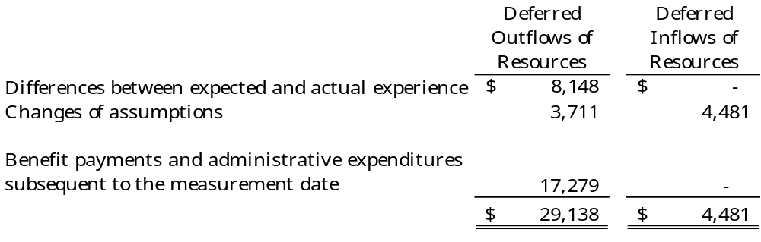

The County paid $17,279 in benefit payments subsequent to the measurement date that are reported as deferred outflows of resources related to pensions which will be recognized as a decrease of the total pension liability in the year ended June 30, 2027. Other amounts reported as deferred outflows and inflows of resources related to pensions will be recognized in pension expense as follows:

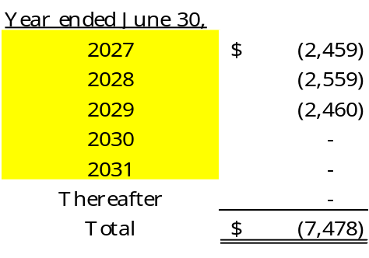
Sensitivity of the County’s total pension liability to changes in the discount rate. The following presents the County’s total pension liability calculated using the discount rate of 2.79%, as well as what the County’s total pension liability would be if it were calculated using a discount rate that is one percentage point lower (1.79%) or one percentage point higher (3.79%) than the current rate:

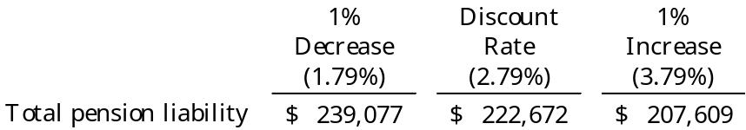

Schedule of Changes in Total Pension Liability, Law Enforcement Officers' Special Separation Allowance
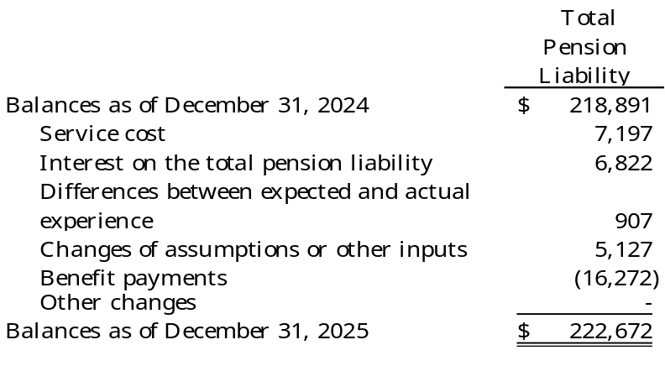

Changes of assumptions. Changes of assumptions and other inputs reflect a change in the discount rate from 2.85% at June 30, 2023, (measurement date) to 2.79% at June 30, 2025 (measurement date).

Changes in Benefit Terms. Reported compensation adjusted to reflect the assumed rate of pay as of the valuation date.

The plan currently uses mortality tables that vary by age, and health status (i.e., disabled and healthy). The current mortality rates are based on published tables and based on studies that cover significant portions of the U.S. population. The healthy mortality rates also contain a provision to reflect future mortality improvements.

The actuarial assumptions used in the December 31, 2025, valuation were based on the results of an actuarial experience study as of December 31, 2024.

Supplemental Retirement Income Plan for Law Enforcement Officers

Plan Description. The County contributes to the Supplemental Retirement Income Plan (Plan), a defined contribution pension plan administered by the Department of State Treasurer and a Board of Trustees. The Plan provides retirement benefits to law enforcement officers employed by the County. Article 5 of G.S. Chapter 135 assigns the authority to establish and amend benefit provisions to the North Carolina General Assembly. The Supplemental Retirement Income Plan for Law Enforcement Officers is included in the Annual Comprehensive Financial Report (ACFR) for the State of North Carolina. The State’s ACFR includes the pension trust fund financial statements for the Internal Revenue Code Section 401(k) plan that includes the Supplemental Retirement Income Plan for Law Enforcement Officers. That report may be obtained by writing to the Office of the State Controller, 1410 Mail Service Center, Raleigh, North Carolina 27699-1410, by calling (919) 981-5454, or at www.osc.nc.gov..

Funding Policy. Article 12E of G.S. Chapter 143 requires the County to contribute each month an amount equal to 5% of each officer's salary, and all amounts contributed are vested immediately. Also, the law enforcement officers may make voluntary contributions to the plan.

The County contributed $20,000 for the reporting year. No amounts were forfeited.

Note to preparer: If a local government or public authority has elected to contribute to the Supplemental Retirement Income Plan for general employees as well as for law enforcement officers, that information should be disclosed here.

Registers of Deeds' Supplemental Pension Fund

Plan Description. Carolina County also contributes to the Registers of Deeds' Supplemental Pension Fund (RODSPF), a noncontributory cost-sharing multiple-employer defined benefit plan administered by the North Carolina Department of State Treasurer. RODSPF provides supplemental pension benefits to any eligible county register of deeds who is retired under the Local Government Employees' Retirement System (LGERS) or an equivalent locally sponsored plan. Article 3 of G.S. Chapter 161 assigns the authority to establish and amend benefit provisions to the North Carolina General Assembly. Management of the plan is vested in the LGERS Board of Trustees, which consists of 13 members – nine appointed by the Governor, one appointed by the state Senate, one appointed by the state House of Representatives, and the State Treasurer and State Superintendent, who serve as ex-officio members. The Registers of Deeds’ Supplemental Pension Fund is included in the Annual Comprehensive Financial Report (ACFR) for the State of North Carolina. The State’s ACFR includes financial statements and required supplementary information for the Resisters of Deeds’ Supplemental Pension Fund. That report may be obtained by writing to the Office of the State Controller, 1410 Mail Service Center, Raleigh, North Carolina 27699-1410, by calling (919) 981-5454, or at www.osc.nc.gov.

Benefits Provided. An individual’s benefits for the year are calculated as a share of accumulated contributions available for benefits for that year, subject to certain statutory limits. An individual’s eligibility is based on at least 10 years of service as a register of deeds with the individual’s share increasing with years of service. Because of the statutory limits noted above, not all contributions available for benefits are distributed.

Contributions. Benefits and administrative expenses are funded by investment income and 1.5% of the receipts collected by each County Commission under Article 1 of G.S. Chapter 161. The statutory contribution currently has no relationship to the actuary’s required contribution. The actuarially determined contribution this year and for the foreseeable future is zero. Registers of Deeds do not contribute. Contribution provisions are established by G.S. 161-50 and may be amended only by the North Carolina General Assembly. Contributions to the pension plan from the County were $4,000 for the year ended June 30, 2026.

Pension Liabilities, Pension Expense, and Deferred Outflows of Resources and Deferred Inflows of Resources Related to Pensions. At June 30, 2026, the County reported an asset of $76,023 for its proportionate share of the net pension asset. The net pension asset was measured as of June 30, 2025. The total pension liability used to calculate the net pension asset was determined by an actuarial valuation as of December 31, 2024. The total pension liability was then rolled forward to the measurement date of June 30, 2025, utilizing update procedures incorporating the actuarial assumptions. The County’s proportion of the net pension asset was based on the County’s share of contributions to the pension plan, relative to contributions to the pension plan of all participating RODSPF employers. At June 30, 2025, the County’s proportion was 0.46%, which was a decrease of .004% from its proportion measured as of June 30, 2024.

For the year ended June 30, 2026, the County recognized pension expense of $12,186. At June 30, 2026, the County reported deferred outflows of resources and deferred inflows of resources related to pensions from the following sources:

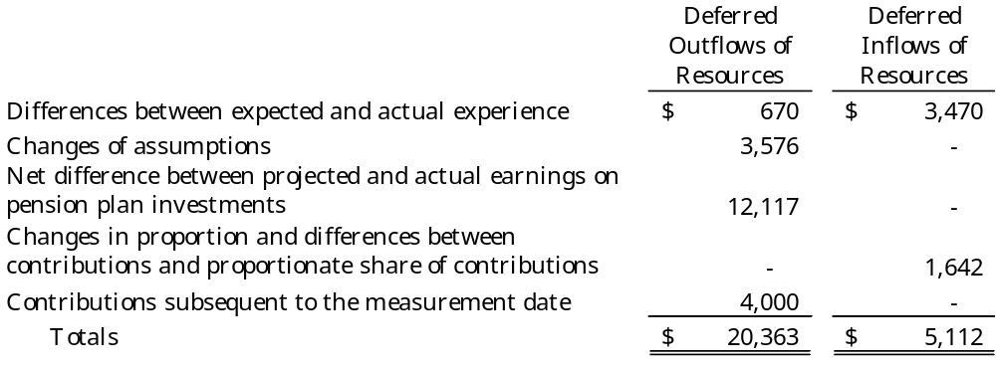
$4,000 reported as deferred outflows of resources related to pensions resulting from County contributions subsequent to the measurement date will be recognized as an increase of the net pension asset in the year ended June 30, 2027.
Other amounts reported as deferred outflows and inflows of resources related to pensions will be recognized in pension expense as follows:

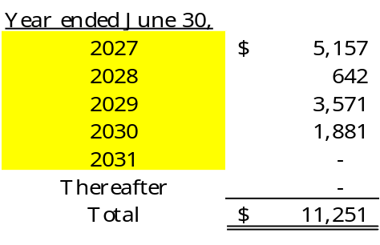
Actuarial Assumptions. The total pension liability in the December 31, 2024, actuarial valuation was determined using the following actuarial assumptions, applied to all periods included in the measurement:

Inflation 3.0%
Salary increases 3.50 to 7.75%, including inflation and productivity factor
Investment rate of return 3.75%, net of pension plan investment
expense, including inflation

The plan currently uses mortality tables that vary by age, gender, employee group (i.e., general, law enforcement officer) and health status (i.e., disabled and healthy). The current mortality rates are based on published tables and based on studies that cover significant portions of the U.S. population. The healthy mortality rates also contain a provision to reflect future mortality improvements.

The actuarial assumptions used in the December 31, 2024, valuation were based on the results of an actuarial experience study as of December 31, 2021.

Future ad hoc COLA amounts are not considered to be substantively automatic and are therefore not included in the measurement.

The projected long-term investment returns and inflation assumptions are developed through review of current and historical capital markets data, sell-side investment research, consultant whitepapers, and historical performance of investment strategies. Fixed income return projections reflect current yields across the U.S. Treasury yield curve and market expectations of forward yields projected and interpolated for multiple tenors and over multiple year horizons. These projections are combined to produce the long-term expected rate of return by weighting the expected future real rates of return by the target asset allocation percentage and by adding expected inflation. The adopted asset allocation policy for the RODSPF is 100% in the fixed income asset class (BIF). The best estimate of arithmetic real rate of return for the fixed income asset class as of June 30, 2026, is 0.9%.

The information above is based on 30-year expectations developed with the consulting actuary for the 2022 asset, liability, and investment policy study for the North Carolina Retirement Systems, including LGERS. The long-term nominal rates of return underlying the real rates of return are arithmetic annualized figures. The real rates of return are calculated from nominal rates by multiplicatively subtracting a long-term inflation assumption of 3.00%. All rates of return and inflation are annualized.

Discount rate. The discount rate used to measure the total pension liability was 3.75%. The projection of cash flows used to determine the discount rate assumed that System contributions will continue to follow the current funding policy. Based on those assumptions, the System’s fiduciary net position was projected to be available to make all projected future benefit payments of current plan members. Therefore, the long-term expected rate of return on pension plan investments was applied to all periods of projected benefit payments to determine the total pension liability.

Sensitivity of the County’s proportionate share of the net pension asset to changes in the discount rate. The following presents the County’s proportionate share of the net pension asset calculated using the discount rate of 3.75%, as well as what the County’s proportionate share of the net pension asset would be if it were calculated using a discount rate that is one percentage point lower (2.75%) or one percentage point higher (4.75%) than the current rate:

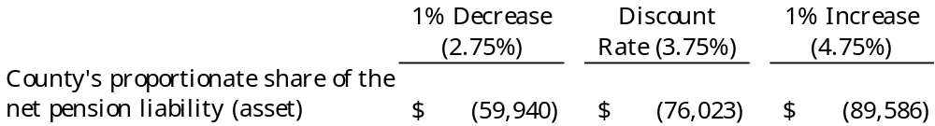

Pension plan fiduciary net position. Detailed information about the pension plan’s fiduciary net position is available in the separately issued ACFR for the State of North Carolina.

Pension Liabilities (Assets), Pension Expense, and Deferred Outflows of Resources and Deferred Inflows of Resources Related to Pensions

The net pension liability (asset) for LGERS and ROD was measured as of June 30, 2025, and the total pension liability used to calculate the net pension liability (asset) was determined by an actuarial valuation as of December 31, 2024. The total pension liability for LEOSSA was measured as of June 30, 2025, with an actuarial valuation date of December 31, 2024.

The County’s proportion of the net pension liability was based on the County’s share of contributions to the pension plan relative to the contribution of all participating entities. Following is information related to the proportionate share and pension expense:

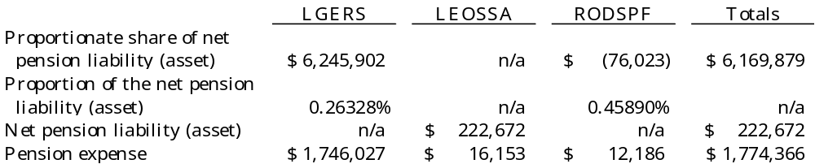

At June 30, 2026, the County reported deferred outflows of resources and deferred inflows of resources related to pensions from the following sources:

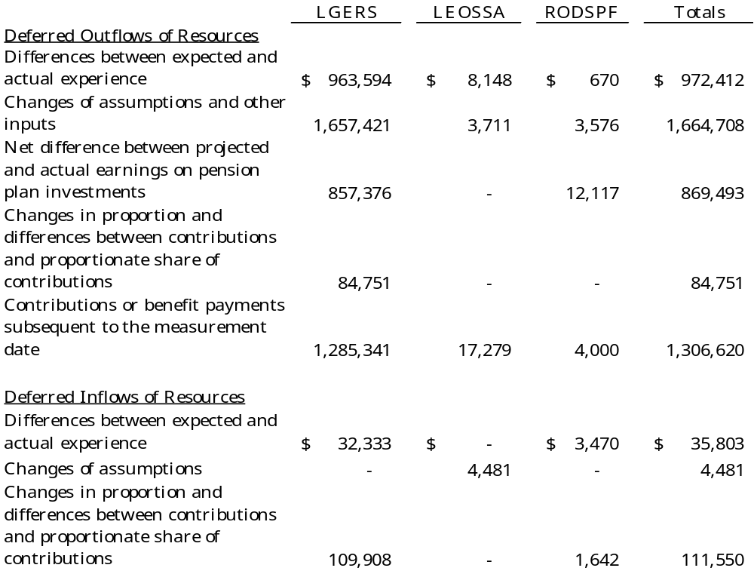

Other Post-Employment Benefit

Note to preparer: Notes for the OPEB plan should be based on data specific to your unit. Assumptions, measurement dates, and other information requiring disclosure will not be uniform across all units in the state. Please refer to GASB Statement No. 75 for specific disclosure requirements. If the plan issues a separate, stand-alone report, GASB Statement No. 75 disclosures are not required to be presented here, and information indicating where and how that report is available should be disclosed.

Please note that disclosures for both the plan and employer reporting have been included and that there are different measurement dates for each. Please ensure that note disclosures in your audit report reflect details that are provided in your valuation and are specific to your plan. If the plan issues a stand-alone report, plan disclosures are not required.

Note to preparer: The following note disclosure presents Carolina County’s partially funded healthcare benefits post-employment benefit plan. Each local government has unique parameters based on its Board-approved benefits, the participation by its members, the plan’s funding, etc. Therefore, it must be tailored for the unique criteria of each local government’s plan. Please note if your funding is in a pool not registered with the SEC (i.e., the State Treasurer OPEB Fund), you must disclose in your accounting policies for Deposits and Investments a brief description of any regulatory oversight for the pool and whether the fair value of the position in the pool is the same as the value of pool shares.
Units that pay-as-you-go calculated by a professional actuary should use the format as presented in the City of Dogwood’s note disclosures. Units that pay-as-you-go calculated by the alternative method should consult GASB Statement No. 75’s Illustration 5. Please note that fiduciary statements will not be applicable under the pay-as-you-go method.

Plan Description. Under a County resolution, Carolina County administers the HCB Plan, a single employer defined benefit plan that is used to provide post-employment benefits other than pensions (OPEB) for all retirees of the County who participate in the LGERS and have at least ten years of creditable service with the County. Retirees hired prior to July 1, 2007, receive the same benefits as active employees. The HCB Plan is available to qualified retirees until the age of 65 or until Medicare eligible, whichever is sooner. As of July 1, 2007, the plan has been closed to new entrants. The plan, which has a June 30, 2026, year-end, does not issue a stand-alone report. Management of the HCB Plan is vested in the Board of Commissioners. The HCB Plan and irrevocable trust are a blended component unit, accounted for as a Pension Trust Fund. Significant accounting policies are disclosed in Note I.D and investment disclosures and the AGPIP are in Note IV.A.2.

Plan membership. At June 30, 2026, the HCB Plan membership consisted of the following:

Inactive plan members or beneficiaries
currently receiving benefit payments 22
Inactive plan members entitled to but not yet
receiving benefit payments 4
Active plan members 54
80

Benefits provided. The HCB Plan provides healthcare benefits for retirees. The County pays a percentage of the cost of coverage for employees’ benefits through private insurers. Employees hired on or after July 1, 2007, are required to participate in a Retirement Health Savings Plan (RHSP) which provides a means for employees to save money for future withdrawals to pay qualified health care expenses.

Note to preparer: Please include specific details regarding who is and who is not covered under the plan, any employer cap to contributions, when or if Medicare assumes coverage, what benefits are included, etc.

Contributions. The Board of Commissioners established the contribution requirements of plan members which may be amended by the Board. The Board establishes rates based on an actuarially determined rate. For the years ended June 30, 2025, and June 30, 2026, the County contributed $800 per active employee. Plan members contribute to the plan based on number of years of creditable service. The County’s contribution is dependent on the employee’s number of years of creditable service. Retirees pay a monthly premium of $350 with up to ten years of creditable service and $175 with ten to twenty years of creditable service. Retirees with more than twenty years of creditable service do not contribute to the plan. The Board of Commissioners may amend the benefit provisions.

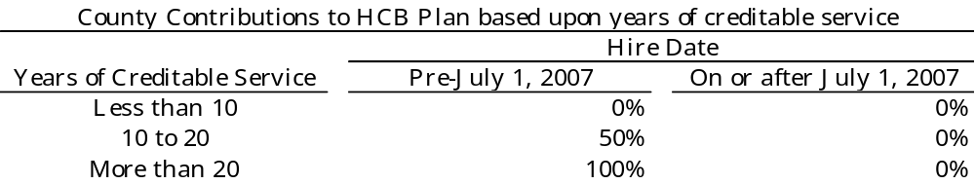

Per a County resolution, the County is required to contribute the projected pay-as-you-go financing requirements, with an additional amount to prefund benefits as determined annually by the Board. For the current year, the County contributed $43,000. The Fund is accounted for as a trust fund.

Investments. The HCB Plan’s policy regarding the allocation of invested assets is established and may be amended by the Board of Commissioners by a majority vote of its members. It is the policy of the Board to pursue an investment strategy that reduces risk through the prudent diversification of the portfolio across a broad selection of distinct asset classes. The HCB Plan discourages the use of cash equivalents, except for liquidity purposes, and aims to refrain from dramatically shifting asset class allocations over short time spans. Investments are valued at fair value. Long-term expected rates of return are not provided by the AGPIP. The following was the target asset allocation policy and the actual asset allocation for each AGPIP investment as of June 30, 2026:

Target Allocation Actual Allocation
Equity Index Fund 55% 60%
Bond Index Fund 25% 22%
STIF Fund 20% 18%

For the year ended June 30, 2026, the annual money-weighted rate of return on investments, net of investment expense, was 4%. The money-weighted rate of return expresses investment performance, net of investment expense, adjusted for the changing amounts actually invested.

The components of the net OPEB liability of the County at June 30, 2026, were as follows:

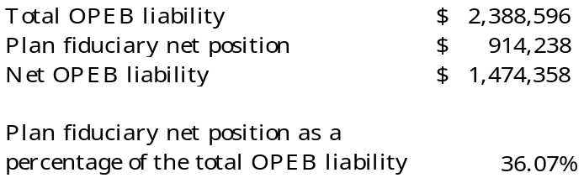

Actuarial assumptions. The total OPEB liability was determined by an actuarial valuation as of December 31, 2025, using the following actuarial assumptions:

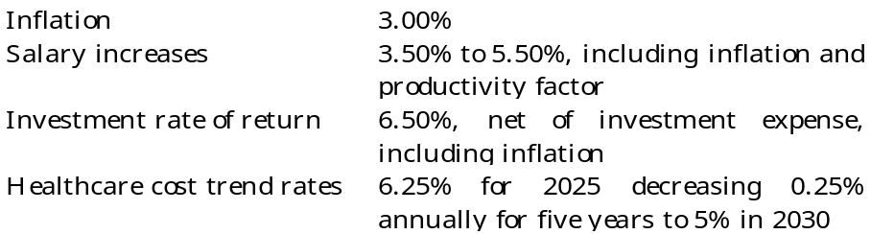

Total OPEB liabilities were rolled forward to June 30, 2026, for the employer and the plan, respectively, utilizing update procedures incorporating the actuarial assumptions.

Mortality rates were based on the RP-2019 Healthy Annuitant base rates projected to the valuation date using MP-2021, projected forward generationally from the valuation date using MP-2021. For general employees, rates are adjusted by 108% (male) and 81% (female) for ages under 78 and by 124% (male) and 113% (female) for age 78 and older. For law enforcement officers, rates are adjusted by 100% for males and 100% for females.

The actuarial assumptions used in the December 31, 2025, valuations were based on the results of an actuarial experience study for the period 2015-2019.

Long-term Expected Rate of Return. An expected rate of return was not provided for the asset profile. The average annual rate of return for the portfolio from inception through June 20, 2026, was 8.18%. The money-weighted rate of return for the year ended June 30, 2026, was 7.71%. The actual return was adjusted to 6.50% based upon the County’s expectation of a long-term rate of return using portfolio performance adjusted by an inflation assumption based upon a LGERS survey.

Discount rate. The discount rate used to measure the total OPEB liability at June 30, 2026, was 6.50% which was a change from the discount rate of 3.87% at June 30, 2025. However, because the OPEB plan’s fiduciary net position was not projected to be sufficient to make all future benefit payments, the discount rate incorporates a municipal bond rate which was 2.79% at June 30, 2026, per the S&P Municipal Bond 20 Year High Grade Rate Index. As of June 30, 2026, the S&P Municipal Bond 20 Year High Grade rate was 2.98%.

Sensitivity of the net OPEB liability to changes in the discount rate. At June 30, 2026, the following represents the net OPEB liability of the County as well as what the County’s net OPEB liability would be if it were calculated using a discount rate that is one percentage point lower (5.50%) or one percentage point higher (7.50%) than the current discount rate:

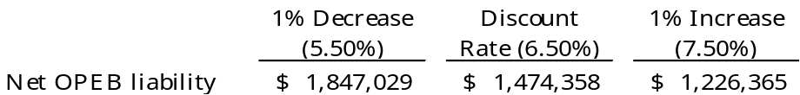

Sensitivity of the net OPEB liability to changes in the healthcare cost trend rates. The following presents the net OPEB liability of the County at June 30, 2026, as well as what the County’s net OPEB liability would be if it were to calculate healthcare cost trend rates that are one percentage point lower (5.25% decreasing to 5%) or one percentage point higher (7.25% decreasing to 5%) than the current healthcare cost trend rate:

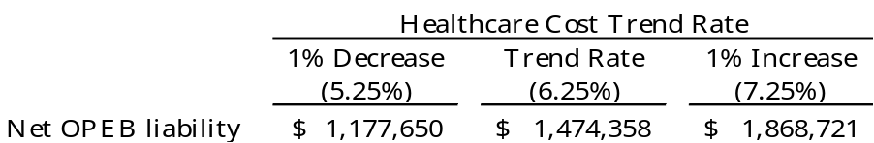

Changes in Net OPEB Liability, OPEB Expense and Deferred Outflows of Resources and Deferred Inflows of Resources Related to OPEB. At June 30, 2026, the County reported a net OPEB liability of $1,474,358. The total OPEB liability was determined by an actuarial valuation as of December 31, 2024. The total pension liability was then rolled forward to the measurement date of June 30, 2025, utilizing update procedures incorporating the actuarial assumptions.

At June 30, 2026, the components of the net OPEB liability of the County, measured as of June 30, 2025, were as follows:
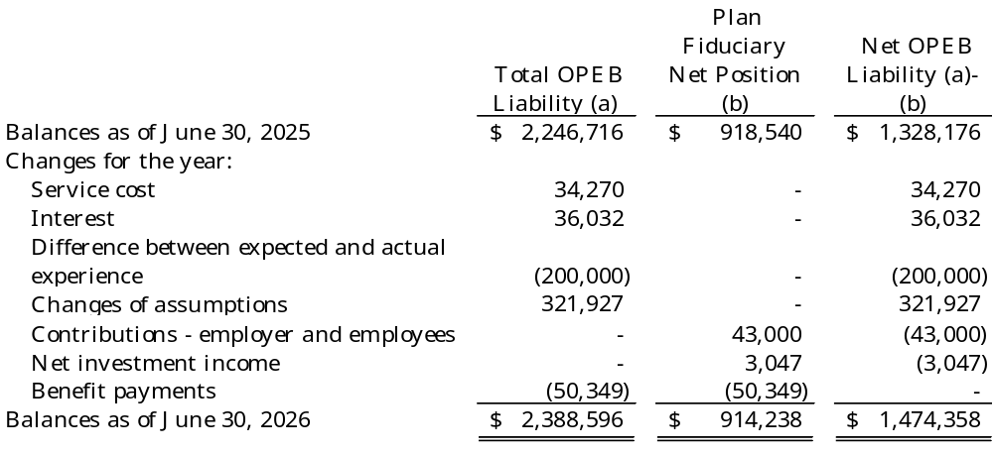

Changes of assumptions. Changes of assumptions and other inputs reflect a change in the discount rate from 3.87% in 2022 to 6.50% in 2023. Medical claims cost and rates were changed based on most recent experience and changed to the current schedule. The Excise Tax of 40% on health care plans that are above the thresholds set by the Affordable Care Act are effective in 2024 and have been reflected.

For the year ended June 30, 2026, the County recognized OPEB expense of $66,767. At June 30, 2026, the County reported deferred outflows of resources and deferred inflows of resources related to OPEB from the following sources:

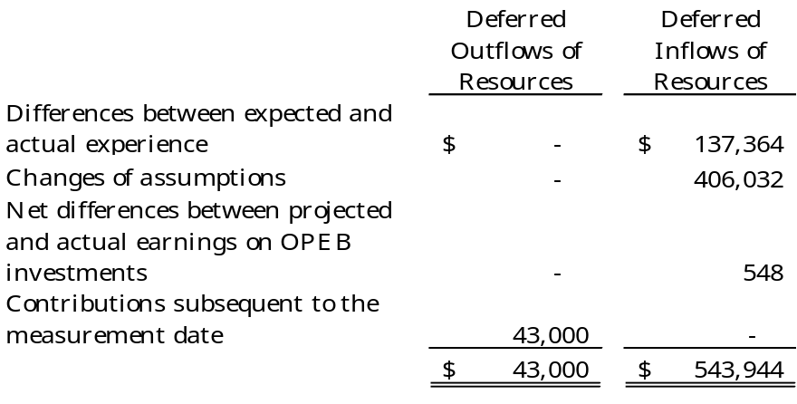

$43,000 reported as deferred outflows of resources related to OPEB resulting from County contributions subsequent to the measurement date will be recognized as a decrease in the net OPEB liability in the year ended June 30, 2027.

Other amounts reported as deferred outflows and inflows of resources related to OPEB will be recognized in OPEB expense as follows:

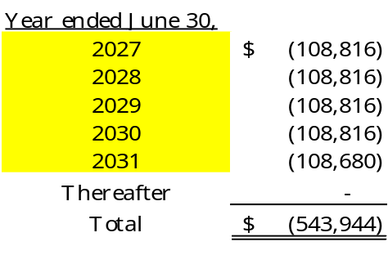

Note to preparer: Carolina County has only one OPEB benefit. For units with multiple OPEB benefits, please provide the necessary required disclosures for each plan. Disclosures that are common to both plans should be reported to avoid unnecessary duplication.

Other Employment Benefits

Note to preparer: Please move employment benefits out from under the “Other Post-Employment Benefit” section to avoid confusion with the implementation of GASB Statement No. 74, Financial Reporting for Postemployment Benefit Plans Other Than Pension Plans, and Statement 45, Accounting and Financial Reporting by Employers for Postemployment Benefits Other Than Pensions. This section will include benefits that primarily are available only to active employees (e.g., death benefits, short-term and long- term disability benefits, etc.).

The County has elected to provide death benefits to employees through the Death Benefit Plan for members of the Local Governmental Employees' Retirement System (Death Benefit Plan), a multiple-employer, State-administered, cost-sharing plan funded on a one-year term cost basis. The beneficiaries of those employees who die in active service after one year of contributing membership in the System, or who die within 180 days after retirement or termination of service and have at least one year of contributing membership service in the System at the time of death are eligible for death benefits. Lump sum death benefit payments to beneficiaries are equal to the employee's 12 highest months’ salary in a row during the 24 months prior to the employee's death, but the benefit will be a minimum of $25,000 and will not exceed $50,000. Because all death benefit payments are made from the Death Benefit Plan and not by the County, the County does not determine the number of eligible participants. The County has no liability beyond the payment of monthly contributions. The contributions to the Death Benefit Plan cannot be separated between the post-employment benefit amount and the other benefit amount. Contributions are determined as a percentage of monthly payroll based upon rates established annually by the State. Separate rates are set for employees not engaged in law enforcement and for law enforcement officers. The County considers these contributions to be immaterial.

Note to preparer: In the disclosure above, the Local Government Employees’ Retirement System (LGERS) was the only group-term life insurance provided to an employee. This insurance has a maximum limit of $50,000. If your unit provides additional group-term life insurance, please include a description of the policy in the above note. In addition, please note that the benefits in excess of $50,000 are considered taxable to the employee as a fringe benefit. Please see Memorandum #1048 for further discussion.

Carolina County Hospital Pension Plan

Please see the separately issued financial report of the Hospital for a complete description of the Hospital pension plan.

Deferred Outflows and Inflows of Resources

Following are the deferred outflows of resources that are reported in the government-wide financial statements at June 30, 2026:

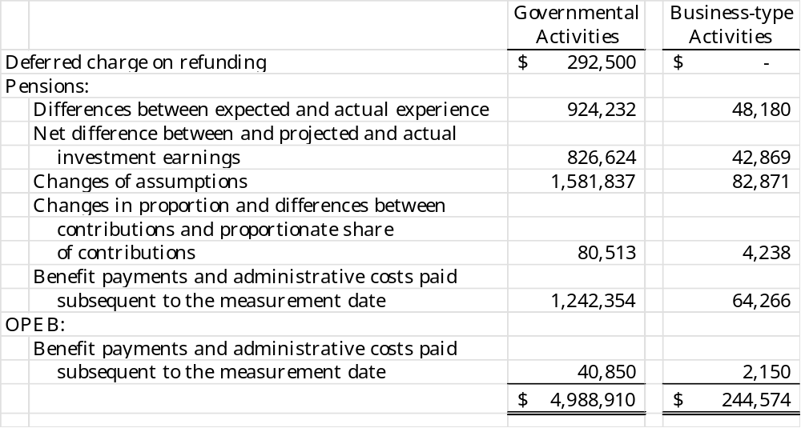

Following are the deferred inflows of resources that are reported in the government-wide financial statements at June 30, 2026:

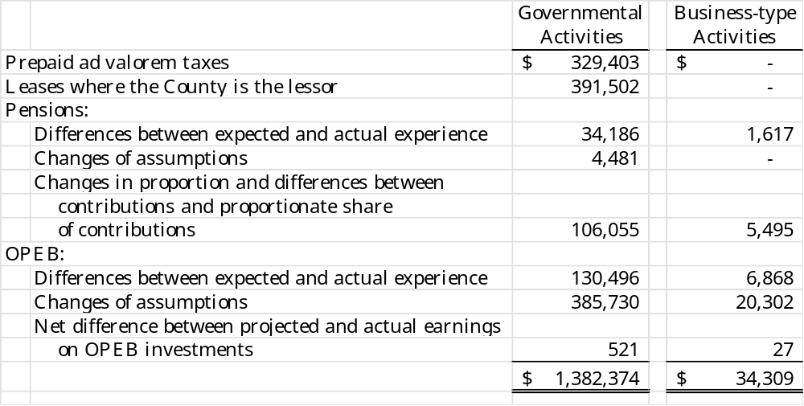

Following are the deferred inflows of resources that are reported in the governmental fund financial statements at June 30, 2026:

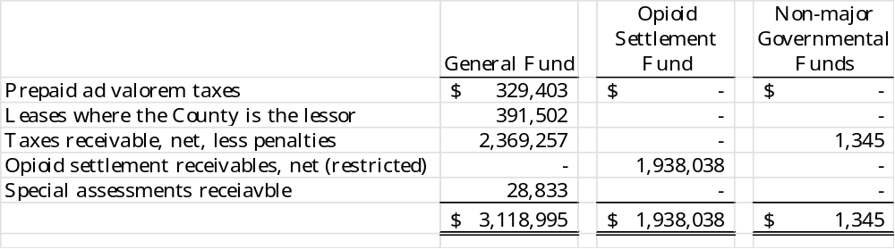

Note to preparer: The deferred inflows of financial resources resulting from the taxes receivable amount does not include the portion related to penalties levied on the ad valorem taxes. Penalties should be remitted to the local educational agency (LEA). These penalties will not be due to the LEA until received, therefore, they should not be included in deferred inflows of resources. When cash is finally received for these penalties, it will immediately be set aside for the LEA in the Fines and Forfeitures Special Revenue Fund. Please refer to Memorandum #1060 for more background.

Closure and Postclosure Care Costs - Wingate Drive Landfill Facility

State and federal laws and regulations require the County to place a final cover on its Wingate Drive Landfill Facility when it stops accepting waste and to perform certain maintenance and monitoring functions at the site for thirty years after closure. Although closure and postclosure care costs will be paid only near or after the date the landfill stops accepting waste, the County reports a portion of these closure and postclosure care costs as an operating expense in each period based on landfill capacity used as of each balance sheet date. The $226,058 reported as landfill closure and postclosure care liability at June 30, 2026, represents a cumulative amount reported to date based on the use of 17% of the total estimated capacity of the landfill. The County will recognize the remaining estimated cost of closure and postclosure care of $1.2 million as the remaining estimated capacity is filled. These amounts are based on what it would cost to perform all closure and post closure care in 2026. The County expects to close the Wingate Drive facility in the year 2052. Actual costs may be higher due to inflation, changes in technology, or changes in regulations.

The County has met the requirements of a local government financial test that is one option under State and federal laws and regulations that help determine if a unit is financially able to meet closure and postclosure care requirements. However, the County has also elected to establish a reserve fund to accumulate resources for the payment of closure and postclosure care costs. A transfer of $65,000 was made to the Landfill Closure and Postclosure Reserve Fund during the fiscal year ended June 30, 2026, and those funds are held in investments with a cost of $65,000 (market value, $65,000) at year-end. The County expects that future inflation costs will be paid from the interest earnings on these annual contributions. However, if interest earnings are inadequate or additional postclosure care requirements are determined (due to changes in technology or applicable laws or regulations, for example), these costs may need to be covered by charges to future landfill users or by future tax revenues.

Risk Management

The County is exposed to various risks of losses related to torts; theft of, damage to, and destruction of assets; errors and omissions; injuries to employees; and natural disasters. The County participates in two self-funded risk-financing pools administered by the North Carolina Association of County Commissioners. Through these pools, the County obtains property coverage equal to replacement cost values of owned property subject to a limit of $200 million for any one occurrence, general, auto, professional, and employment practices liability coverage of $2 million per occurrence, auto physical damage coverage for owned autos at actual cash value, crime coverage of $250,000 per occurrence, and workers' compensation coverage up to the North Carolina statutory limits. Additional sub-limits are $10,000,000 for earthquakes and $50,000,000 per named storm. The pools are audited annually by certified public accountants, and the audited financial statements are available to the County upon request. Both pools are reinsured through a multi-state public entity captive for single occurrence losses in excess of a $500,000 retention up to a $2 million limit for liability coverage and $1,750,000 of each loss in excess of a $250,000 per occurrence retention for property and auto physical damage. For workers’ compensation there is a per occurrence retention of $750,000. The County provides employee health and dental benefits through a self-insured plan provided by Dogwood Insurance Company (DIC). Claims are administered and paid directly from the plan by DIC. Specific stop-loss is set at $100,000 per individual health insurance claim with an unlimited lifetime maximum. Aggregate stop-loss is set at the level of 125% with a minimum aggregate attachment point of $6,516,502 and a contract period maximum of $1,000,000.

The County carries flood insurance through the National Flood Insurance Plan (NFIP). Because the County is in an area of the State that has been mapped and designated an “A” area (an area close to a river, lake, or stream) by the Federal Emergency Management Agency, the County is eligible to purchase coverage of $500,000 per structure through the NFIP. The County also is eligible to and has purchased commercial flood insurance for another $3,500,000 of coverage per structure.

In accordance with G.S. 159-29, County employees who have access to $100 or more of the County’s funds at any given time are performance bonded through a commercial surety bond. The Director of Finance is individually bonded for $1,000,000. The remaining employees who have access to funds are bonded under a blanket bond for $250,000.

Note to preparer: The carrying of a performance bond of the Finance Officer’s position and a blanket bond for all others who have access to the local government’s assets in excess of $100 is required by G.S. 159-29. Please disclose the amounts of the fidelity bond and blanket bond separately. In cases in which the Finance Officer serves as finance officer for two separate entities (a County and a Tourism Development Authority, for example), each unit should have assurance that it is protected in the case of finance officer impropriety. See Memorandum #2014-08: Operation of and Accounting for Discretely Presented Component Units, Including Tourism Development Authorities for further guidance.

The County carries commercial coverage for all other risks of loss. There have been no significant reductions in insurance coverage from the previous year and settled claims have not exceeded coverage in any of the past three fiscal years. Carolina County Hospital is exposed to various risks of loss related to torts; theft of, damage to, and destruction of assets; errors and omissions; injuries to employees; natural disasters; and medical malpractice. The Hospital carries commercial insurance for these risks of loss. There have been no significant reductions in insurance coverage from the previous year and settled claims have not exceeded coverage in any of the past three fiscal years.

Note to Preparer: Per GASB Statement 102 (see Memorandum #2026-03 at State and Local Government Finance Division Memos for an explanation and example disclosures) disclosures may be needed for a concentration related to a significant inflow or outflow such as the largest taxpayer ceasing operations, discussing its anticipated revenue effects upon the County. Disclosures may be needed for constraints, such as the anticipated costs and customer rate effect upon a water and sewer system for new environmental laws. A disclosure is required if all of the following are true: 1) if a concentration or constraint is known to a unit prior to issuance of the financial statements; 2) if the concentration or constraint makes the unit vulnerable to risk of a substantial impact; and 3) an event has occurred, is occurring, or is likely to occur within 12 months of financial statement issuance.

Contingent Liabilities

At June 30, 2026, the County was a defendant to various lawsuits. In the opinion of the County's management and the County attorney, the ultimate effect of these legal matters will not have a material adverse effect on the County's financial position.

7. Short-term Debt

The County did not have any short-term debt outstanding at the beginning of the year. The following short-term debt was issued by Water and Sewer Districts during the year and remains outstanding at the end of the year. These issues finance various water and sewer improvements.

Bond Anticipation Notes

Serviced by the County's Water and Sewer District No. 1:
Water and Sewer Notes issued on June 29, 2026, and due on
November 30, 2026, interest at 12.00%. The notes will be
repaid from a $750,000 bond issue expected to be sold in the
next fiscal year. $375,000

Serviced by the County’s Water and Sewer District No. 2:
Water and Sewer Notes issued on June 29, 2026, and due on
November 30, 2026, interest at 11.75%. The notes will be
repaid from a $900,000 bond issue expected to be sold in the
next fiscal year. 300,000
Total $675,000

Long-Term Obligations

a. Leases
The County has entered into agreements to lease certain equipment. The lease agreements qualify as other than short-term leases under GASB 87 and, therefore, have been recorded at the present value of the future minimum lease payments as of the date of their inception.

The first agreement was executed in June 2026 to lease public safety vehicles and requires 59 monthly payments of $3,936. An initial lease liability was recorded in the amount of $179,755. As of June 30, 2026, the value of the liability is $168,048. There are no variable payment components of the lease. The lease liability is measured at a discount rate of 11.7%, which is the stated rate in the lease agreement.

The second agreement was executed in July 2025 to lease computer equipment and requires 60 monthly payments of $2,417. An initial lease liability was recorded in the amount of $100,000. As of June 30, 2026, the value of the lease liability is $93,488. There are no variable payment components of the lease. The lease liability is measured at a discount rate of 15.7%, which is the stated rate in the lease agreement.

The future minimum lease obligations and the net present value of the minimum lease payments as of June 30, 2026, are as follows:

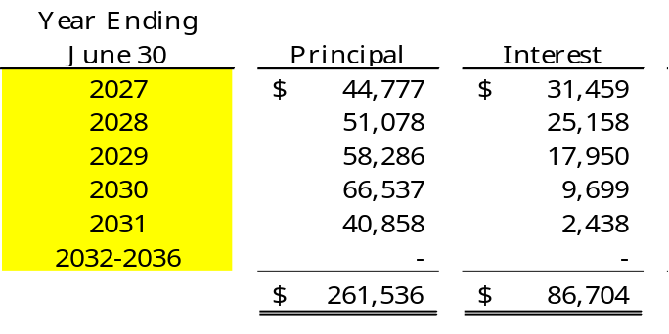

Note to preparer: In paragraph 19 of GASB 87, Leases, contracts that transfer ownership of the underlying asset and do not contain termination options are reported as financed purchases, not leases. If both conditions exist in a contract or a group of contracts, then a liability that is currently reported as a lease exception under paragraph 4 of GASB 88, Certain Disclosures Related to Debt, including Direct Borrowings and Direct Placements, will need to be reassessed to implement GASB 87.

b. Installment Financing

As authorized by G.S. 160A-20 and G.S. 153A-158.1, the County financed various property acquisitions in a direct placement for use by the Carolina County Board of Education during the fiscal year ended June 30, 2026, by an installment financing agreement. The installment financing was issued pursuant to a deed of trust that requires that legal title to the property financed remain with the County as long as the debt is outstanding because the property is pledged as collateral for the debt. The County has entered into a lease with Carolina County Board of Education that transfers the rights and responsibilities for maintenance and insurance of the property to the Board of Education. The lease calls for nominal annual lease payments and also contains a bargain purchase option. The lease term is the same as that of the installment purchase obligation. Due to the economic substance of the transaction, the capital assets associated with the installment purchase obligation are recorded by the Board of Education.

The installment financing was executed on July 1, 2025, for various property improvements for use by the Carolina County Board of Education. The transaction requires seven principal payments by the County of $171,429 and sixteen semi-annual interest payments at an interest rate of 7%. For Carolina County, the future minimum payments as of June 30, 2026, including $126,000 of interest, are:

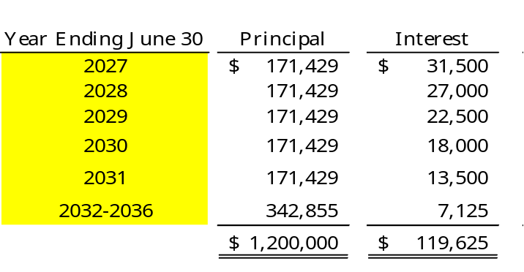

General Obligation Indebtedness

All general obligation bonds serviced by the County's General Fund are collateralized by the full faith, credit, and taxing power of the County. Carolina County’s Water and Sewer Districts issue general obligation bonds to provide funds for the acquisition and construction of major water system capital improvements. These bonds, which are recorded in the Water and Sewer District No. 1 Fund, are collateralized by the full faith, credit, and taxing power of the District. Principal and interest payments are appropriated when due. In the event of a default, the County agrees to pay to the Purchaser, on demand, interest on any and all amounts due and owing by the County under this Agreement.

The County's general obligation bonds payable at June 30, 2026, are comprised of the following individual issues:

Serviced by the County's General Fund:

$2,500,000 2023 Community College Improvement Serial Bonds due on September 1 and March 1 in 45 installments of $50,000 through September 1, 2047; interest at 6.70%.
$2,250,000
$750,000 2020 Municipal Building privately held serial bonds due on July 1 and January 1 in 18 installments of $25,000 through January 1, 2034; interest at 5.10%. | 450,000
$7,370,000 2011 School Facility Serial Bonds due on July 1 and January 1 in 38 installments of $75,000 and one of  $45,000 through July 1, 2049; interest at 6.50%. | 2,895,000
$2,340,000 2025 Hospital Improvement Serial Bonds due in 12
annual installments of $155,000 and one of $160,000 through May 1, 2038; interest at 6.00%.
 | 2,330,000
$3,365,000 2026 Current Refunding Bonds, due on July 1 and January 1 in 20 installments of $168,250 through July 1, 2035; interest at 3.75%. | 3,365,000
 | $11,290,000

Serviced by the County's Water and Sewer District No. 1:

$2,350,000 2022 Water Serial Bonds due in annual installments of $150,000 to $250,000 through December 1,  2034; interest at 5.10%. | $2,066,542

At June 30, 2026, Carolina County had bonds authorized but unissued of $1,250,000 and a legal debt margin of $506,399,216.

Annual debt service requirements to maturity for the County's and the District's general obligation bonds are as follows:

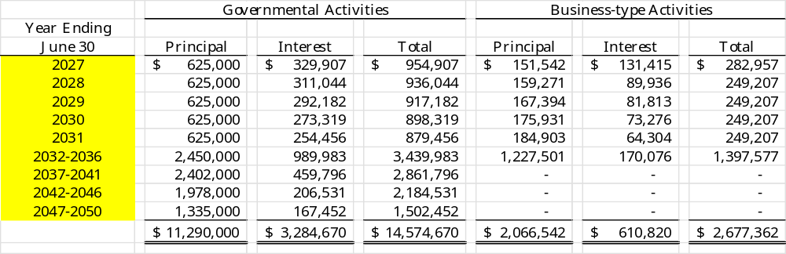

Revenue Bonds

In June 2019, the County issued $2 million of direct placement Hospital Revenue Bonds to finance capital improvements at Carolina County Hospital. At 8% interest, the interest on the bonds is payable semi-annually on April 1 and October 1. The revenue bonds, which mature through April 1, 2034, are reported on the Hospital's financial statements because the principal and interest on the bonds are payable from the net revenues of the Hospital. The revenue bonds do not constitute a legal or equitable pledge, charge, lien, or encumbrance upon any of the County's property or upon its income, receipts, or revenues. The taxing power of the County is not pledged for the payment of the principal or interest on the revenue bonds, and no owner has the right to compel the exercise of the taxing power of the County or the forfeiture of any of its property in connection with any default under the bond order.

Note to preparer: Revenue bond indenture information for each outstanding revenue bond issue should be disclosed as applicable. Revenue bond rate covenants are subject to variability. Consult a copy of the bond order or other documents for the exact covenants and the associated reporting requirements. The City of Dogwood includes a sample calculation of a rate covenant.

Revenue bond debt service requirements to maturity are as follows:

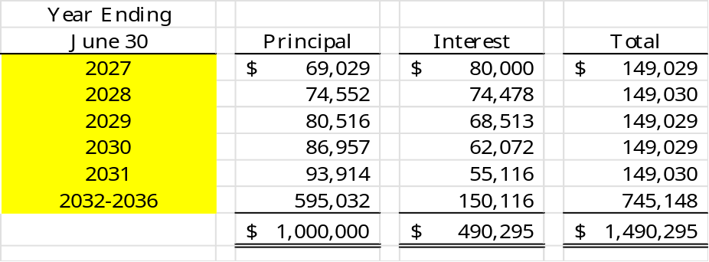

- Subscriptions

A SBITA was entered into during fiscal year 2024. The SBITA was for a Learning Management System. The initial term of the agreement was three years. The remaining term at June 30, 2026, is eighteen months. The Subscription did not have a stated interest rate. The County’s estimated incremental borrowing rate of 1.25% was used to discount the subscription payments. The liability balance at June 30, 2026, was $11,852.

During the current year, the County entered into a SBITA for a web-based strategy and performance management solution. The term of the agreement is five years. The SBITA did not have a stated interest rate. The County’s estimated incremental borrowing rate of 1.25% was used to discount the subscription payments. The initial liability for the subscription was $48,781. The liability balance remaining at June 30, 2026, was $38,781.

The future minimum subscription obligations and the net present value of these minimum payments as of June 30, 2026, were as follows:

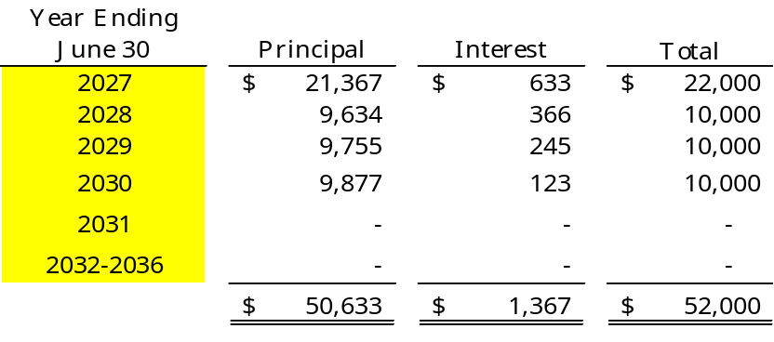

Current Refunding

On January 12, 2026, the County issued $3,365,000 of general obligation current refunding bonds to provide resources to purchase U.S. Government securities that were placed in an irrevocable trust and used to refund $3,300,000 of general obligation bonds on March 10, 2026. As a result, the refunded bonds are defeased and the liability has been removed from the governmental activities column of the statement of net position. The reacquisition price exceeded the net carrying amount of the old debt by $315,000. This refunding was undertaken to reduce total debt service payments by $182,000 and resulted in an economic gain of $105,000.

Note to preparer: Carolina County assumes that the refunding transaction does not require any of the note disclosures necessary to comply with GASB Statement No. 86, Certain Debt Extinguishment Issues. Units are encouraged to review the refunding transaction to determine if additional disclosures are needed.

Debt Related to Capital Activities: Of the total Governmental Activities debt listed, $4,127,169 relates to assets the County holds title.

Note to preparer: The Carolina County notes have been revised to illustrate the implementation of GASB 88, Certain Disclosures Related to Debt, including Direct Borrowings and Direct Placements. Whether or not the disclosure requirements in GASB 88 apply to the debt issues outstanding for a given local government depends upon the specific situation under which each outstanding debt instrument was issued and the terms in the related debt documents. Please refer to the debt or bond documents for more information on how to disclose your government’s specific debt. For more information, please refer to Memorandum #2019-08 .

Long-Term Obligation Activity

The following is a summary of changes in the County’s long-term obligations for the fiscal year ended June 30, 2026:
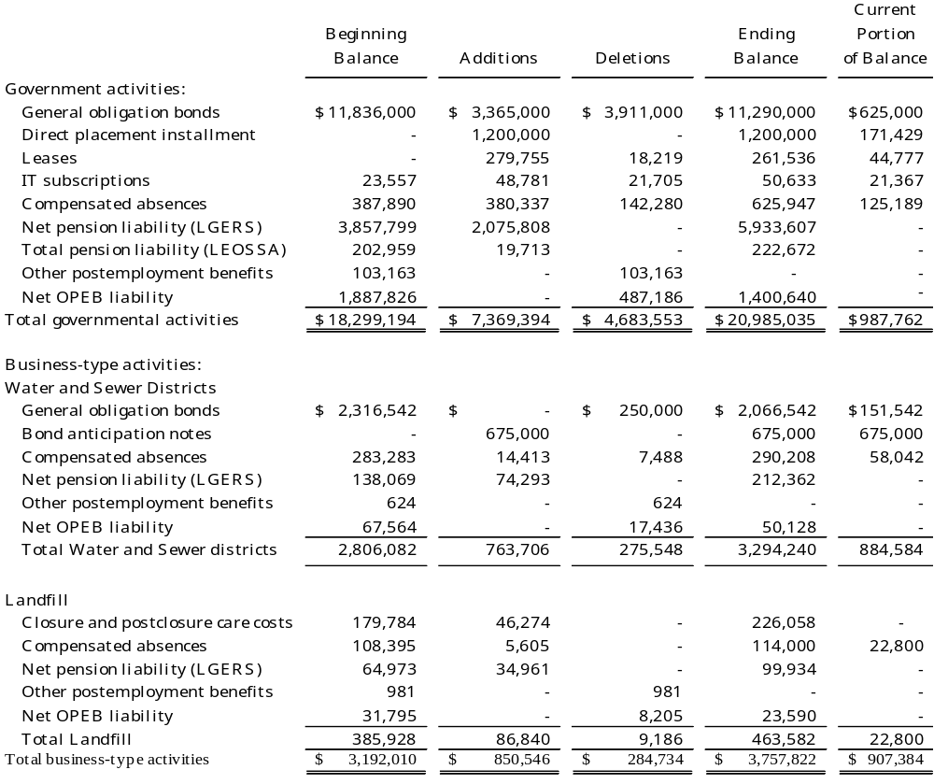

Net pension liability, total pension liability, and net other postemployment liability for governmental activities are all typically liquidated in the General Fund. Compensated absences for governmental activities typically have been liquidated in the General Fund. An expense and a liability for compensated absences and the salary-related payments are recorded as the leave is earned.

Note to preparer: Installment purchase agreements which are used to finance the acquisition of capital assets for general government use should be included in the Statement of Net Position. A continuing contract for which there is no formal financing should be included in the commitments note.

Note to Preparer: Please show a detailed long-term obligation note. Show the Water and Sewer Funds and Electric Fund (if applicable) separately for the Business-type activities section, as shown above.

The following is a summary of changes in the Hospital’s long-term obligations for the fiscal year ended September 30, 2025:
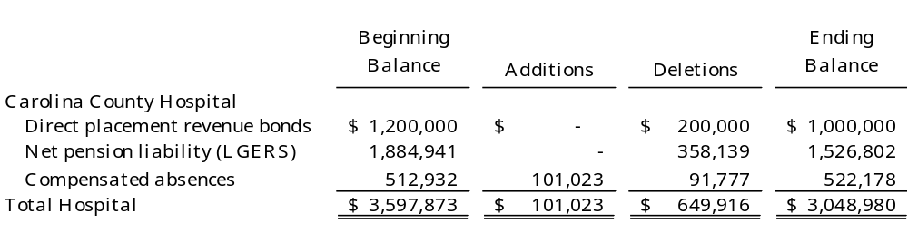

The following is a summary of changes in the TDA’s long-term obligations for the fiscal year ended June 30, 2026:
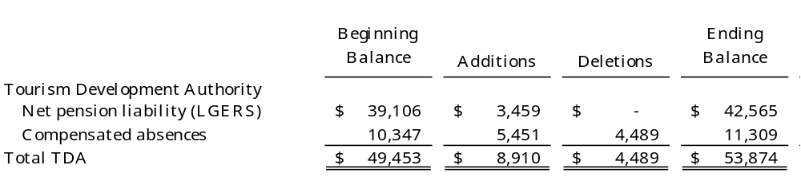

Conduit Debt Obligations

Carolina County Industrial Facility and Pollution Control Authority have issued industrial revenue bonds to provide financial assistance to private businesses for economic development purposes. These bonds are secured by the properties financed and letters of credit and are payable solely from payments received from the private businesses involved. Ownership of the acquired facilities is in the name of the private business served by the bond issuance. Neither the County nor the Authority nor the State nor any political subdivision thereof, is obligated in any manner for the repayment of the bonds. Accordingly, the bonds are not reported as liabilities in the accompanying financial statements. As of June 30, 2026, there were three series of industrial revenue bonds outstanding, with an aggregate principal amount payable of $6 million. The County has made a limited commitment to maintain the tax-exempt status of these three issues.

Note to preparer: GASB 91, Conduit Debt Obligations, provides the accounting and financial reporting standards for such obligations. The standards address the circumstances that require the issuer to recognize a liability for a conduit debt obligation. The standard also requires certain disclosures for transactions that meet the definition of conduit debt. The disclosures vary depending on whether the issuer has recognized a liability for the conduit debt obligation.

Interfund Balances and Transfer Activity

Note to preparer: The purpose of each Transfer and all Interfund Balances (if applicable) must be disclosed (GASB 38 paragraph 14). Understanding interfund balances plays a significant role in the determination of fiscal health. The justification and a repayment schedule should be disclosed for balances that are not expected to be repaid within the current fiscal year. All interfund transactions throughout the year are considered essential to fair presentation at the basic financial statement level and should be included in the notes to the financial statements. For interfund transfers, amounts transferred between funds by individual major fund, non-major governmental funds in the aggregate, non-major enterprise funds in the aggregate, internal service funds in the aggregate, and fiduciary fund type, a general description of the principal purposes of interfund transfers should be disclosed in the notes, along with the purposes for and amounts of non-routine transfers and transfers inconsistent with the activities of the fund making the transfers. These provisions should be applied to material items only.

Note to preparer: For a sample Interfund balance note, please see the City of Dogwood Illustrative sample statements. Please do not simply cut and paste the sample note for transfers and Interfund balances (due to/from / advances to/from). The note disclosure should provide a thorough explanation applicable to the Unit of the purpose of their specific transfers and/or loans, including terms of repayment for any loans.

Transfers to/from other funds at June 30, 2026, consist of the following:

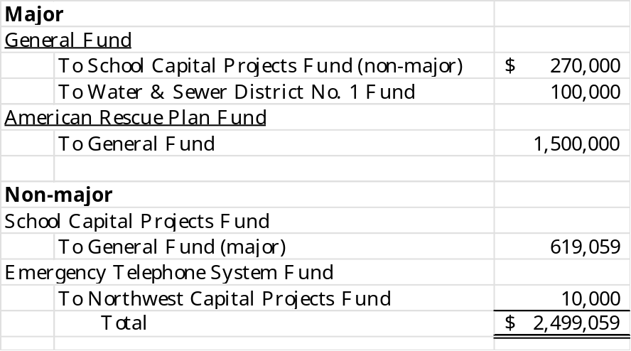

The County made transfers for the following purposes:
- To move $200,000 of funds to accumulate resources for school capital projects.
- To move $70,000 of funds for current school construction projects.
- To move $100,000 of funds to subsidize operating costs of water & sewer services.
- To move $1,500,000 of grants funds for reimbursement for premium pay and revenue loss.
- To move $619,059 of lottery proceeds to use for school debt service.
- To move $10,000 of restricted E911 funds for radio switching equipment.

- On-Behalf Payments for Fringe Benefits and Salaries

Note to preparer: Note disclosures for on-behalf payments paid by the Firemen’s Relief Fund for fringe benefits and salaries have not been included because they have been deemed immaterial to Carolina County. If these amounts are material to your unit, please consider the following note disclosure.

The County has recognized as a revenue and an expenditure on-behalf payments for fringe benefits and salaries of $1,192 for the salary supplement and stipend benefits paid to eligible firemen by the local board of trustees of the Firemen’s Relief Fund during the fiscal year ended June 30, 2026. Under State law, the local board of trustees for the Fund receives an amount each year, which the board may use at its own discretion for eligible firemen or their departments.

Note to preparer: For employees and volunteers of governmental fire departments, the independent auditor may have to contact the local board of trustees to determine the amount of money the board has paid out for salary supplements and stipends. If payment from the Firemen’s Relief Fund is not made to the government unit, the on-behalf payments paragraph can be excluded from the audit report.

Net Investment in Capital Assets

Note to preparer: If the net investment in capital assets amount is not easily determinable based on the amounts presented in the basic financial statements, include a calculation in the notes or submit it in a document separate from the audit submission. The calculation is required for the GFOA ACFR application.

- Fund Balance

Carolina County has a revenue spending policy that provides a policy for programs with multiple revenue sources. The Finance Officers will use resources in the following hierarchy: bond proceeds, federal funds, State funds, local non-county funds, county funds. For purposes of fund balance classification, expenditures are to be spent from restricted fund balance first, followed in order by committed fund balance, assigned fund balance, and lastly unassigned fund balance. The Finance Officer has the authority to deviate from this policy if it is in the best interest of the County.

Note to Preparer: Units should modify the above language to reflect their own policies.

The following is a schedule of the calculation of fund balance available for appropriation in the General fund as of June 30, 2026:

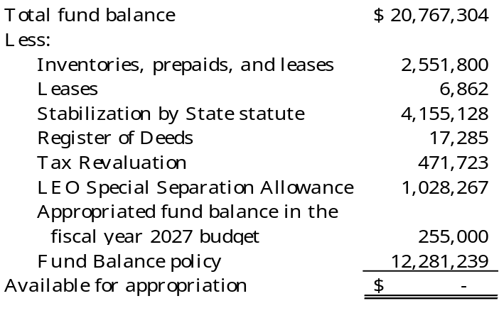

The governing board has adopted a policy to maintain a minimum level of available fund balance in the General Fund. The target level is 16 percent of current year expenditures of the General Fund.

Note to Preparer: The above schedule is prepared from the General Fund Balance Sheet as presented in the basic financial statements. Each restriction, commitment, and assignment of fund balance should be included in the calculation above.

The unit should also include any other items that the board authorized, even if it is included in unassigned on the Balance Sheet. This is where the unit can disclose any fund balance policies and reduce it from the remaining amount. In this example, the fund balance policy is included in unassigned fund balance. In unusual circumstances, fund balance policies can be included in Committed Fund Balance. For more information on GASB 54 components of fund balance, please review Memorandum #2010-35.

The unit is also required to disclose the dollar amount of outstanding encumbrances for all major funds and non-major funds in the aggregate. Outstanding encumbrances are not shown on the face of the statement but are included in Restricted for Stabilization by State Statute (RSS); however, in funds other than the General Fund, they might be shown as some other restricted amount. In either case, the amount of significant outstanding encumbrances must be disclosed for each major fund and in the aggregate for non- major funds. Below is example of such disclosure.

- Outstanding Encumbrances

Outstanding encumbrances are amounts needed to pay any commitments related to purchase orders and contracts that remain unperformed at year-end. $255,000 were outstanding as of June 30, 2026, for the General Fund.

Note to preparer: General Fund encumbrances should include those for the legally adopted general fund as well as any funds consolidated into the general fund for a GAAP presentation in accordance with GASB Statement No. 54.

Segment Information

Note to preparer: Be alert if a non-major proprietary fund has revenue-backed debt. Segment information is only required for enterprise funds with outstanding revenue-backed debt if the fund is not presented as major or when the segment does not encompass the entire fund. In disclosing segment information, present the type of goods or services; a condensed statement of net position; condensed statement of revenues, expenses, and changes in net position; and a condensed statement of cash flows. See paragraph 122 of GASB Statement No. 34 for more details.

VI. Related Organization

The chairman of the County's governing board is also responsible for appointing the members of the board of the Carolina County Recreation Corporation, but the County's accountability for this organization does not extend beyond making these appointments. The Corporation is a nonprofit organization that exists to develop and provide recreational activities for County residents. It is funded primarily with private donations.

VII. Opioid Settlement Funds

In April 2022, drug manufacturer Johnson & Johnson, and three drug distributors, McKesson, AmerisourceBergen, and Cardinal Health, finalized a $26 billion nationwide settlement related to multiple opioid lawsuits. These funds are disbursed to each participating State over an 18-year period according to an allocation agreement reached with participating States. The majority of the funds must be used for opioid abatement and remediation activities and programs, and the distribution of the funds is front loaded. The North Carolina MOA between the State and local governments allocates funds 15% to the State, 80% to local governments, and 5% to a County incentive fund.

The County received $540,000 in the current fiscal year, spent $500,000, and, per the MOA, accounts for the amounts in a special revenue fund, the Opioid Settlement Fund (major fund).

In July 2025, Secondary Opioid Manufacturer Settlements were reached with Alvogen Inc., Amneal Pharmaceuticals LLC, Apotex Corp., Hikma Pharmaceuticals USA, Indivior Inc., Sun Pharmaceutical Industries Inc., and Zydus Pharmaceuticals Inc. A settlement was also reached with Purdue Pharma L.P.’s bankruptcy plan for $7.4 billion. The Secondary Settlements are subject to the terms of the existing MOA with the State.

Note to Preparer: After reviewing the method through which a County receives the resources, if it is determined that the activity should follow the exchange vs nonexchange method, the County will report additional settlements in the fiscal year a Board resolution approving the settlement is adopted.

Note to the Preparer: Please refer to the DST blog post from September 2023: Accounting For Opioid Settlement Funds – An Update . Guidance for allowable uses of Opioid Settlement Funds is available in the MOA which you may view at the following link - NC DOJ Opioid MOA

Per the MOA, every Local Government receiving Opioid Settlement Funds shall create a separate special revenue fund. There are two usage options the local government may select: Option A: A list of 12 categories of evidence-based strategies to address the opioid epidemic. See the NC MOA Exhibit A for a current list of the high impact opioid abatement strategies. Option B: A wider array of strategies to address the impact of the opioid epidemic. See the NC MOA Exhibit B for a current version of the Option B national strategy list.

The Grant and Project Ordinance allowed in G.S. 159-13.2 required a technical correction to allow for the Opioid Fund to be accounted for with a project ordinance since the funds are not from the federal or state level. The legislation allowing for the technical correction passed in May of 2024, is effective July 1, 2023, and is found here.

Additional guidance is available from the NC Association of County Commissioners: Opioid Litigation Settlement

VIII. Reimbursement for Pandemic-Related Expenditures

In FY 2021, the American Rescue Plan Act (ARPA) established the Coronavirus State and Local Fiscal Recovery Funds to support urgent COVID-19 response efforts and replace lost revenue for the eligible state, local, territorial, and tribal governments. The County was allocated $4,200,000 of fiscal recovery funds paid in two equal installments. The first installment of $2,100,000 was received in July 2022. The second installment of $2,100,000 was received in July 2023. County staff and the Board of Commissioners elected to use $440,000 of the ARPA funds for premium pay in FY 2023. The $440,000 was transferred from the ARPA Fund to the General Fund.

The County used $500,000 for premium pay in fiscal year 2025 and $1,000,000 was used for eligible general government expenditures under revenue replacement. These amounts were transferred to the General Fund from the ARPA Fund during fiscal year 2025. The remaining $2,260,000 was used in fiscal year 2026 for eligible general government expenditures under revenue replacement.

Note to Preparer: Throughout Carolina County, the term “ARPA” or “ARP” is used for the funding from the federal program Coronavirus State Local Fiscal Recovery Funds (CSLFRF) (21.027). The way the funding has been discussed, ARPA and CSLFRF have been synonymous, but APRA has funded many new and existing programs. ARPA provided $1.9 trillion of pandemic relief, and $350 billion went to CSLFRF. NC Legislation has referred to the funds as State Fiscal Recovery Funds, and we have seen OSBM refer to them as Local Fiscal Recovery Funds. It is recommended that ARPA funds are kept in a special revenue fund. ARPA revenues are unearned revenue until all eligibility requirements have been met. Once the use is determined, the funds are then transferred to the appropriate fund before being expended. Once the use is determined, it is considered earned revenue.

Transferred funds are treated as restricted cash on the fund statements until all eligibility requirements have been met. ARPA funds not encumbered by December 31, 2024, and expended by December 31, 2026, must be returned to the federal government. See the UNC School of Government ARPA Blog Posts for additional information related to allowable uses. American Rescue Plan (ARPA) Blog Posts – American Rescue Plan (ARPA)

Note to Preparer: The UNC School of Government recommends the ARPA fund is reported as a major fund. Beginning with the 2024 illustrative financial statements, we follow the School of Government guidance.

IX. Joint Ventures

The County, in conjunction with the City of Dogwood, participates in the City of Dogwood - Carolina County Regional Airport Authority. Each participating government appoints three members to the six-member board. The Airport is a joint venture established to facilitate economic expansion within the County and improve the quality of life for its citizens. The Airport has been in existence for five years, but it is not yet self-sustaining. The County has an ongoing financial responsibility for the Airport because it and the City are legally obligated under the intergovernmental agreement that created the Airport to honor any deficiencies if proceeds from other default remedies are insufficient. The County contributed $1,014,922 to the Airport during the fiscal year ended June 30, 2026. The participating governments do not have any equity interest in the joint venture, so no equity interest has been reflected in the financial statements at June 30, 2026. Complete financial statements for the Airport can be obtained from the Airport's administrative offices at 0000 Runway Avenue, Dogwood, NC 00000.

The County also participates in a joint venture to operate Central Carolina Regional Library with five other local governments. Each participating government appoints one board member to the six-member board of the Library. The County has an ongoing financial responsibility for the joint venture because the Library's continued existence depends on the participating governments' continued funding. None of the participating governments have any equity interest in the Library, so no equity interest has been reflected in the financial statements at June 30, 2026. In accordance with the intergovernmental agreement between the participating governments, the County appropriated $2,024,806 to the Library to supplement its activities. Complete financial statements for the Library can be obtained from the Library's offices at 0001 Periodical Road, Dogwood, NC 00000.

The County, in conjunction with the State of North Carolina and the Carolina County Board of Education, participates in a joint venture to operate the Carolina County Community College. Each of the three participants appoints four members of the thirteen-member board of trustees of the community college. The president of the community college's student government serves as an ex officio nonvoting member of the community college's board of trustees. The community college is included as a component unit of the State. The County has the basic responsibility for providing funding for the facilities of the community college and provides some financial support for the community college's operations. In addition to providing annual appropriations for the facilities, the County periodically issues general obligation bonds to provide financing for new and restructured facilities. Of the last general obligation bond issue for this purpose, $2,250,000 in debt is still outstanding. The County has an ongoing financial responsibility for the community college because of the statutory responsibilities to provide funding for the community college's facilities. The County contributed $2,000,000 and $500,000 to the community college for operating and capital purposes, respectively, during the fiscal year ended June 30, 2026. In addition, the County made debt service payments of $254,100 during the fiscal year on general obligation bonds issued for community college capital facilities. The participating governments do not have any equity interest in the joint venture; therefore, no equity interest has been reflected in the County's financial statements at June 30, 2026. Complete financial statements for the community college may be obtained from the community college's administrative offices at 10002 Cedar Hill Drive, Dogwood, NC 00000.

The County, along with four other adjoining counties, has an equity interest in a cooperative known as Carolina Cooperative. The purpose of the co-op is to purchase supplies for the member counties at prices lower than each individual county could negotiate on its own. Carolina Cooperative is a separate legal entity and receives its own separate annual audit and issues its own separate financial statements. These statements may be obtained by contacting the cooperative at the following address: Carolina Cooperative, 100 Tar Heel Lane, Dogwood, NC 00000, or telephone number (919) 555-5555.

As of June 30, 2026, the County’s interest in Carolina Cooperative was $8,932, which represents its percentage share of the total equity of the entity as recorded in its audit for the fiscal year ended June 30, 2026. This total is recorded as an “Other Asset” on the Statement of Net Position of Carolina County in the governmental activities’ column. The equity interest does not appear on the Statement of Assets, Liabilities, and Changes in Fund Balances as it does not represent a current funding source for the County. Therefore, the amount of the equity interest appears on the reconciliation between the net position of the governmental activities on the Statement of Net Position and the total fund balance of governmental funds on the Governmental Funds Balance Sheet.

In addition, the County’s equity interest in the cooperative increased during the past fiscal year from $8,383 to the current amount of $8,932. This increase of $549 appears as an income item on the Statement of Activities but not in the Statement of Revenues, Expenditures, and Changes in Fund Balances because it does not represent a current funding source for the County. The $549 of income appears as a reconciling item between these statements as well.

Jointly Governed Organization

The County, in conjunction with five other counties and thirty-eight municipalities, established the Red Bird Council of Governments (Council). The participating governments established the Council to coordinate various funding received from federal and State agencies. Each participating government appoints one member to the Council’s governing board. The County paid membership fees of $20,000 to the Council during the fiscal year ended June 30, 2026. The County was the subrecipient of a grant for $420,000 from the U.S. Department of Health and Human Services and the Division of Aging of the North Carolina Department of Health and Human Services that was passed through the Council.

- Related Party Transactions

Note to preparer: Disclose significant transactions with elected officials, employees, and related organizations. Disclosures should include the nature of the relationship, a description and dollar amount of any transaction, the amount(s) due to or from the related parties, and any other significant details.

Summary Disclosure of Significant Commitments and Contingencies

Federal and State Assisted Programs. The County has received proceeds from several federal and State grants. Periodic audits of these grants are required, and certain costs may be questioned as not being appropriate expenditures under the grant agreements. Such audits could result in the refund of grant moneys to the grantor agencies. Management believes that any required refunds will be immaterial. No provision has been made in the accompanying financial statements for the refund of grant moneys.

Changes in Accounting Principles

For the year ended June 30, 2026, GASB Statement No. 103, Financial Reporting Model Improvements, was implemented. The objective of this Statement is to improve key components of the financial reporting model to enhance its effectiveness in providing information that is essential for decision making and assessing a government’s accountability. The Statement changes the Management’s Discussion and Analysis to limit discussion areas while requiring detailed analysis to explain why balances and results of operations changed. The Statement clarifies items reported as Unusual or Infrequent Items, formerly reported as Special or Extraordinary Items, as well as reporting requirements. Changes are required to the reporting format of the proprietary fund Statement of Revenues, Expenses, and Changes in Fund Net Position. The Statement requires changes to the reporting of major and nonmajor component units. Also, all budgetary comparison information is now required to be presented as Required Supplementary Information. No restatements were required as a result of implementation.

For the year ended June 30, 2026, GASB Statement No. 104, Disclosure of Certain Capital Assets, was implemented. The Statement requires disclosures of certain asset types separately (Note IV.A.5).

For the year ended June 30, 2026, GASB Statement No. 105, Subsequent Events, was implemented. The objective of this Statement is to improve the financial reporting requirements for subsequent events, thereby enhancing consistency in their application and better meeting the information needs of financial statements users (Note XIV).

Note to Preparer: Units may have implementation amounts that their evaluation results showed as immaterial for restatement.

Significant Effects of Subsequent Events

Note to preparer: Events that occur after the date of the financial statements but before the date the financial statements are available to be issued that have a significant effect on the unit should be disclosed (see GASB Statement 105). For a component unit with a different fiscal year end, such as Carolina County Hospital, the auditor should disclose significant subsequent events between the component unit’s fiscal year end, and the date the reporting entity’s financial statements are available to be issued. Example: On September 26, 2024, Hurricane Helene devastated much of the Western part of North Carolina. The effects upon Carolina County were ….

- Unusual or Infrequent Item

For the year ended June 30, 2026, the financial statements include an unusual or infrequent item as a transaction for the sale of land was unusual in nature. The land had a book value of $1,000 and was sold for $28,482.

Note to preparer: This disclosure is included only to illustrate the presentation of an unusual or infrequent item. As with all GASB statements, preparers should include disclosure only when the item is material to the reporting unit.

Required Supplementary Information

- General Fund, Budgetary Comparison Schedule
- Tax Revaluation Fund, Budgetary Comparison Schedule
- Opioid Settlement Fund, Budgetary Comparison Schedule
- Notes to Budgetary Comparison Schedules
- Schedule of County’s Proportionate Share of Net Pension Liability (Asset) for Local Governmental Employees’ Retirement System

- Schedule of County’s Contributions to Local Governmental Employees’ Retirement System

- Schedule of the Tourism Development Authority’s Proportionate Share of Net Pension Liability (Asset) for Local Governmental Employees’ Retirement System

- Schedule of the Tourism Development Authority’s Contributions to Local Governmental Employees’ Retirement System

- Schedule of Proportionate Share of Net Pension Asset for Register of Deeds’ Supplemental Pension Fund

- Schedule of Contributions to Register of Deeds’ Supplemental Pension Fund

- Schedule of Changes in Total Pension Liability of the Law Enforcement Officers’ Special Separation Allowance

- Schedule of Total Pension Liability as a Percentage of Covered- Employee Payroll of the Law Enforcement Officers’ Special Separation Allowance

- Schedule of Changes in the Net OPEB Liability and Related Ratios of the Healthcare Benefit Plan

- Schedule of Contributions and Investment Returns of the Healthcare Benefit Plan

